|  |  |  |  |
| --- | --- | --- | --- |
| Taxpayer’s name  **RAKESH KOKA** | |  | Social security number  **165-05-9229** |
| Spouse’s name | |  | Spouse’s social security number |
| Part I | Tax Return Information — Tax Year Ending December 31, | **2020** ( Enter year you are authorizing. ) | |

Enter whole dollars only on lines 1 through 5.

Note: Form 1040-SS filers use line 4 only. Leave lines 1, 2, 3, and 5 blank.

1. Adjusted gross income . . . . . . . . . . . . . . . . . . . . . . . . . . 1 **60,180.**

Form

**8879**

(

Rev. January

2021)

Department of the Treasury

Internal Revenue Service

IRS

*e-file*

Signature Authorization

a

ERO must obtain and retain completed Form 8879.

a

Go to

*www.irs.gov/Form8879*

for the latest information.

OMB No. 1545-0074

Submission Identification Number (SID)

F

1. Total tax . . . . . . . . . . . . . . . . . . . . . . . . . . . . . . . 2 **6,301.**
2. Federal income tax withheld from Form(s) W-2 and Form(s) 1099 . . . . . . . . . . . . . 3 **7,362.**
3. Amount you want refunded to you . . . . . . . . . . . . . . . . . . . . . . 4 **2,861.**
4. Amount you owe . . . . . . . . . . . . . . . . . . . . . . . . . . . . 5

Part II Taxpayer Declaration and Signature Authorization (Be sure you get and keep a copy of your return)

Under penalties of perjury, I declare that I have examined a copy of the income tax return (original or amended) I am now authorizing, and to the best of my knowledge and belief, it is true, correct, and complete. I further declare that the amounts in Part I above are the amounts from the income tax return (original or amended) I am now authorizing. I consent to allow my intermediate service provider, transmitter, or electronic return originator (ERO) to send my return to the IRS and to receive from the IRS (a) an acknowledgement of receipt or reason for rejection of the transmission, (b) the reason for any delay in processing the return or refund, and (c) the date of any refund. If applicable, I authorize the U.S. Treasury and its designated Financial Agent to initiate an ACH electronic funds withdrawal (direct debit) entry to the financial institution account indicated in the tax preparation software for payment of my federal taxes owed on this return and/or a payment of estimated tax, and the financial institution to debit the entry to this account. This authorization is to remain in full force and effect until I notify the U.S. Treasury Financial Agent to terminate the authorization. To revoke (cancel) a payment, I must contact the U.S. Treasury Financial Agent at 1-888-353-4537. Payment cancellation requests must be received no later than 2 business days prior to the payment (settlement) date. I also authorize the financial institutions involved in the processing of the electronic payment of taxes to receive confidential information necessary to answer inquiries and resolve issues related to the payment. I further acknowledge that the personal identification number (PIN) below is my signature for the income tax return (original or amended) I am now authorizing and, if applicable, my Electronic Funds Withdrawal Consent.

Taxpayer’s PIN: check one box only

|  |  |  |  |  |
| --- | --- | --- | --- | --- |
| **5** | **9** | **2** | **2** | **9** |

I authorize **GLOBAL TAXES LLC** to enter or generate my PIN as my

Enter five digits, but

ERO firm name don’t enter all zeros signature on the income tax return (original or amended) I am now authorizing.

I will enter my PIN as my signature on the income tax return (original or amended) I am now authorizing. Check this box only if you are entering your own PIN and your return is filed using the Practitioner PIN method. The ERO must complete Part III below.

Your signature a Date a

Rakesh koka5/17/2021

Spouse’s PIN: check one box only

I authorize to enter or generate my PIN

as my

ERO firm name Enter five digits, but

signature on the income tax return (original or amended) I am now authorizing. don’t enter all zeros

I will enter my PIN as my signature on the income tax return (original or amended) I am now authorizing. Check this box only if you are entering your own PIN and your return is filed using the Practitioner PIN method. The ERO must complete Part III below.

Spouse’s signature a Date a

Practitioner PIN Method Returns Only—continue below Part III Certification and Authentication — Practitioner PIN Method Only

ERO’s EFIN/PIN. Enter your six-digit EFIN followed by your five-digit self-selected PIN. **5 8 7 2 7 8 6 1 9 8 9**

Don’t enter all zeros

I certify that the above numeric entry is my PIN, which is my signature for the electronic individual income tax return (original or amended) I am now authorized to file for tax year indicated above for the taxpayer(s) indicated above. I confirm that I am submitting this return in accordance with the requirements of the Practitioner PIN method and Pub. 1345, Handbook for Authorized IRS *e-file* Providers of Individual Income Tax Returns.

|  |  |
| --- | --- |
| ERO’s signature a | Date a |
|  | ERO Must Retain This Form — See Instructions Don’t Submit This Form to the IRS Unless Requested To Do So |

For Paperwork Reduction Act Notice, see your tax return instructions. **BAA REV 04/20/21 PRO** Form 8879 (Rev. 01-2021)

Department of the Treasury—Internal Revenue Service (99) **1040** U.S. Individual Income Tax Return 20**20** OMB No. 1545-0074 IRS Use Only—Do not write or staple in this space.

Form

Filing Status Single Married filing jointly Married filing separately (MFS) Head of household (HOH) Qualifying widow(er) (QW)

Check only If you checked the MFS box, enter the name of your spouse. If you checked the HOH or QW box, enter the child’s name if the qualifying one box.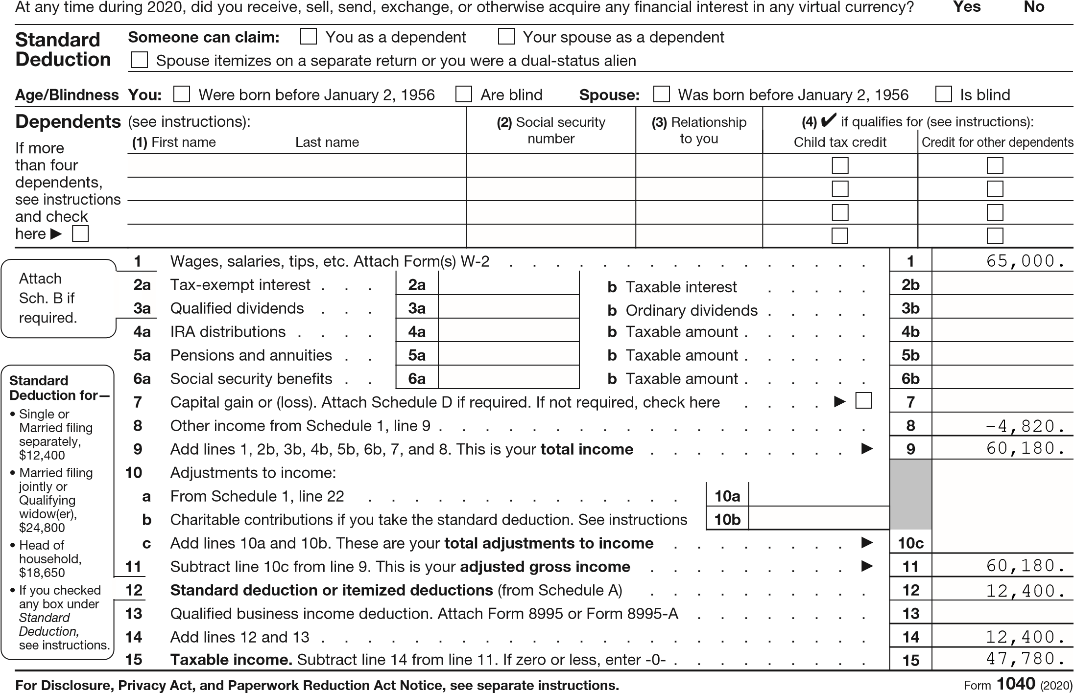

person is a child but not your dependent a

|  |  |  |  |  |  |  |
| --- | --- | --- | --- | --- | --- | --- |
| Your first name and middle initial  **RAKESH** | Last name  **KOKA** | | | | | Your social security number  **165-05-9229** |
| If joint return, spouse’s first name and middle initial | Last name | | | | | Spouse’s social security numbe r |
| Home address (number and street). If you have a P.O. box, see instructions.  **707 WIGGENSFERRY DR** | | | | | Apt. no. | Presidential Election Campaign  Check here if you, or your spouse if filing jointly, want $3 to go to this fund. Checking a box below will not change your tax or refund.  Spouse  You |
| City, town, or post office. If you have a foreign address, also complete spaces below.  **SAINT LOUIS** | | | State  **MO** | ZIP code  **631416503** | |
| Foreign country name | | Foreign province/state/county | | Foreign postal code | |

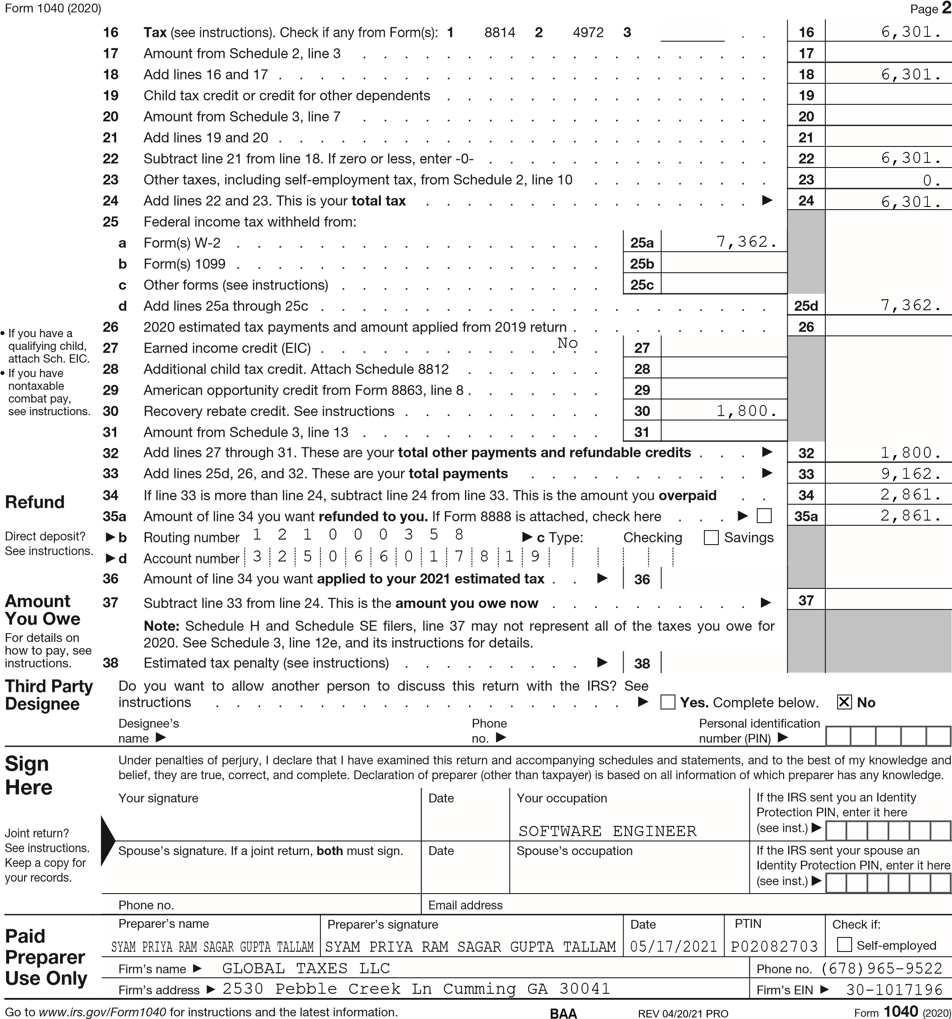

SCHEDULE 1 OMB No. 1545-0074

(Form 1040) Additional Income and Adjustments to Income 20**20**

Department of the Treasury aAttach to Form 1040, 1040-SR, or 1040-NR. Attachment

Internal Revenue Service a Go to *www.irs.gov/Form1040* for instructions and the latest information. Sequence No. 01

Name(s) shown on Form 1040, 1040-SR, or 1040-NR Your social security number

**RAKESH KOKA 165-05-9229**

Part I Additional Income

1 Taxable refunds, credits, or offsets of state and local income taxes . . . . . . . 1

2a Alimony received . . . . . . . . . . . . . . . . . . . . . . . . . . . 2 a

b Date of original divorce or separation agreement (see instructions) a

1. Business income or (loss). Attach Schedule C . . . . . . . . . . . . . . . 3
2. Other gains or (losses). Attach Form 4797 . . . . . . . . . . . . . . . . . 4
3. Rental real estate, royalties, partnerships, S corporations, trusts, etc. Attach Schedule E 5 **-4,820.**
4. Farm income or (loss). Attach Schedule F . . . . . . . . . . . . . . . . . 6
5. Unemployment compensation . . . . . . . . . . . . . . . . . . . . . . 7
6. Other income. List type and amount a

8

1. Combine lines 1 through 8. Enter here and on Form 1040, 1040-SR, or 1040-NR,

line 8 . . . . . . . . . . . . . . . . . . . . . . . . . . . . . . . . 9 **-4,820.**

Part II Adjustments to Income

1. Educator expenses . . . . . . . . . . . . . . . . . . . . . . . . . . 10
2. Certain business expenses of reservists, performing artists, and fee-basis government

officials. Attach Form 2106 . . . . . . . . . . . . . . . . . . . . . . . 11 12 Health savings account deduction. Attach Form 8889 . . . . . . . . . . . . 12

1. Moving expenses for members of the Armed Forces. Attach Form 3903 . . . . . 13
2. Deductible part of self-employment tax. Attach Schedule SE . . . . . . . . . 14
3. Self-employed SEP, SIMPLE, and qualified plans . . . . . . . . . . . . . . 15
4. Self-employed health insurance deduction . . . . . . . . . . . . . . . . . 16
5. Penalty on early withdrawal of savings . . . . . . . . . . . . . . . . . . 17

18a Alimony paid . . . . . . . . . . . . . . . . . . . . . . . . . . . . . 18 a b Recipient’s SSN . . . . . . . . . . . . . . . . . . . . a c Date of original divorce or separation agreement (see instructions) a

1. IRA deduction . . . . . . . . . . . . . . . . . . . . . . . . . . . . 19
2. Student loan interest deduction . . . . . . . . . . . . . . . . . . . . . 20
3. Tuition and fees deduction. Attach Form 8917 . . . . . . . . . . . . . . . 21
4. Add lines 10 through 21. These are your adjustments to income. Enter here and

on Form 1040, 1040-SR, or 1040-NR, line 10a . . . . . . . . . . . . . . . 22

For Paperwork Reduction Act Notice, see your tax return instructions. **BAA REV 04/20/21 PRO** Schedule 1 (Form 1040) 2020

SCHEDULE E Supplemental Income and Loss OMB No. 1545-0074

(Form 1040) (From rental real estate, royalties, partnerships, S corporations, estates, trusts, REMICs, etc.) 20**20**

a Attach to Form 1040, 1040-SR, 1040-NR, or 1041.

Department of the Treasury Attachment

Internal Revenue Service (99) a Go to *www.irs.gov/ScheduleE* for instructions and the latest information. Sequence No. 13

Name(s) shown on return Your social security number

**RAKESH KOKA 165-05-9229**

Part I Income or Loss From Rental Real Estate and Royalties Note: If you are in the business of renting personal property, use Schedule C. See instructions. If you are an individual, report farm rental income or loss from Form 4835 on page 2, line 40.

1. Did you make any payments in 2020 that would require you to file Form(s) 1099? See instructions . . . . . Yes No
2. If “Yes,” did you or will you file required Form(s) 1099? . . . . . . . . . . . . . . . . . . . Yes No

|  |  |  |  |  |  |  |  |  |
| --- | --- | --- | --- | --- | --- | --- | --- | --- |
| 1a | Physical address of each property (street, city, state, ZIP code) | |  |  |  |  | | |
| A | **MANIKONDA JAGIR HYDERABAD TELANGANA IN 500089** | |  |  |  |  | | |
| B |  | |  |  |  |  | | |
| C |  | |  |  |  |  | | |
| 1b | Type of Property  (from list below) | 2 For each rental real estate property listed above, report the number of fair rental and personal use days. Check the QJV box only if you meet the requirements to file as a qualified joint venture. See instructions. |  | Fair Rental  Days | Personal Use  Days | QJV | | |
| A | **3** | A | **310** | **0** |  |  |  |
| B |  | B |  |  |  |  |  |
| C |  | C |  |  |  |  |  |

Type of Property:

1. Single Family Residence 3 Vacation/Short-Term Rental 5 Land 7 Self-Rental
2. Multi-Family Residence 4 Commercial 6 Royalties 8 Other (describe )

|  |  |  |  |  |  |  |  |
| --- | --- | --- | --- | --- | --- | --- | --- |
| Income: | Properties: |  | A | | B | | C |
| 3 Rents received . . . . . . . . . . . . . | | 3 | **400.** | |  | |  |
| 4 Royalties received . . . . . . . . . . . . | | 4 |  | |  | |  |
| Expenses:   1. Advertising . . . . . . . . . . . . . . 2. Auto and travel (see instructions) . . . . . . . 7 Cleaning and maintenance . . . . . . . . . 8 Commissions. . . . . . . . . . . . . . 9 Insurance . . . . . . . . . . . . . . . 3. Legal and other professional fees . . . . . . . 4. Management fees . . . . . . . . . . . . 5. Mortgage interest paid to banks, etc. (see instructions) 6. Other interest. . . . . . . . . . . . . . 7. Repairs. . . . . . . . . . . . . . . . 8. Supplies . . . . . . . . . . . . . . . 9. Taxes . . . . . . . . . . . . . . . . 10. Utilities. . . . . . . . . . . . . . . . 11. Depreciation expense or depletion . . . . . . 12. Other (list) a | | 5 |  | |  | |  |
| 6 |  | |  | |  |
| 7 | **940.** | |  | |  |
| 8 |  | |  | |  |
| 9 |  | |  | |  |
| 10 | **800.** | |  | |  |
| 11 |  | |  | |  |
| 12 |  | |  | |  |
| 13 |  | |  | |  |
| 14 | **1,450.** | |  | |  |
| 15 | **900.** | |  | |  |
| 16 |  | |  | |  |
| 17 | **1,130.** | |  | |  |
| 18 |  | |  | |  |
| 19 |  | |  | |  |
| 1. Total expenses. Add lines 5 through 19 . . . . . 2. Subtract line 20 from line 3 (rents) and/or 4 (royalties). If   result is a (loss), see instructions to find out if you must file Form 6198 . . . . . . . . . . . . .   1. Deductible rental real estate loss after limitation, if any, on Form 8582 (see instructions) . . . . . . .   23a Total of all amounts reported on line 3 for all rental properties b Total of all amounts reported on line 4 for all royalty properties c Total of all amounts reported on line 12 for all properties d Total of all amounts reported on line 18 for all properties e Total of all amounts reported on line 20 for all properties   1. Income. Add positive amounts shown on line 21. Do not 2. Losses. Add royalty losses from line 21 and rental real estate losses from line 22. Enter total losses here . 3. Total rental real estate and royalty income or (loss).   here. If Parts II, III, IV, and line 40 on page 2 do not apply to you, also enter this amount on  Schedule 1 (Form 1040), line 5. Otherwise, include this amount in the total on line 41 on page 2 | | 20 | **5,220.** | |  | |  |
| 21 | **-4,820.** | |  | |  |
| 22 | ( )**-4,820.** | | ( ) | | ( ) |
| . . . .  . . . . . . . . . .  . . . . . .  . . . . . .  include any losses  Combine lines 24 and 25. Enter the result | | 23a | **400.** | |  |
| 23 b |  | |
| 23 c |  | |
| 23 d |  | |
| 23e | **5,220.** | |
| . . . . . . .  . | | 24 |
| 25 | ( **4,820.** ) |
| 26 | **-4,820.** |

For Paperwork Reduction Act Notice, see the separate instructions. Schedule E (Form 1040) 2020

**BAA REV 04/20/21 PRO**

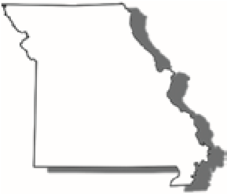

**2020**

**Individual Income**

**Tax Return - Long Form**

Form

**MO-1040**



For Calendar Year January 1 - December 31, 2020 Print in BLACK ink only and DO NOT STAPLE.

## Amended Return Composite Return

( For use by S corporations or Partnerships )

Federal Extension - Select this box if you have an approved federal extension. Attach a copy Federal Extension (Form 4868).

If filing a fiscal year return enter the beginning and ending dates here.

Single

Married Filing

Combined

Claimed as a

Dependent

**Filing Status**

Fiscal Year Beginning (MM/DD/YY) Fiscal Year Ending (MM/DD/YY) **Vendor Code**



|  |
| --- |
| **Department Use Only** |

|  |
| --- |
| **1555** |

Married Filing Head of Qualifying

Separately Household Widow(er)

Age 62 through 64 Age 65 or OlderBlind 100% DisabledNon-Obligated Spouse

Yourself SpouseYourself SpouseYourself Spouse Yourself SpouseYourself Spouse

Deceased Deceased

Social Security Number

SRXVH·V6RFLDO6HFXULW\1XPEHU

6

-

-

M.I.

In Care Of Name (Attorney, Executor, Personal Representative, etc.)

Last Name

in 2020

First Name

Suffix

SRXVH·V/DVW1DPH

6

6

SRXVH·V)LUVW1DPH

M.I.

Suffix

in 2020

-

**RAKESH**

**KOKA**

**165**

**05**

**9229**

|  |
| --- |
| **Name** |

Present Address (Include Apartment Number or Rural Route)

|  |
| --- |
| **WIGGENSFERRY DR** |

|  |
| --- |
| **STCO** |

|  |  |  |  |  |  |  |
| --- | --- | --- | --- | --- | --- | --- |
|  |  |  |  |  | **_** |  |
| **SAINT LOUIS** |  | **MO** |  | **63141** |  | **6503** |

# City, Town, or Post Office State ZIP Code

|  |
| --- |
| **Address** |

County of Residence

You may contribute to any one or all of the trust funds on Line 47. See pages 11-12 of the instructions for more trust fund information.

|  |  |  |  |  |  |  |  |  |  |  |  |  |  |  |
| --- | --- | --- | --- | --- | --- | --- | --- | --- | --- | --- | --- | --- | --- | --- |
| &KLOGUHQ·V  Trust Fund | Veterans Trust Fund | Elderly Home  Delivered Meals Trust Fund | Missouri  National Guard Trust Fund | **Workers**  :RUNHUV·  Memorial Fund | **LEAD**  Childhood  Lead Testing Fund | Mi |  | ary |  | G  eneral  R  evenue |  | Organ Donor Program Fund | Kansas  City  Regional  Law  Enforcement  Memorial  Foundation Fund | Soldiers  Memorial  Military Museum in St. Louis Fund |
| ssouri Milit  Family Relief Fund | General  Revenue Fund |

**REV 04/20/21 PRO**

**IN**

**20322011555**

Yourself (Y) Spouse (S)

00

00

00

00

00

|  |
| --- |
| **Income** |

1. Federal adjusted gross income from federal return

|  |  |
| --- | --- |
| 1S |  |

|  |  |
| --- | --- |
| 2S |  |

|  |  |
| --- | --- |
| 3S |  |

|  |  |
| --- | --- |
| 1Y | **60180** |
|  |  |
| 2Y |  |
|  |  |
| 3Y | **60180** |
|  |  |
| 4Y |  |
|  |  |
| 5Y | **60180** |

(see worksheet on page 7 of the instructions) . . . . . . . . . . . . ... 2. Total additions (from **Form MO-A**, Part 1, Line 7) . . . . . . . . . ... 3. Total income - Add Lines 1 and 2 . . . . . . . . . . . . . . . . . . . . . . ...

00

00

00

00

00

|  |  |
| --- | --- |
| 5S |  |

|  |  |
| --- | --- |
| 4S |  |

4. Total subtractions (from Form MO-A, Part 1, Line 18) . . . . . . ... 5. Missouri adjusted gross income - Subtract Line 4 from Line 3. ...

|  |  |
| --- | --- |
| 6 | **60180** |

1. Total Missouri adjusted gross income - Add columns 5Y and 5S. . . . . . . . . . . .. 00
2. Income percentages - Divide columns 5Y and 5S by total on

|  |  |
| --- | --- |
| 7Y | **100** |

|  |  |
| --- | --- |
| 7S |  |

Line 6. (Must equal 100%) . . . . . . . . . . . . . . . . . . . . . . . . . . . .% %

1. Pension, Social Security, Social Security Disability, and Military exemption (from Form

|  |  |
| --- | --- |
| 8 |  |

MO-A, Part 3, Section E). . . . . . . . . . . . . . . . . . . . . . . . . . . . . . . . . . . . . . . . . . . . . . . . . . . . . . . . . 00

00

00

00

|  |  |  |
| --- | --- | --- |
| 9 |  | **6301** |
|  | |  |
| 10 |  |  |
|  | |  |
| 11 |  | **6301** |
|  | |  |
| 12 | **15.00** |  |

1. Tax from federal return . . . . . . . . . . . . . . . . . . . . . . . . . . . . . . . . . ..
2. Other tax from federal return. . . . . . . . . . . . . . . . . . . . . . . . . . . . . . .. 11. Total tax from federal return. Do not enter federal income tax withheld. .
3. Federal tax percentage – Enter the percentage based on your Missouri Adjusted Gross Income, Line 6. Use the chart below to

% find your percentage . . . . . . . . . . . . . . . . . . . . . . . .

Missouri Adjusted Gross Income Range, Line 6: Federal Tax Percentage:

$25,000 or less........................................................................35 % $25,001 to $50,000..................................................................25%

$50,001 to $100,000................................................................15%

$100,001 to $125,000...............................................................5%

$125,001 or more.....................................................................0 %

1. Federal income tax deduction – Multiply Line 11 by the percentage on Line 12. Enter this

|  |  |
| --- | --- |
| 13 | **945** |

amount not to exceed $5,000 for an individual or $10,000 for combined filers. . . . . . . . . . . . . . . . 00

1. Missouri standard deduction or itemized deductions. (If itemizing, See Form MO-A, Part 2)
   * Single or Married Filing Separate-$12,400 • Head of Household-$18,650

|  |
| --- |
| **Exemptions and Deductions** |

* + Married Filing Combined or Qualifying Widow(er)-$24,800

|  |  |
| --- | --- |
| 14 | **12400** |

Note: If age 65 or older, blind, or claimed as a dependent, see page 6.. . . . . . . . . . . . . . . . . . . . . . . .

00

00

00

00

00

00

00

|  |  |
| --- | --- |
| 15 |  |

|  |  |
| --- | --- |
| 16 |  |

1. Long-term care insurance deduction . . . . . . . . . . . . . . . . . . . . . . . . . . . . . . . . . . . . . . . . . . . . . . . 16. Health care sharing ministry deduction. . . . . . . . . . . . . . . . . . . . . . . . . . . . . . . . . . . . . . . . . . . . . .

|  |  |
| --- | --- |
| 17 |  |

1. Active Duty Military income deduction . . . . . . . . . . . . . . . . . . . . . . . . . . . . . . . . . . . . . . . . . . . . . .

|  |  |
| --- | --- |
| 18 |  |

1. Inactive Duty Military income deduction . . . . . . . . . . . . . . . . . . . . . . . . . . . . . . . . . . . . . . . . . . . . .

|  |  |
| --- | --- |
| 19 |  |

|  |  |
| --- | --- |
| 20 |  |

1. Bring jobs home deduction . . . . . . . . . . . . . . . . . . . . . . . . . . . . . . . . . . . . . . . . . . . . . . . . . . . . . . . 20. Transportation facilities deduction . . . . . . . . . . . . . . . . . . . . . . . . . . . . . . . . . . . . . . . . . . . . . . . . . A. Port Cargo Expansion C. Qualified Trade Activities

B. International Trade Facility

**20322021555**

**IN**

**REV 04/20/21 PRO**

|  |  |  |
| --- | --- | --- |
|  | 21 |  |
|  |  |
| 22 | **13345** |
|  |  |
| 23 | **46835** |
|  |  |
| 24S | |  |
|  | |  |
| 25S | |  |
|  | |  |
| 26S | |  |
|  | |  |
| 27S | |  |
|  | |  |
| 28S | |  |
|  | |  |
| 29S | |  |
|  | |  |
| 30S | |  |
|  | |  |
| 31S | |  |
|  | |  |
| 32S | |  |
|  | |  |
|  | 33 | **2345** |
|  |  |
| 34 | **2652** |
|  |  |
| 35 |  |
|  |  |
| 36 |  |
|  |  |
| 37 |  |
|  |  |
| 38 |  |
|  |  |
| 39 |  |
|  |  |
| 40 |  |
|  |  |
| 41 | **2652** |

1. First Time Home Buyers deduction. A. B. .
2. Total deductions - Add Lines 8 and 13 through 21 . . . . . . . . . . . . . . . . . . . . . . . . . . . . . . . . . . . . .
3. Subtotal - Subtract Line 22 from Line 6 . . . . . . . . . . . . . . . . . . . . . . . . . . . . . . . . . . . . . . . . . . . . .

00

00

00

00

00

1. Multiply Line 23 by appropriate percentages (%) on

**Deductions Continued**

|  |  |
| --- | --- |
| 24Y | **46835** |
|  |  |
| 25Y |  |
|  |  |
| 26Y | **46835** |
|  |  |
| 27Y | **2345** |
|  |  |
| 28Y |  |
|  |  |
| 29Y | **100** |
|  |  |
| 30Y | **2345** |
|  |  |
| 31Y |  |
|  |  |
| 32Y | **2345** |

Lines 7Y and 7S . . . . . . . . . . . . . . . . . . . . . . . . . . . . . . . . . . .. .

00

00

1. Enterprise zone or rural empowerment zone income modification . . . . . . . . . . . . . . . . . . . . . . . . . . . . . . . . . . . . . . .. .
2. Taxable income - Subtract Line 25 from Line 24 . . . . . . . . . . .. .

00

00

00

1. Tax (see tax chart on page 22 of the instructions). . . . . . . . . .. .

00

00

00

1. Resident credit - Attach **Form MO-CR**DQGRWKHUVWDWHV·

income tax return(s). . . . . . . . . . . . . . . . . . . . . . . . . . . . . . . . .. .

1. Missouri income percentage - Enter 100% unless you are completing **Form MO-NRI**. Attach Form MO-NRI and a

copy of your federal return if less than 100% . . . . . . . . . . . . .% %

|  |
| --- |
| **Tax** |

1. Balance - Subtract Line 28 from Line 27; OR

multiply Line 27 by percentage on Line 29 . . . . . . . . . . . . . . .. 00 . 00

1. Other taxes - Select box and attach federal form indicated. Lump sum distribution (Form 4972)

Recapture of low income housing credit (Form 8611). .

00

00

1. Subtotal - Add Lines 30 and 31 . . . . . . . . . . . . . . . . . . . . . . . .. . 33. Total Tax - Add Lines 32Y and 32S . . . . . . . . . . . . . . . . . . . . . . . . . . . . . . . . . . . . . . . . . . . . . . . . .
2. MISSOURI tax withheld - Attach Forms W-2 and 1099. . . . . . . . . . . . . . . . . . . . . . . . . . . . . . . . . .
3. 2020 Missouri estimated tax payments - Include overpayment from 2019 applied to 2020 . . . . . . . . .
4. Missouri tax payments for nonresident partners or S corporation shareholders - Attach Forms

**MO-2NR** and **MO-NRP** . . . . . . . . . . . . . . . . . . . . . . . . . . . . . . . . . . . . . . . . . . . . . . . . . . . . . . . . . .

00

00

00

00

00

00

00

00

00

00

00

1. Missouri tax payments for nonresident entertainers - Attach **Form MO-2ENT** . . . . . . . . . . . . . . . . 38. Amount paid with Missouri extension of time to file (**Form MO-60**). . . . . . . . . . . . . . . . . . . . . . . . . 39. Miscellaneous tax credits (from **Form MO-TC**, Line 13) - Attach Form MO-TC . . . . . . . . . . . . . . . 40. Property tax credit - Attach **Form MO-PTS** . . . . . . . . . . . . . . . . . . . . . . . . . . . . . . . . . . . . . . . . . . . 41. Total payments and credits - Add Lines 34 through 40 . . . . . . . . . . . . . . . . . . . . . . . . . . . . . . . . . .

|  |
| --- |
| **Payments and Credits** |

**IN**

**REV 04/20/21 PRO**

**20322031555**

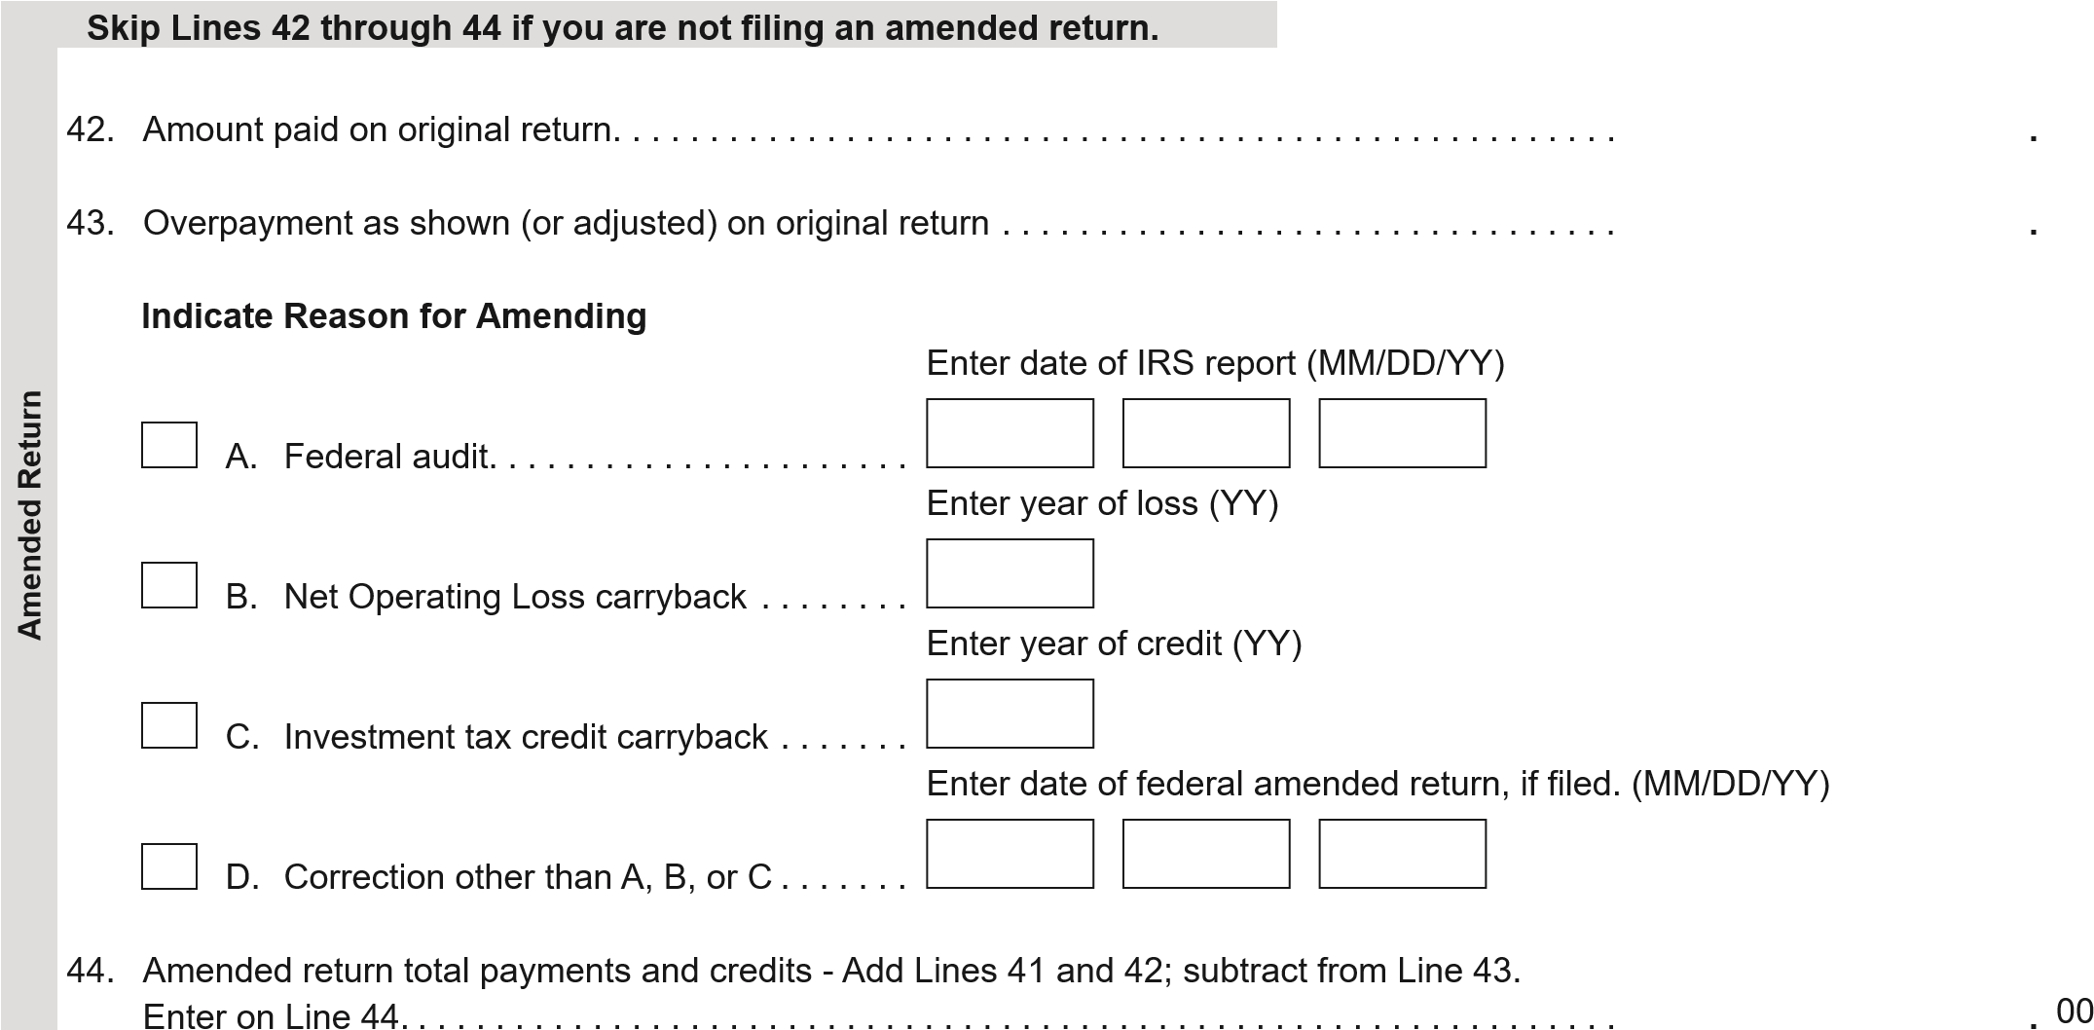

00

00

1. If Line 41, or if amended return, Line 44, is larger than Line 33, enter the difference.

|  |  |
| --- | --- |
| 45 | **307** |

|  |  |
| --- | --- |
| 43 |  |

|  |  |
| --- | --- |
| 42 |  |

|  |  |
| --- | --- |
| 44 |  |

Amount of OVERPAYMENT . . . . . . . . . . . . . . . . . . . . . . . . . . . . . . . . . . . . . . . . . . . . . . . . . . . . . . . . ..

00

00

00

.

00

.

|  |  |
| --- | --- |
| 46 |  |

1. Amount of Line 45 to be applied to your 2021 estimated tax . . . . . . . . . . . . . . . . . . . . . . . . . . . ..
2. Enter the amount of your donation in the trust fund boxes below. See instructions for additional trust fund codes.

00

.

&KLOGUHQ·V

Trust Fund

Veterans

Trust Fund

Elderly Home

Delivered Meals

Trust Fund

00

.

00

.

RUNHUV·

:

Memorial Fund

Childhood

Lead

Testing Fund

00

.

00

.

00

.

Organ Donor

Program Fund

b.

47

47

c.

47

f.

00

.

Additional

Fund

Code

Additional

Fund

Amount

00

.

Kansas City

Regional Law

Enforcement

Memorial

Foundation Fund

j.

47

00

.

Soldiers

Memorial

Military

Museum in

St. Louis Fund

47

k.

Missouri

National Guard

Trust Fund

d.

47

00

.

General

Revenue Fund

Missouri

Military Family

Relief Fund

47

g.

47

h.

00

.

m.

47

Additional

Fund

Code

Additional

Fund

Amount

47a.

47e.

|  |
| --- |
| **Refund** |

47i.

47l.

|  |  |
| --- | --- |
| 47 |  |

Total Donation - Add amounts from Boxes 47a through 47m and enter here . . . . . . . . . . . . . . . ..

00

00

00

1. Amount of Line 45 to be deposited into a Missouri 529 Education Plan (MOST)

|  |
| --- |
| **121000358** |

|  |  |
| --- | --- |
| 48 |  |

|  |  |
| --- | --- |
| 49 | **307** |

account. Enter the total deposit amount from **Form 5632**. . . . . . . . . . . . . . . . . . . . . . . . . . . . . . .. 49. **REFUND** - Subtract Lines 46, 47, and 48 from Line 45 and enter here . . . . . . . . . . . . . . . . . . . .. a. Routing

|  |
| --- |
| **325066017819** |

Numberc. Checking Savings b. Account Number

**IN**

**REV 04/20/21 PRO**

**20322041555**

50. If Line 33 is larger than Line 41 or Line 44, enter the difference.

|  |  |
| --- | --- |
| 50 |  |

|  |  |
| --- | --- |
| 51 |  |

Amount of UNDERPAYMENT . . . . . . . . . . . . . . . . . . . . . . . . . . . . . . . . . . . . . . . . . . . . . . . . . . . .. 51. Underpayment of estimated tax penalty - Attach **Form MO-2210**. Enter penalty amount here . . ..

00

00

Select this box if you are a farmer exempt from the underpayment of estimated tax penalty.

|  |
| --- |
| **Amount Due** |

52. **AMOUNT DUE** - Add Lines 50 and 51.

If you pay by check, you authorize the Department of Revenue to process the check

|  |  |
| --- | --- |
| 52 |  |

electronically. Any returned check may be presented again electronically . . . . . . . . . . . . . . . . . .. 00

Yes

No

UHSDUHU·V7HOHSKRQH

3

Signature

3

UHSDUHU·V6LJQDWXUH

SRXVH·V6LJQDWXUH,IILOLQJFRPELQHG%27+PXVWVLJQ

6

Daytime Telephone

D

ate

(

MM

/

DD

/

YY

)

UHSDUHU·V$GGUHVV

3

ZIP Code

State

I authorize the Director of Revenue or delegate to discuss my return and attachments with the preparer

RUDQ\PHPEHURIWKHSUHSDUHU·VILUP

.

.

.

.

.

.

.

.

.

.

.

.

.

.

.

.

.

.

.

.

.

.

.

.

.

.

.

.

.

.

.

.

.

.

.

.

.

.

.

.

.

.

.

.

.

.

.

.

.

.

.

.

.

.

.

.

E-mail Address

1

UHSDUHU·V)(,1661RU37,

3

D

ate

(

MM

/

DD

/

YY

)

D

ate

(

MM

/

DD

/

YY

)

**Signature**

Under penalties of perjury, I declare that I have examined this return, including accompanying schedules and statements, and to

the best

of my knowledge and belief it is true, correct, and complete. By signing or entering my name in the “Signature” field(s) below,

I am providing

the Department of Revenue with my signature as required under

**Section 143.561, RSMo.**

Declaration of preparer (other than taxpayer) is

unauthorized aliens as defined under federal law and that I am not eligible for any tax exemption, credit, or abatement if I e

mploy such

aliens.

based on all information of which he or she has knowledge. As provided in

**Chapter 143, RSMo.**

, a penalty of up to $500 shall be

imposed

on any individual who files a frivolous return. I also declare under penalties of perjury that I employ no illegal or

Yes

No

Did you pay a tax return preparer to complete your return, but the preparer failed to sign the return or provide

an Internal Revenue Service preparer tax identification number?

If you marked yes, please insert the

preparer’s name, address, and phone number in the applicable sections of the signature block above.

.

.

.

.

.

.

**30-1017196**

**GA**

**30041**

**6789659522**

**SYAM@GTAXFILE.COM**

**SYAM PRIYA RAM SAGAR GUPTA TALLAM**

**7144739973**

**05**

**17**

**21**

**PEBBLE CREEK LN CUMMING**

**2530**

**Department Use Only**

A FA E10 DE F

.

|  |  |  |  |
| --- | --- | --- | --- |
|  |  |  | ( Revised 12-2020) |
| **Mail To:** | **Balance Due:** | **Refund or No Amount Due:** | **Phone (Balance Due):** (573) 751-7200 |
|  | Missouri Department of Revenue | Missouri Department of Revenue | **Phone (Refund or No Amount Due):** (573) 751-3505 |
|  | P.O. Box 329 | P.O. Box 500 | **Fax:** (573) 522-1762 |
|  | Jefferson City, MO 65105-0329 | Jefferson City, MO 65105-0500 | **E-mail:income@dor.mo.gov** |

**IN**

**REV 04/20/21 PRO**

**20322051555**