**Paper Filing Instructions for applying ITIN for Spouse**

**Steps to be followed** –

1. **You and Your Spouse have to sign on Form 1040 . See below image**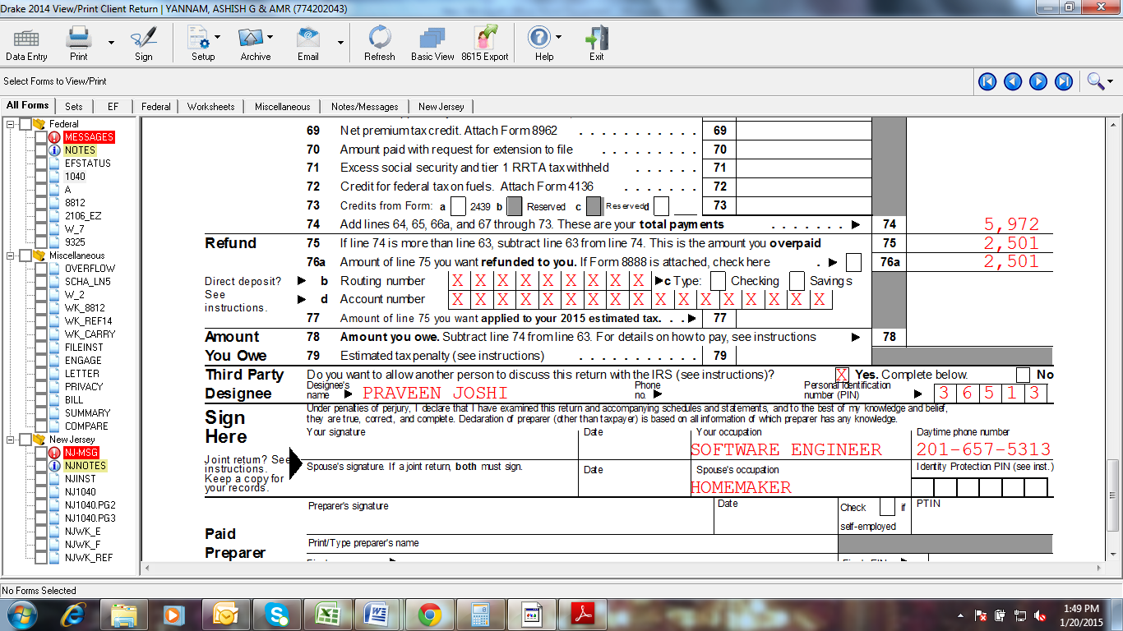
2. **Attach Form W7 (ITIN Application) & you has to Sign it. See below image**

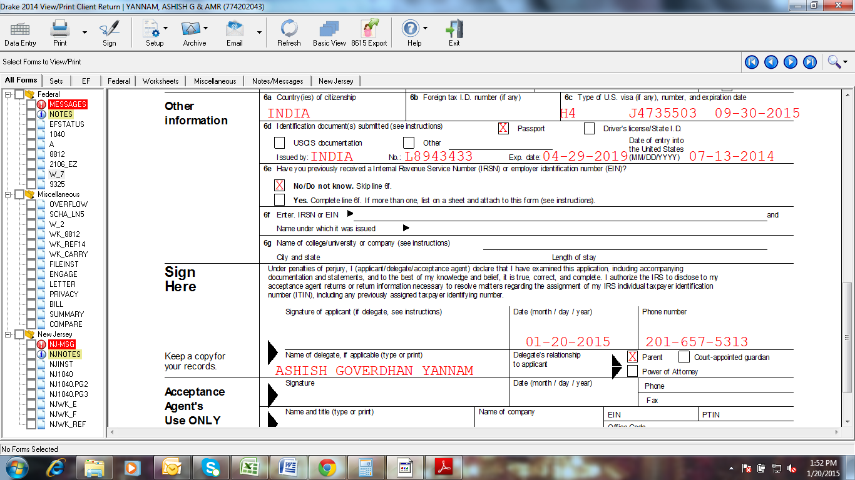

1. **Attach a copy of all W2’s of the year 2020.**
2. POST the ENTIRE federal document to the below IRS Address.

Department of the Treasury  
Internal Revenue Service  
Austin, TX 73301-0002

**Note: Cross check your Bank details once again.**