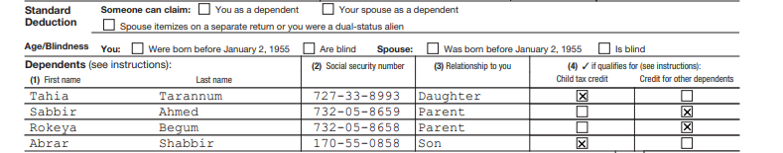

Ahmed Shabbir-FIRST AND LAST NAME

039719431-SSN

01/01/1979-DOB

CA-STATE

stimulas check: y

3400+2400

filled jointly

married

2 children