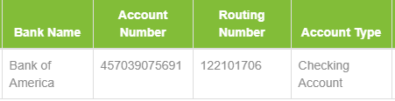

**Property Address in India**

HOUSE# C-177, APUROOPA COLONY, IDA JEEDIMETLA, HYDERABAD TELENGANA  500055