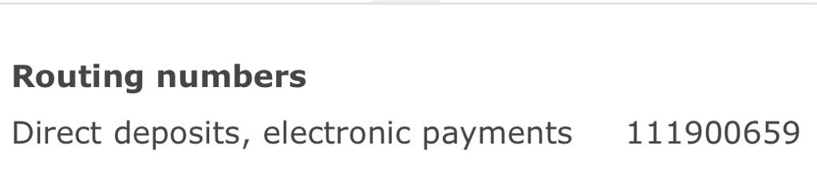Name of the bank :Wellsfargo

Name of the bank holder- Sindhu Bojadla

Current address- 333 Normandy street, apartment 702 , Houston, Texas, 77015

