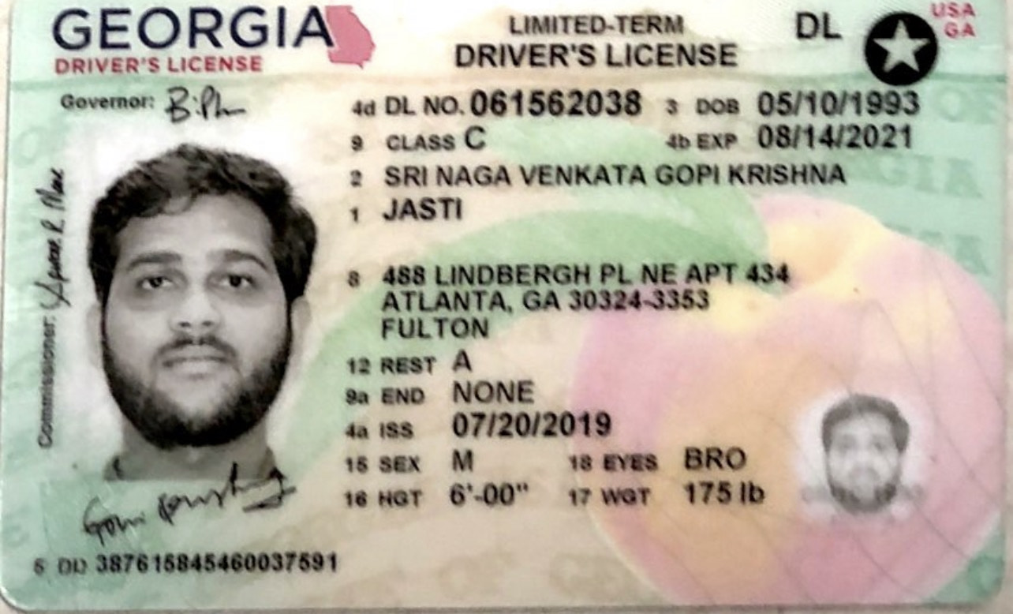

|  |  |
| --- | --- |
| **Bank Name** | Chase Bank |
| **Routing Number (Paper/Electronic)** | 061092387 |
| **Account Number** | 702169357 |
| **Checking / Saving Account** | Checking |
| **Account Holder** | Sri Venkat Jasti |