**Form W7 Renewal Paper Filing Instructions.**

**Federal**

1. You have to SIGN on Form w7 and mention date in MM/DD/YYYY format.
2. POST the ENTIRE Form W7 to the below IRS Address.
3. Attach Form CP-565 Letter

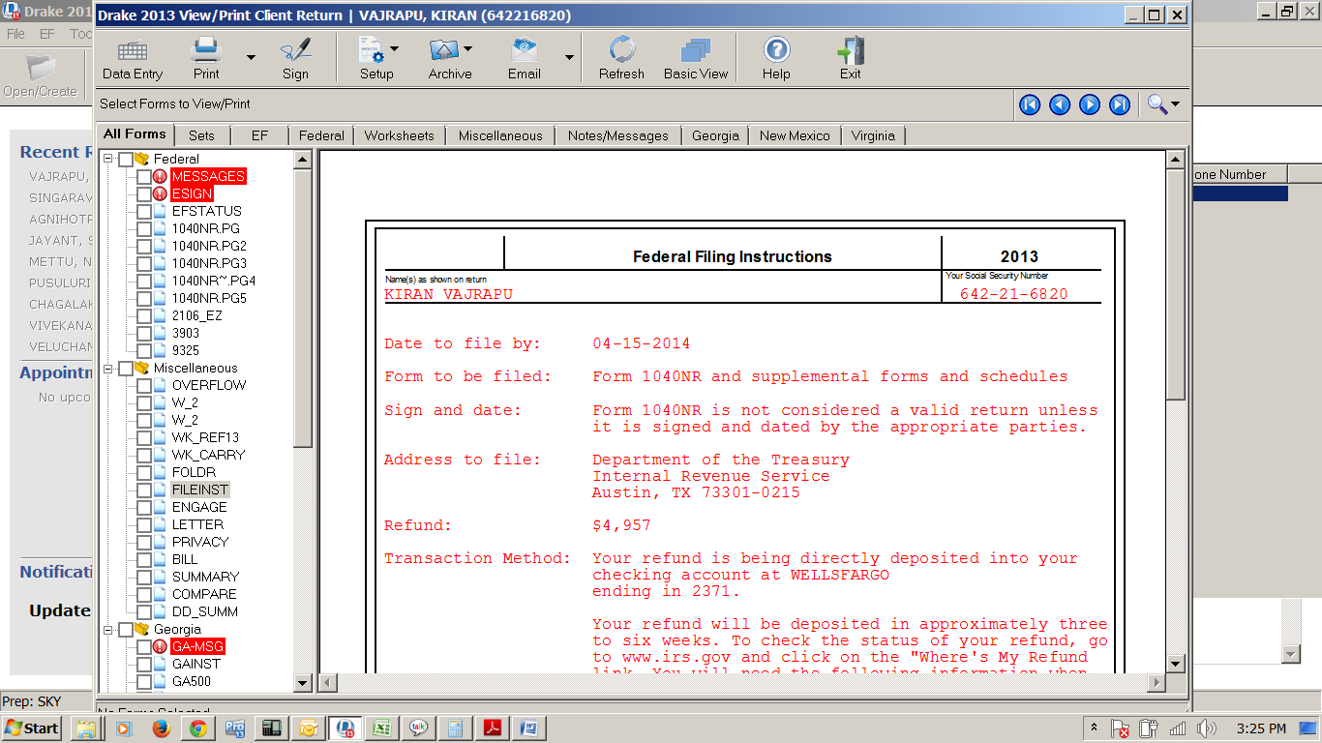

**Note**: Pls. Cross check your Bank details before you send the documents to IRS and it will take 4 – 6 weeks to get the Refund amount credited into your Bank Account.

Let us know if you have any further questions.