901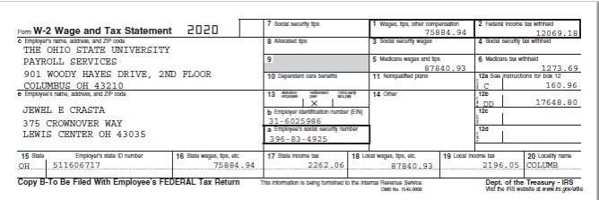 75

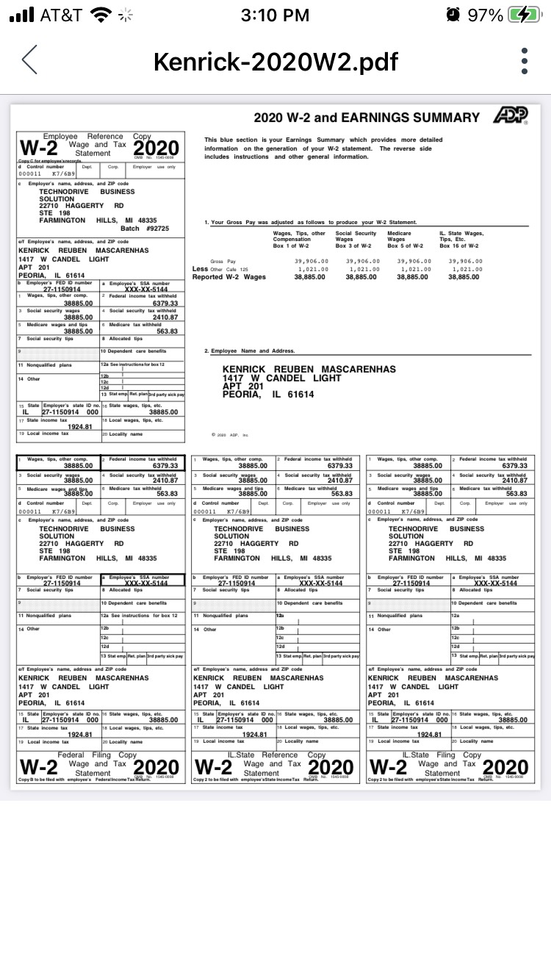

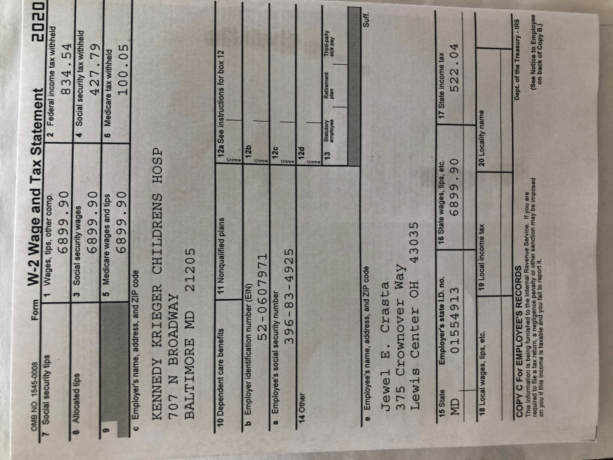

I hope you are well. We were referred by Harendra Varma Rudraraju.

We want to know your price for filing the federal return. We have already filed our state returns.

On TurboTax, we’re getting a federal refund of $4427.

My husband, Kenrick, and I were both employed in 2020 on H1B. We want to file jointly. We have one dependent child. Her first name is Jenelle and last name is Mascarenhas. DOB is 07/19/2019.