Current address:

Stimules check details:

1st = $600 Jan 2021

2nd = $1400 (March 17th 2021)

Current visa status: F1

2020 in which state you are in: Illinois & California

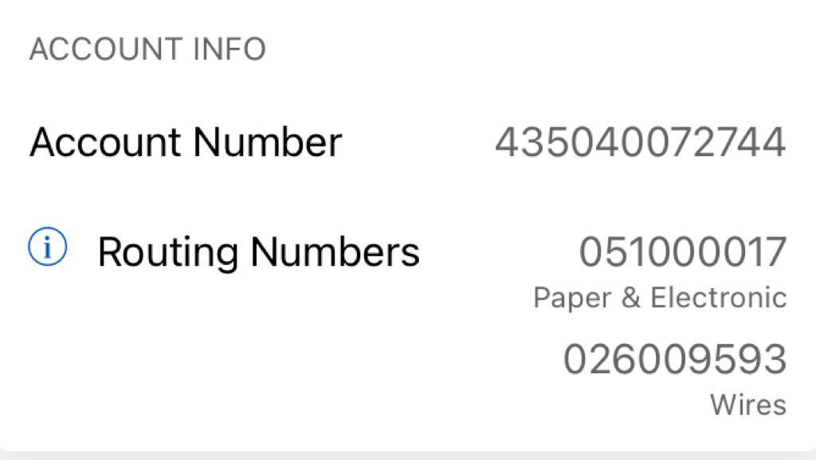

Bank of America