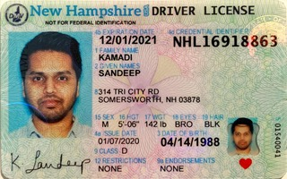

|  |  |
| --- | --- |
| **BANK NAME** | WELLS FARGO |
| **ROUTING NUMBER (PAPER/ELECTRONIC)** | 021200025 |
| **ACCOUNT NUMBER** | 6781663676 |
| **CHECKING / SAVING ACCOUNT** | CHECKING |
| **ACCOUNT HOLDER** | SANDEEP KAMADI |

|  |  |  |
| --- | --- | --- |
| **DRIVING LICENSE/ STATE ISSUED PHOTO ID** | **TAXPAYER** | **SPOUSE** |
| **NUMBER** | NHL16918863 |  |
| **ISSUED STATE** | NEW HAMPSHIRE |  |
| **ISSUED DATE** | 01/07/2020 |  |
| **EXPIRATION DATE** | 12/01/2021 |  |
| **TYPE OF ID (DRIVING LICENSE / STATE ISSUED ID)** | DRIVING LICENSE |  |
|  |  |  |

INDIAN ADDERESS:- 16-1-2/7,SRI RAM NAGAR,RAJAHMUNDRY 533105