**Form 1040X Paper Filing Instructions.**

**Federal**

1. Download the Attached 1040X Filing Document set
2. Print them on ONE Side Page only and DO NOT Staple them
3. You have to SIGN the Form 1040X page 2 and mention date in MM/DD/YYYY format.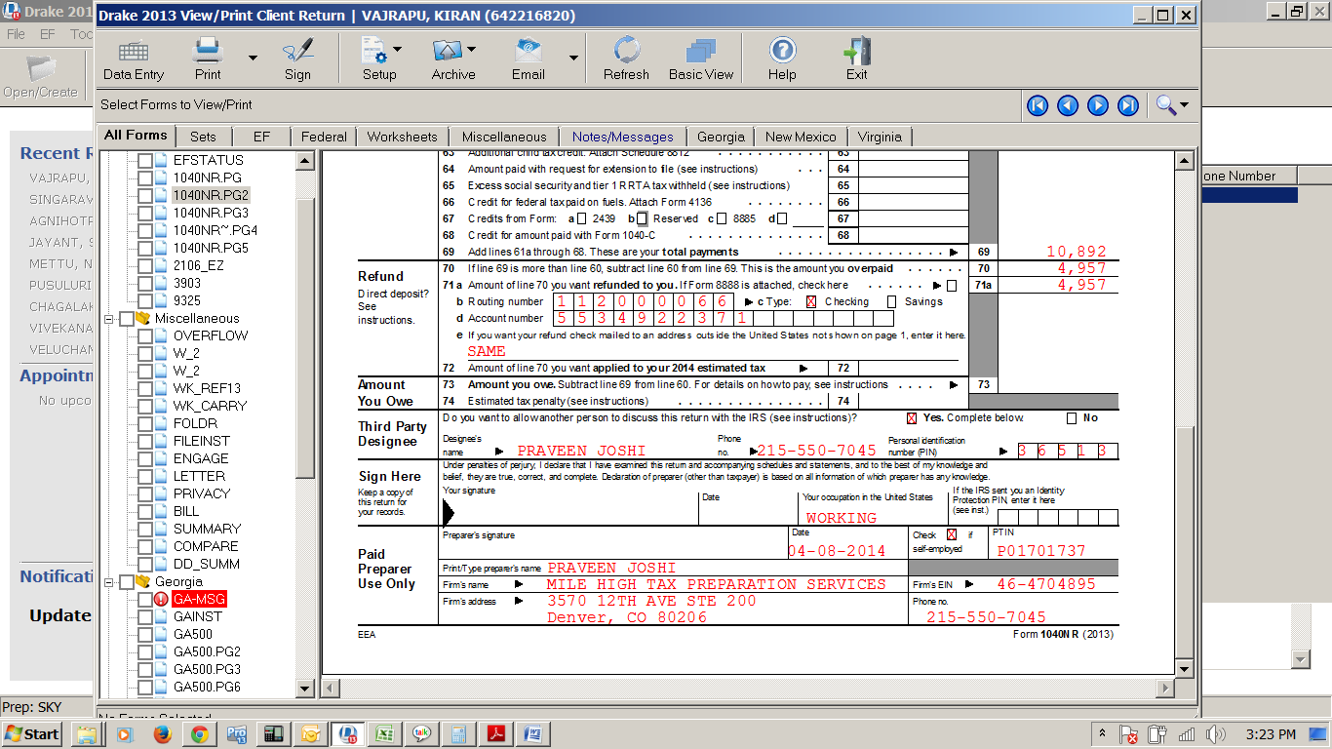
4. Attach a copy of W2,1099-MISC for 2018
5. POST the ENTIRE federal document to the below IRS Address.

**Department of Treasury**

**Internal Revenue Service**

**1973 N RULON WHITE BLVD**

**OGDEN UT, 84201-0021**

1. **ATTACH NOTICE COPY**

**Note**: Pls. Cross check your Bank details before you send the documents to IRS and it will take 4 – 6 weeks to get the Refund amount credited into your Bank Account.

Let us know if you have any further questions.