**I have new born baby medical bills for my kid.   
Can I show it in the IT tax**

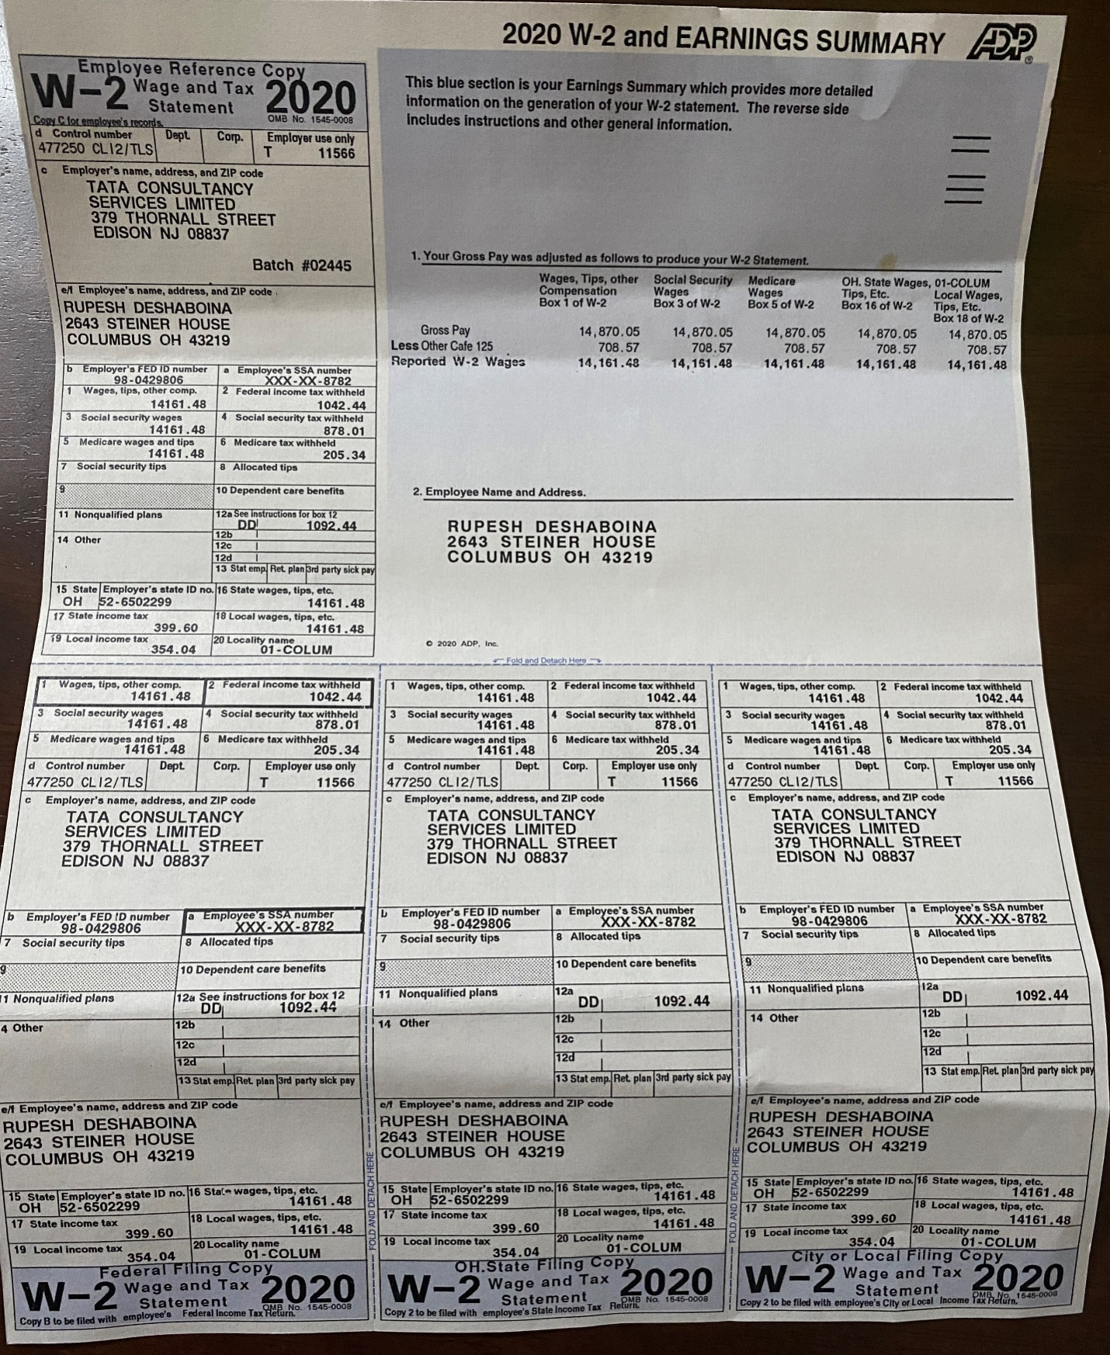

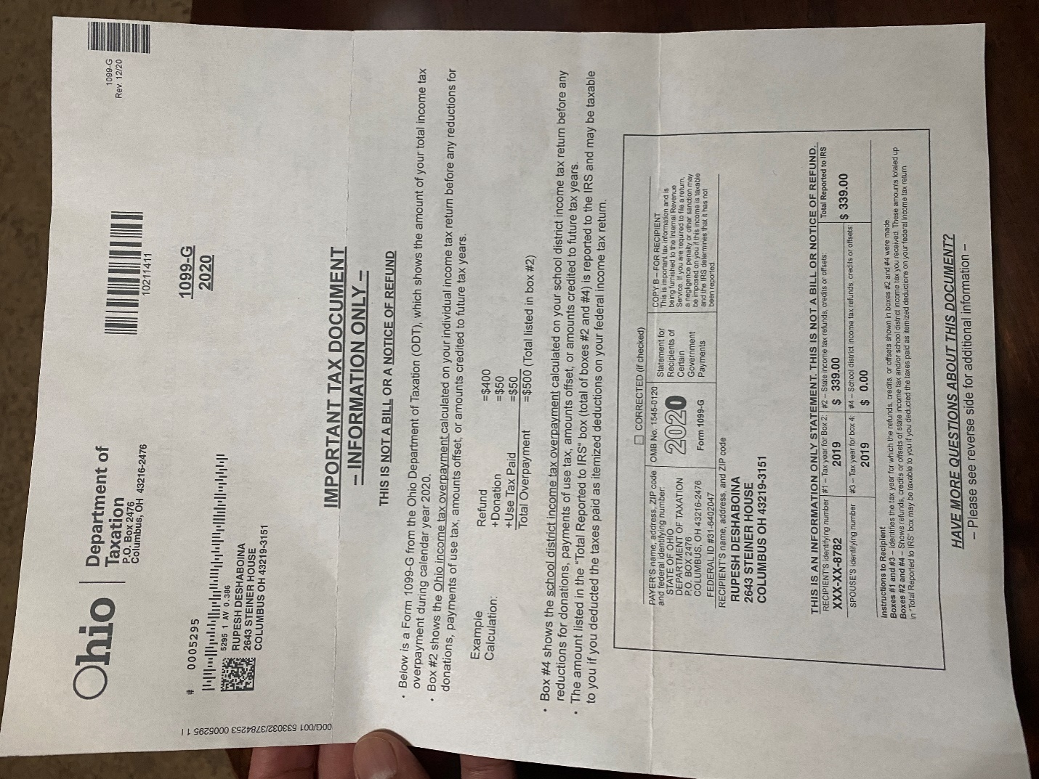

S