**Form 1040 Paper Filing Instructions.**

**Federal**

1. Download the Attached 1040 Filing Document set
2. Print them on ONE Side Page only and DO NOT Staple them
3. You have to SIGN the statement of declaration
4. You have to SIGN the Form 1040 page 2 and mention date in MM/DD/YYYY format.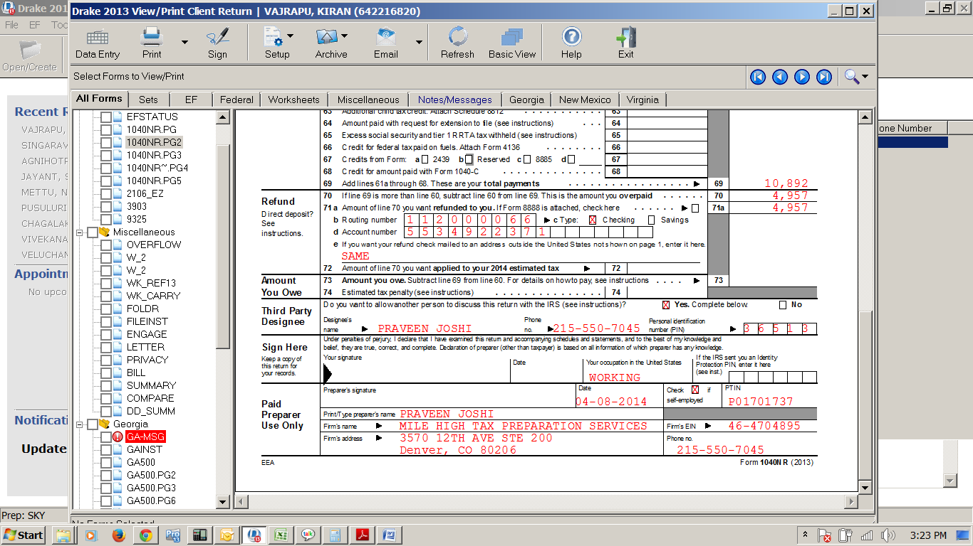
5. Attach a copy of W2 for 2020
6. POST the ENTIRE federal document to the below IRS Address.

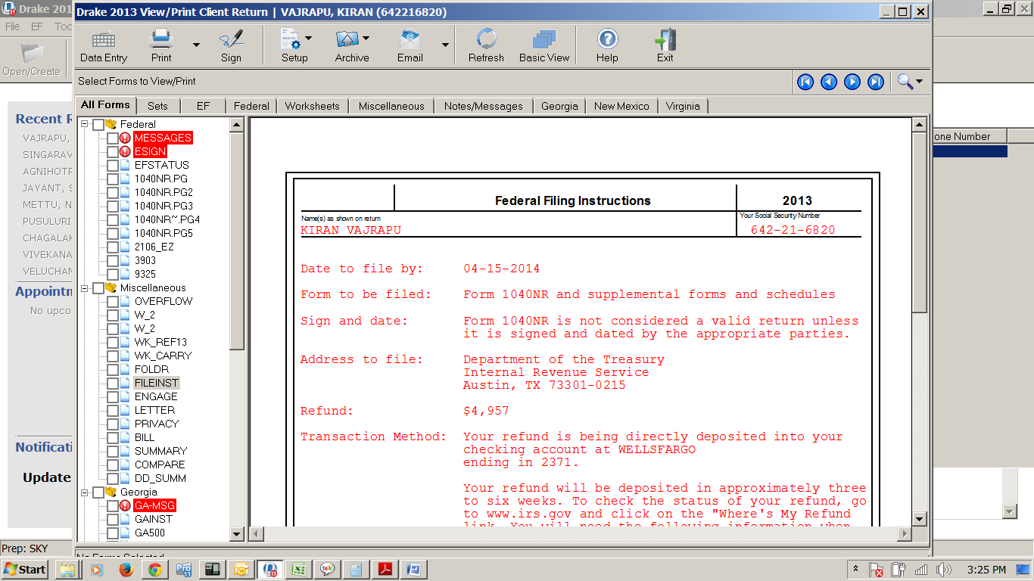

**Note**: Pls. Cross check your Bank details before you send the documents to IRS and it will take 4 – 6 weeks to get the Refund amount credited into your Bank Account.

Let us know if you have any further questions.