**Paper Filing Instructions for ITIN for Dependent**

**Steps to be followed** –

1. **Download the Attached PDF Federal tax documents**
2. **Print them on ONE side page only and DO NOT STAPLE.**
3. **Attach Form W7 (ITIN Application) and you have to Sign it on behalf of your child, See Image Below.**

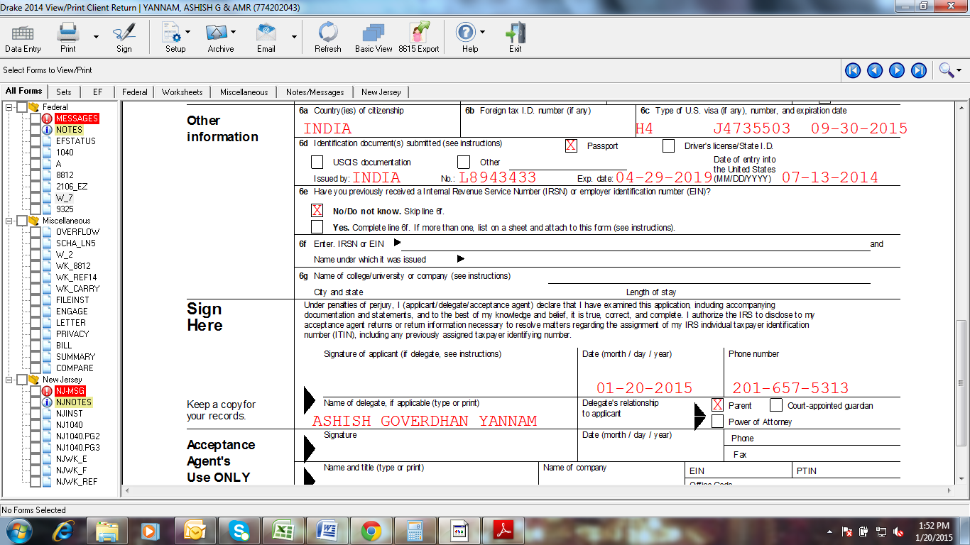

1. **Attach a copy of all W2’s of year 2020.**
2. **Visit IRS Office along with your DEPENDENT and Original Passport, IRS office address is provided in the Email.**

**Let us know if you have any questions.**