|  |  |
| --- | --- |
| **BANK NAME** | CHASE |
| **ROUTING NUMBER (PAPER/ELECTRONIC)** | 074000010 |
| **ACCOUNT NUMBER** | 772906686 |
| **CHECKING / SAVING ACCOUNT** | CHECKING |
| **ACCOUNT HOLDER** | NAGESH DAMMALAPATI |

**PLS. PROVIDE THE BELOW DETAILS TO E - FILE YOUR TAXES WITH IRS AND STATE DEPARTMENTS.**

1. **IF FILING STATUS IS SINGLE, PROVIDE ONLY YOUR ID PROOF**
2. **IF FILING JOINTLY, PROVIDE YOU AND YOUR SPOUSE ID PROOF**

|  |  |  |
| --- | --- | --- |
| **DRIVING LICENSE/ STATE ISSUED PHOTO ID** | **TAXPAYER** | **SPOUSE** |
| **NUMBER** |  |  |
| **ISSUED STATE** |  |  |
| **ISSUED DATE** |  |  |
| **EXPIRATION DATE** |  |  |
| **TYPE OF ID (DRIVING LICENSE / STATE ISSUED ID)** |  |  |
|  |  |  |

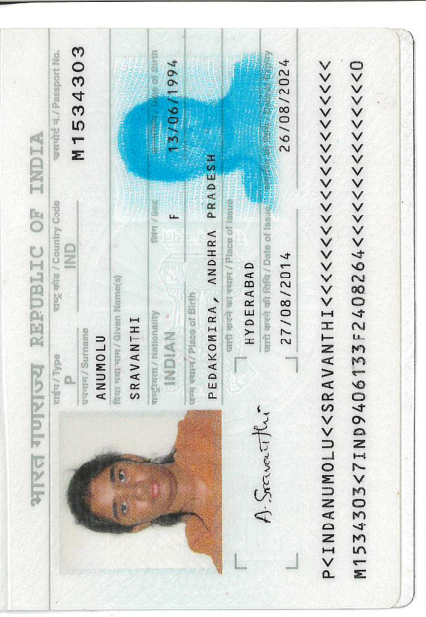

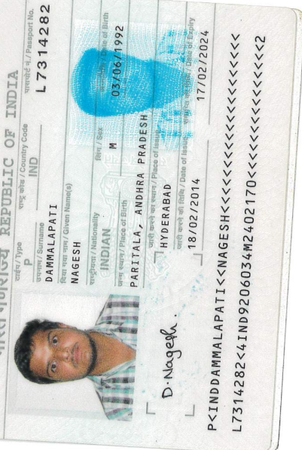

https://my-email-signature.link/signature.gif?u=280419&e=219867499&v=760882849b1979fa5b141cd0487d1b500a5377ba7c3b282a628c89afb41e09fb