Hi Bhagya,

Attached the 1098 form.

Thanks,

Nikhith.

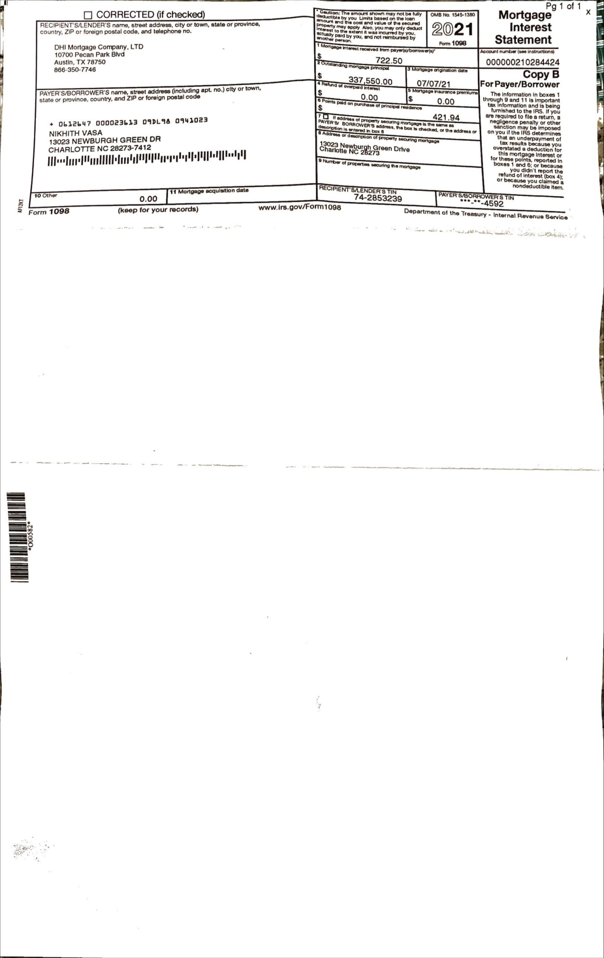

On Tue, Feb 1, 2022 at 2:29 PM Nick Vasa <[vasanick06@gmail.com](mailto:vasanick06@gmail.com)> wrote:

--

Thank you,

Nikhith vasa.

--

Thank you,

Nikhith vasa.