|  |  |
| --- | --- |
| **Bank Name** | WellsFargo bank |
| **Routing Number (Paper/Electronic)** | 062000080 |
| **Account Number** | 2825365998 |
| **Checking / Saving Account** | checking |
| **Account Holder** | SESHIKANTH DANDE |

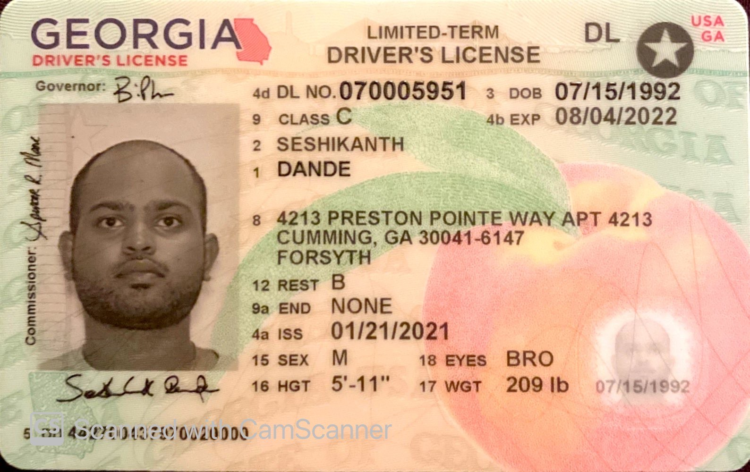

Reference address: 1-1-17/a RTC x Roads, Swetha enclave, jawaharnagar, Hyderabad, TG - 500020

On Thu, Feb 3, 2022 at 12:43 PM seshikanth dande <[seshikanthdande07@gmail.com](mailto:seshikanthdande07@gmail.com)> wrote:

|  |  |
| --- | --- |
| **Bank Name** | WellsFargo bank |
| **Routing Number (Paper/Electronic)** | 062000080 |
| **Account Number** | 2825365998 |
| **Checking / Saving Account** | checking |
| **Account Holder** | SESHIKANTH DANDE |

**Pls. provide the below details to E - File your taxes with IRS and state departments.**

1. **If Filing status is Single, provide only your ID proof**
2. **If Filing Jointly, provide you and your Spouse ID proof**

|  |  |  |
| --- | --- | --- |
| **Driving License/ State issued photo ID** | **Taxpayer** | **Spouse** |
| **Number:070005951** |  |  |
| **Issued State:Georgia** |  |  |
| **Issued Date:01/21/2021** |  |  |
| **Expiration date:08/04/2022** |  |  |
| **Type of ID (Driving License / State issued ID/passport): DL** |  |  |
| **Reference address of india: N/a** |  |  |

Warm regards,

Seshikanth Dande

+15103246484

On Tue, Feb 1, 2022 at 5:38 PM Bhagya - Gtax <[bhagya@gtaxfile.com](mailto:bhagya@gtaxfile.com)> wrote:

**Dear SESHIKANTH ,**

**Thanks for making the payment, we request you to Pls. give us your Consent to E- File your taxes. let us know if any changes are their before we file the returns.**

**Pls. cross check your bank details, if you have not provided pls. share them with us to get direct deposit of Refund amount.**

|  |  |
| --- | --- |
| **Bank Name** |  |
| **Routing Number (Paper/Electronic)** |  |
| **Account Number** |  |
| **Checking / Saving Account** |  |
| **Account Holder** |  |

**Pls. provide the below details to E - File your taxes with IRS and state departments.**

1. **If Filing status is Single, provide only your ID proof**
2. **If Filing Jointly, provide you and your Spouse ID proof**

|  |  |  |
| --- | --- | --- |
| **Driving License/ State issued photo ID** | **Taxpayer** | **Spouse** |
| **Number** |  |  |
| **Issued State** |  |  |
| **Issued Date** |  |  |
| **Expiration date** |  |  |
| **Type of ID (Driving License / State issued ID/passport)** |  |  |
| **Reference address of india** |  |  |

**Pls. Refer your friends and colleagues to utilize our services to file their taxes with IRS respectively.**

**Note:**

**1. For All E-Filing Cases, Refund will be credited within 21 days in bank account.**

**2. For All Paper Filing case, it will take 4 – 8 week's to get Refund and ITIN from IRS.**

**Let us know if you have any question, where we can help you out.**

**Refer Your Friends/Colleagues & Get $10 Per Referral...**

**Please feel free to reach us on the below coordinates for more information on our above services. Also, we will be pleased to serve your referrals and honor with $10 per paid client.**

**Thanks in advance for your business and referrals,**

**Thank you,**

**Regards:**

**Bhagya,**

**TEAM LEADER**

**Phone:  628-288-3658**

**what's app: 919-399-3028**

**Email:** [**bhagya@gtaxfile.com**](mailto:hema@gtaxfile.com)

**Website:** [**www.gtaxfile.com**](http://www.gtaxfile.com/)

--

Warm regards,

Seshikanth Dande

+15103246484