1. Last name: Ramamoorthy

2. Middle name:

3. First name: Jeevanandhan

4. Occupation: Software Professional

5. DOB: 03/06/1987

6. Email id: rjeevanandhan@gmail.com

7. Contact no: 571-477-8929

8. Current address: 592 Pensacola Dr Gaithersburg MD 20878

9. Marital status on 31st Dec 2021: Single

10. Visa status on 31st Dec 2021: Was on F1 before that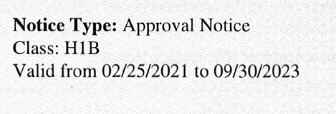

11. No of months stayed in US in the year 2021: 12

12. State lived in US in 2021(mention name & date if lived more than one state): Maryland

13. How many stimulus pay checks (3rd stimulus) received and mention the amount 2021: none

14. Any Advance child tax credit amount received in 2021: none

15. Any loans in India or USA: none

16.First port of entry date to USA: Chicago

17.First name (spouse): na

18.Last name(spouse):na

19.D.O.B(spouse):na