New Mortgage company:
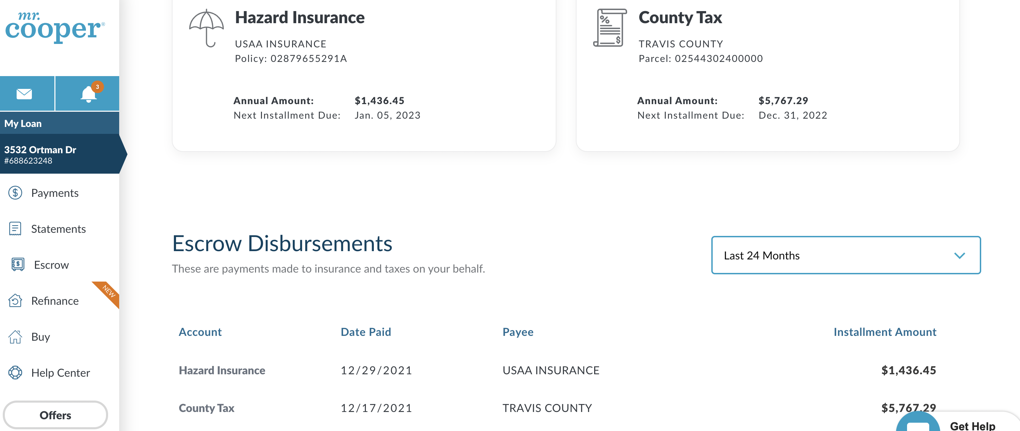

Earlier Mortgage Company that sold/transferred my mortgage to Mr. Cooper
