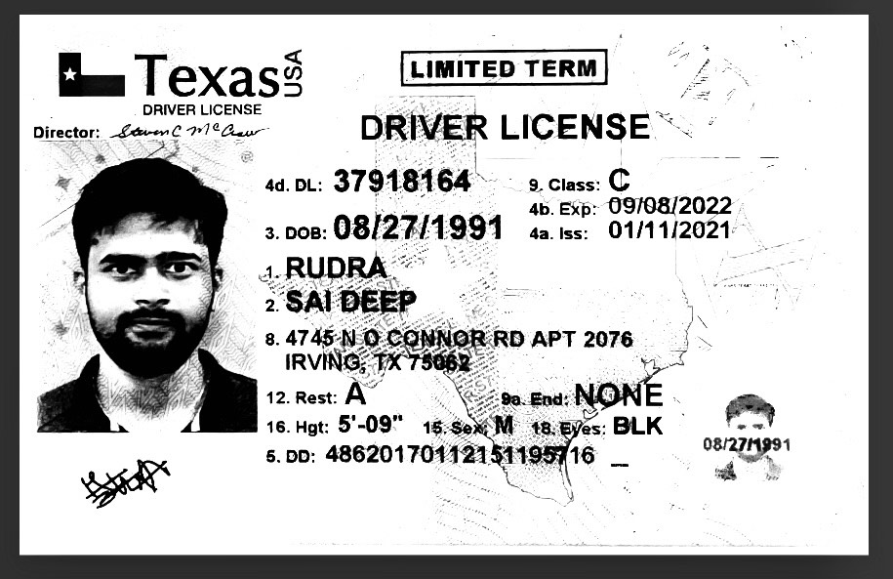

Required details :

Acc-no : 586034253952

Routing number: 111000025

Bank of anerica