**FIRST NAME:** SHALENI

**LAST NAME:** MEDIKONDA

**CURRENT ADDRESS:** 555 W MADISON ST, APT 4203, CHICAGO, IL, 60661

**VISA:** H1-B STATUS

**DOB:** APRIL 6, 1997

**SSN:** 869-85-0441

**NUMBER:** +1 (571)-383-0814

**EMAIL:** [MEDIKONDA.SHALENI@GMAIL.COM](mailto:medikonda.shaleni@gmail.com)

**MARITAL STATUS:** SINGLE, NOT MARRIED

**INDIAN ADDRESS:** H.NO: 1-59/3/63, SERILINGAMPALLY, RAMIAH NAGAR, OPP. LINGAMPALLY MMTS RLY STN, HYDERABAD, TELANGANA, 500019

**STIMULUS CHECK DETAILS ON 2020 AND 2021:** DID NOT FILE/DID NOT RECEIVE ANYTHING

**ON JAN 1ST 2021:** I WAS IN CHANTILLY, VIRGINIA

**ON DEC31ST 2021:** I WAS IN CHICAGO, ILLINOIS

**OCCUPATION:** IT, WORKING AS A BUSINESS INTELLIGENCE ANALYST AT SHOWINGTIME FROM SEP 2020, AND LATER SHOWINGTIME GOT ACQUIRED BY ZILLOW AND FROM NOVEMBER 2021, POSTED AS BUSINESS ANALYST AT ZILLOW (CURRENT). WAS WORKING AS A TEACHING ASSISTANT AT NORTHEASTERN UNIVERSITY (BOSTON, MA), FROM JAN 2020-JUNE 2020 DURING MY MASTERS.

**FIRST PORT OF ENTRY:** TRAVELLED FROM INDIA ON DEC 27, 2018 TO WASHINGTON AIRPORT. PORT OF ENTRY IN MY I-94 RECORDS INDICATE AUH. ATTACHED MORE DETAILS BELOW.

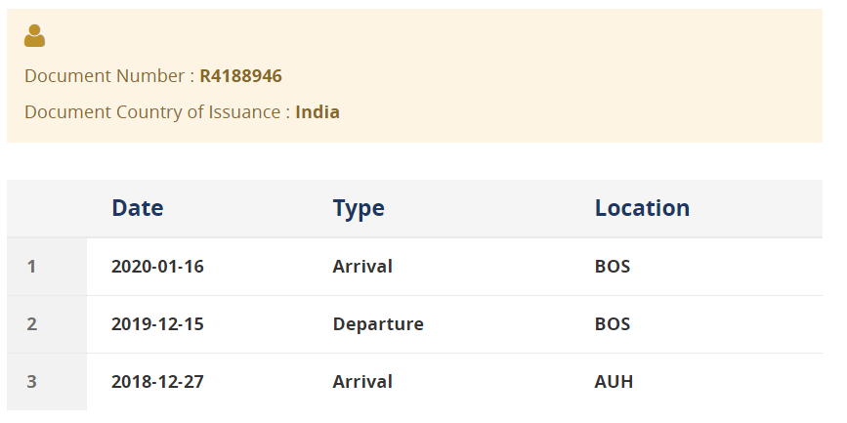

***I HAVEN'T FILED MY TAXES LAST YEAR, SO I NEED TO FILE IT FOR BOTH THE YEARS NOW***. ALSO, I HAVE A ***CORRECTED W2C FORM FOR 2020***, SINCE MY COMPANY SHOWINGTIME HAD MY ADDRESS WRONG - INITIALLY HAD STATE MA, BUT ***I WAS IN VIRGINIA (VA) ON 31ST DEC 2020 AND ON 1ST JAN 2020.***

(I MOVED TO BOSTON FOR MY MASTER'S ON JAN 7TH 2020).

***I ALSO ATTACHED MY TAX DETAILS WITH THE STOCK UNITS THAT ZILLOW PROVIDED ME WITH.***

I'M VERY NEW TO THIS PROCESS OF FILING, SO PLEASE FEEL FREE TO ASK ME QUESTIONS ABOUT ANYTHING THAT'S CONFUSING HERE AND IT WOULD BE A GREAT HELP IF YOU COULD EXPLAIN TO ME THE PROCESS AS WELL.

THANKS A LOT!

BEST REGARDS,

SHALENI MEDIKONDA

+1 (571)-383-0814