Car: Lexus RX 450, miles used in 2021 was about 10000

Here are the details that you requested from me to file the tax

SINGLE: Married  
FIRST NAME: Sudheer   
LAST NAME: Peddineni Kalava   
SSN NO: 827-08-7237  
OCCUPATION: Engineering Manager   
DATE OF BIRTH: Aug 12 1986   
E-Mail ID: [speddine@gmail.com](mailto:speddine@gmail.com)  
PHONE NO: 5107502210  
CURRENT ADDRESS: 2767 Tribune Ave, Hayward, CA 94542  
VISA STATUS: H1B   
PORT OF ENTRY: SFO  
STATE OF RESIDENCY DURING 2021: CA  
STIMULUS RECEIVED IN 2021(3RD CHECK) **None**

My wife's details   
FIRST NAME: Alekhya Reddy  
LAST NAME: Pothu  
SSN NO: 894-37-7033  
OCCUPATION: Software Engineer   
DATE OF BIRTH: Sep 16 1988  
E-Mail ID: [alekhya.pothu@gmail.com](mailto:alekhya.pothu@gmail.com)  
PHONE NO: 713-452-0974  
CURRENT ADDRESS: 2767 TRIBUNE ave, Hayward, CA, 94542  
VISA STATUS: TN  
PORT OF ENTRY: SFO  
STATE OF RESIDENCY DURING 2021: CA  
STIMULUS RECEIVED IN 2021(3RD CHECK): **None**

Refund received from CA in 2020 was: $2,738.00

Also ISO executed in 2021 for Amplitude is:

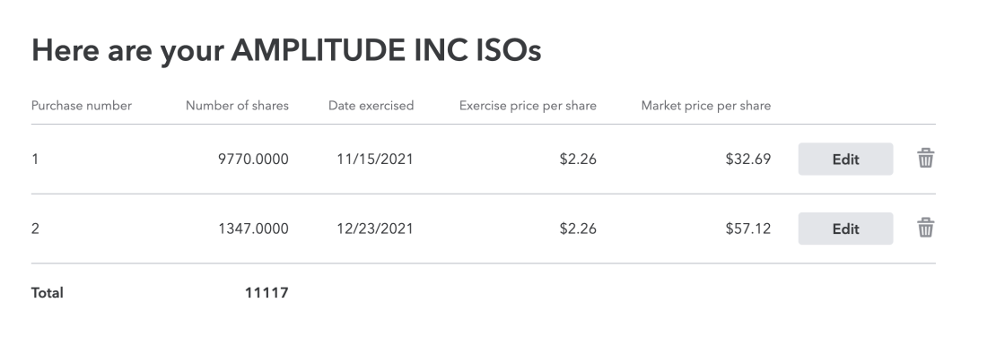

**Deductions**:

Property taxes paid during 2021: **$19,959.00**

Home energy credits from Solar panel installation that I should get is : **9,381.00**

Donation

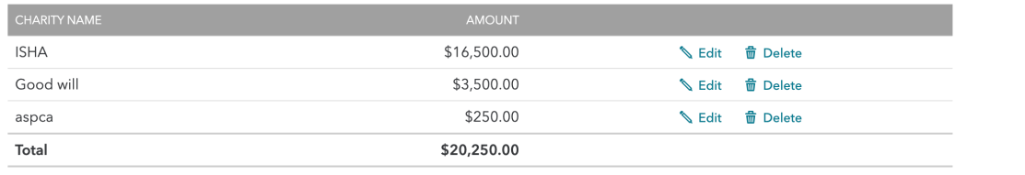

Car registration fees: 637.00

Job related expenses are about 16000 from complete WFH

From my RSU, my employer told me this

*“Because the February 25, 2021 RSU release occurred during a limited trading window during the lock-up period following our IPO, Fidelity will not be reporting this sell-to-cover transaction on a Form 1099. As a result, you are encouraged to print a copy of your February 25, 2021 RSU distribution transaction history from NetBenefits when gathering your 2021 tax documents. You will need to provide this information to assist your tax advisor in properly adjusting Schedule D of your income tax return.*

*We’re working on a year-end email to communicate this to employees (likely to be sent in early December). In the meantime, let us know if you have any further questions.”*

*I attached my feb statement*

Please let me know what else you need from me.