April 7, 2022

Anser Parvez Nadvi

1255 University Ave.,#312

Sacramento, CA 95825

RE: Social Security & Medicare Taxes SSN xxx-xx-0789

Dear Mr. Nadvi:

For the calendar year 2021 University Enterprises, Inc. withheld $17.22 in Social Security taxes and $4.03 in Medicare taxes from your payroll checks. There was an issue with the processing of your FICA exemption paperwork; and therefore, we were unable to exempt you from these taxes.

University Enterprises, Inc. will not be making any adjustments to your withholdings. You should be able to send the necessary information to request a refund when you file your federal income taxes. Please be sure to include this letter with your request.

If you have any further questions, please contact me for assistance.

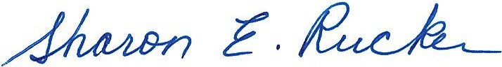

Sincerely,

Sharon E. Rucker

Payroll Manager