SINGLE

FIRST NAME: RAJESH

LAST NAME: MUNIGANTI

SSN NO: 008-51-7722

OCCUPATION: PROCESS ENGINEER

DATE OF BIRTH: 03-03-1990

E-Mail ID: RAJESH.MUNIGANTII@GMAIL.COM

PHONE NO: 734-716-3744

CURRENT ADDRESS: 3 S PINE ISLAND RD, APT 405, PLANTATION, FL - 33324

VISA STATUS: H1B

PORT OF ENTRY: MIAMI

STATE OF RESIDENCY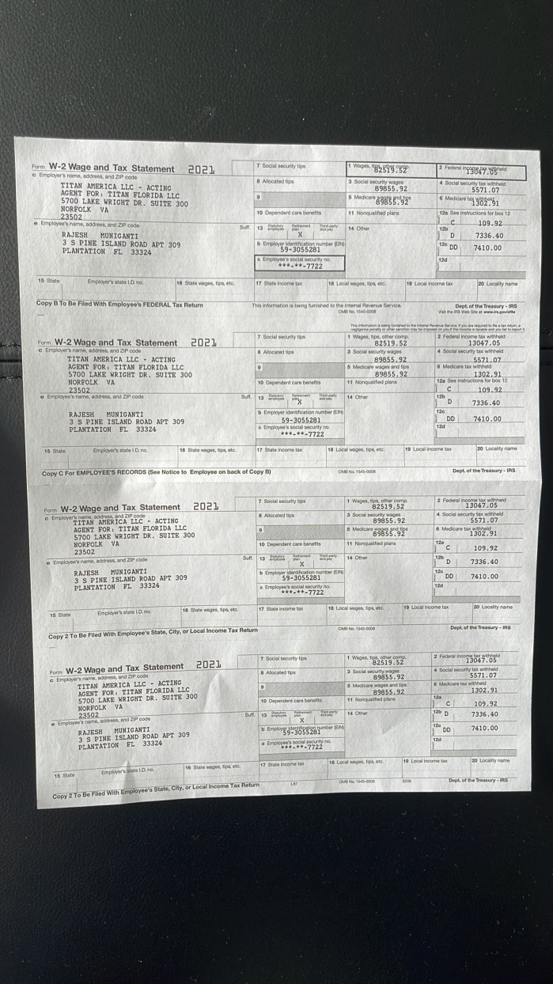 DURING 2021: FLORIDA

STIMULUS RECEIVED IN 2021(3RD CHECK) NO