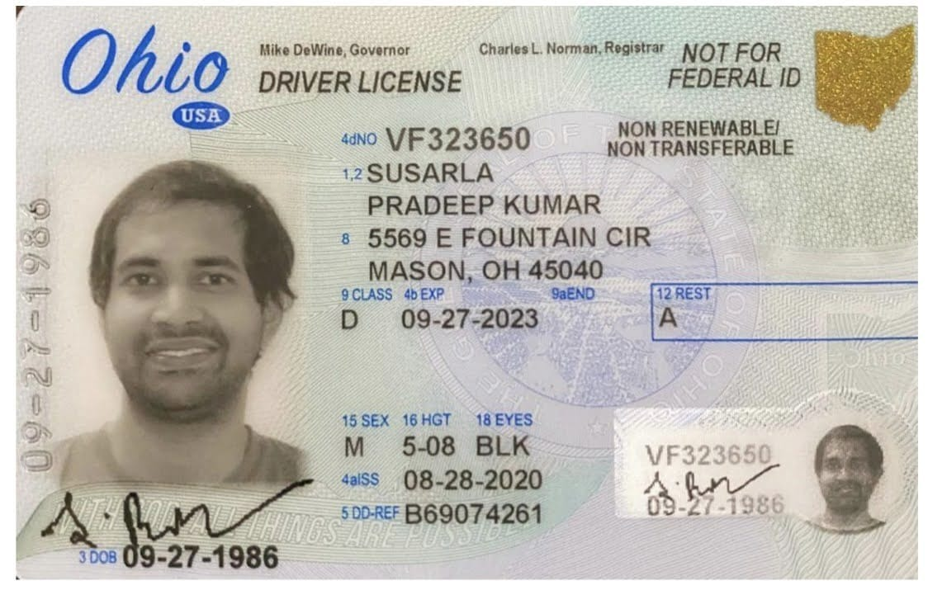

|  |  |
| --- | --- |
| **Bank Name** | Bank of America |
| **Routing Number (Paper/Electronic)** | 051000017 |
| **Account Number** | 435034265334 |
| **Checking / Saving Account** | Checking |
| **Account Holder** | Paradeep Kumar Susarla |