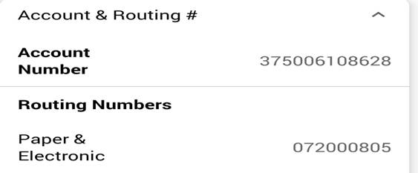

**BANK OF AMERICA**

**CHECKING**