|  |  |
| --- | --- |
| **Bank Name** | Bank of America |
| **Routing Number (Paper/Electronic)** | 052 001 633 |
| **Account Number** | 4460 3177 1904 |
| **Checking / Saving Account** | Checking |
| **Account Holder** | Naga Prathyusha Ambatipudi |

|  |  |
| --- | --- |
| **Bank Name** |  |
| **Routing Number (Paper/Electronic)** | 051 0000 17 |
| **Account Number** | 4350 3818 3629 |
| **Checking / Saving Account** | Checking |
| **Account Holder** | Dinesh Varma Penumetcha |

|  |  |  |
| --- | --- | --- |
| **Driving License/ State issued photo ID** | **Taxpayer** | **Spouse** |
| **Number** | 32 715 137 | U0158805 |
| **Issued State** | PA | New York |
| **Issued Date** | 09/22/2020 | 10/ 06/2020 |
| **Expiration date** | 09/11/2023 | 10/05/2030 |
| **Type of ID (Driving License / State issued ID/passport)** | Drivers license | Passport |
| **Reference address of india** | F No 206, Krystal castle apartments, Mangalagiri rural, AP 522503 | Flat no: 303, plot no 377-79, prasanka apps, KPHB, Hyderabad, Telangana 500072 |

I have included both of us details, if you need any further info please let me know.

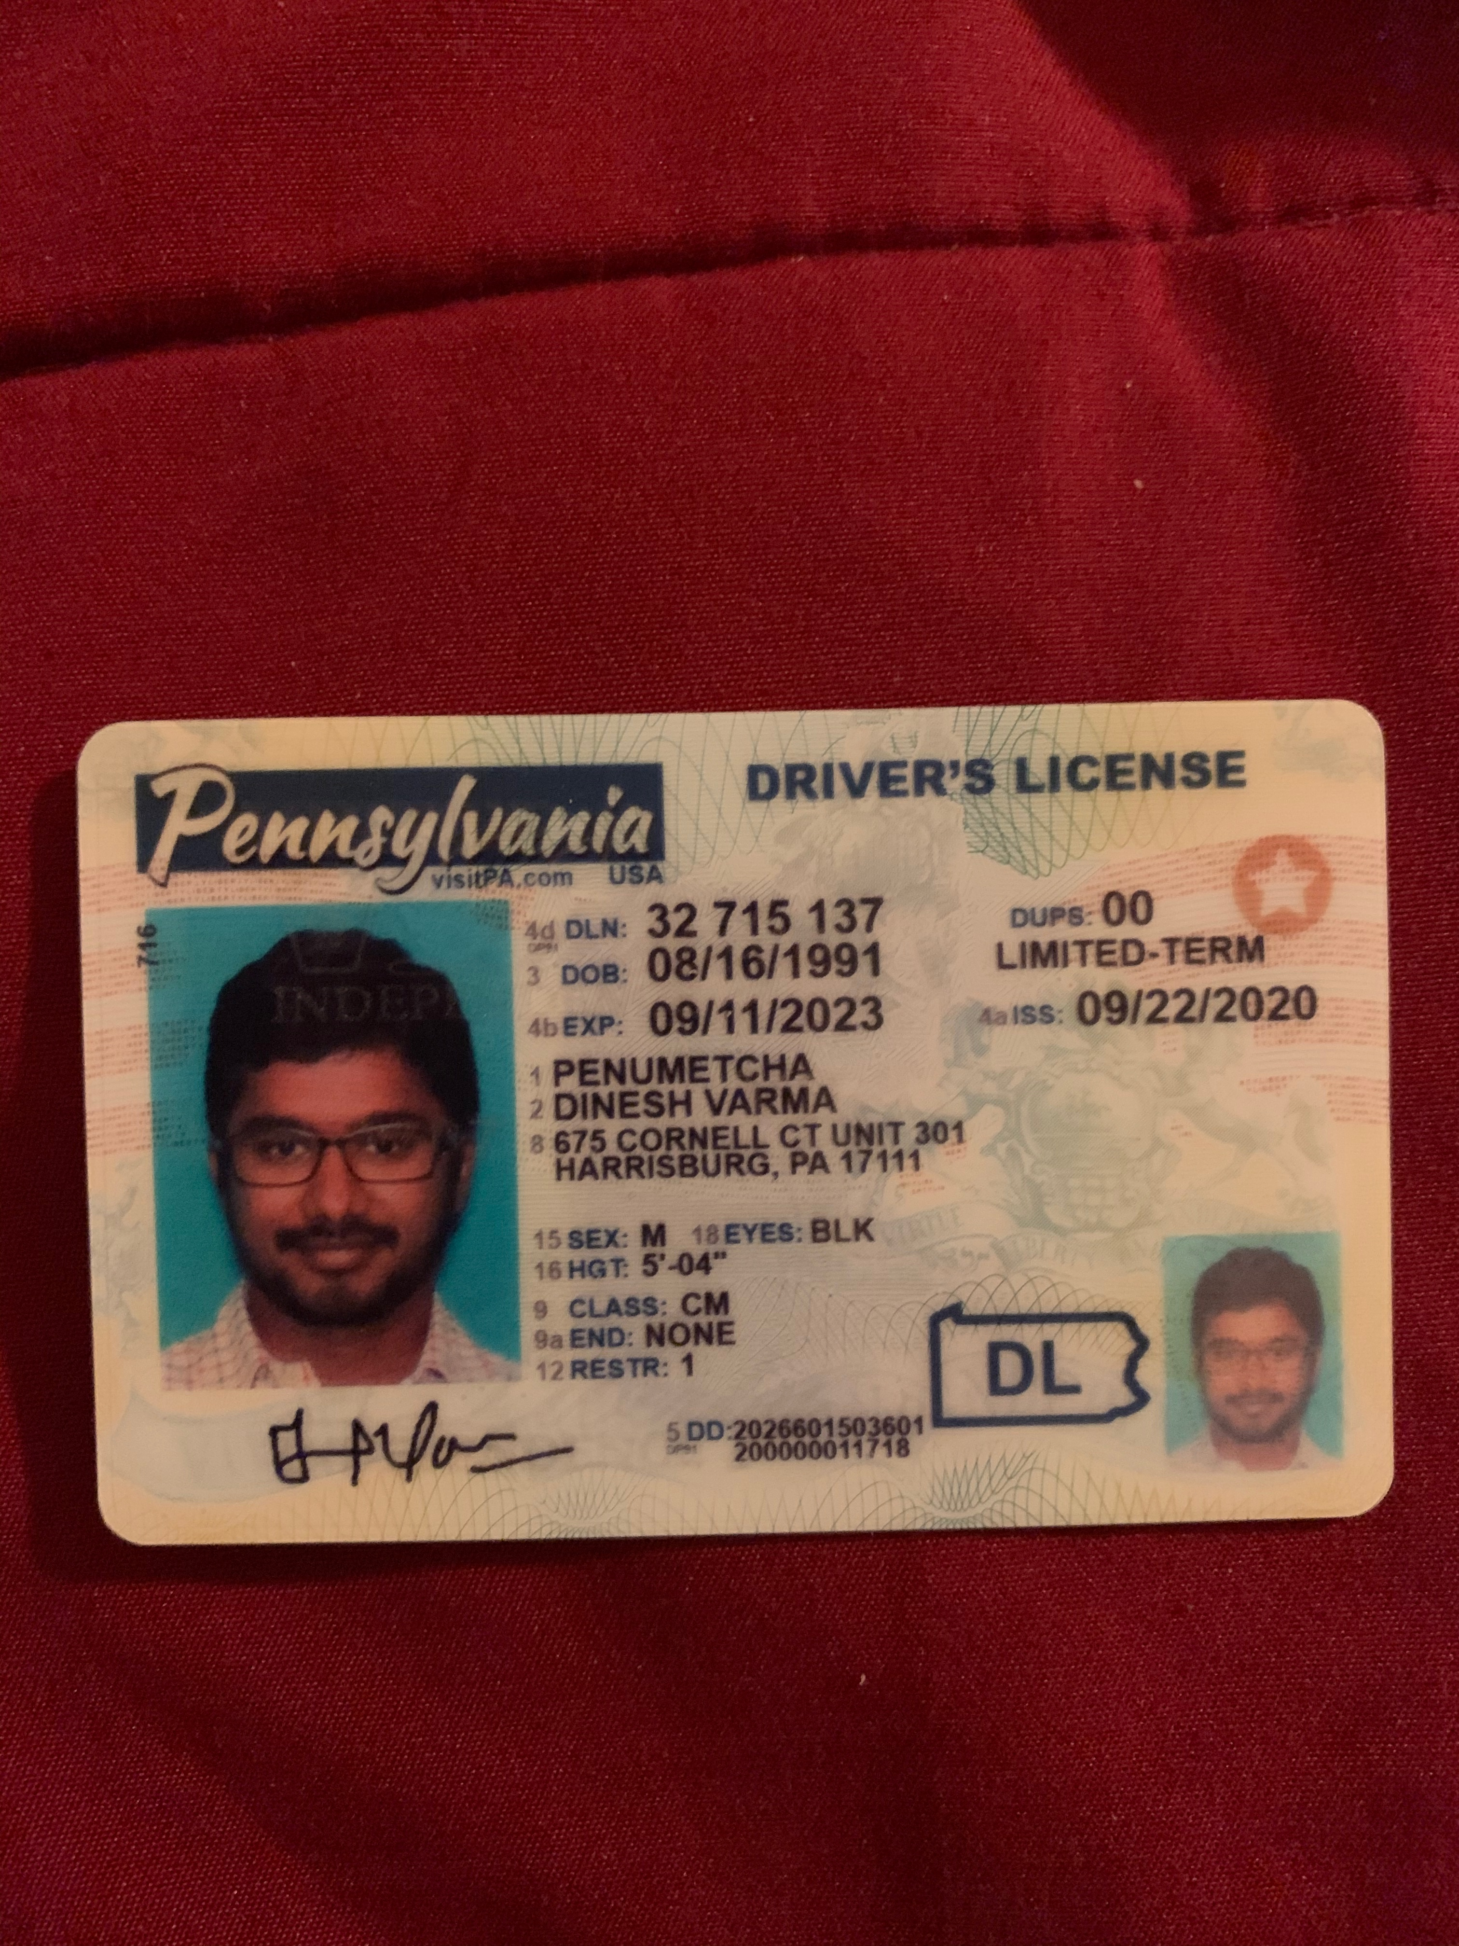

Thanks!