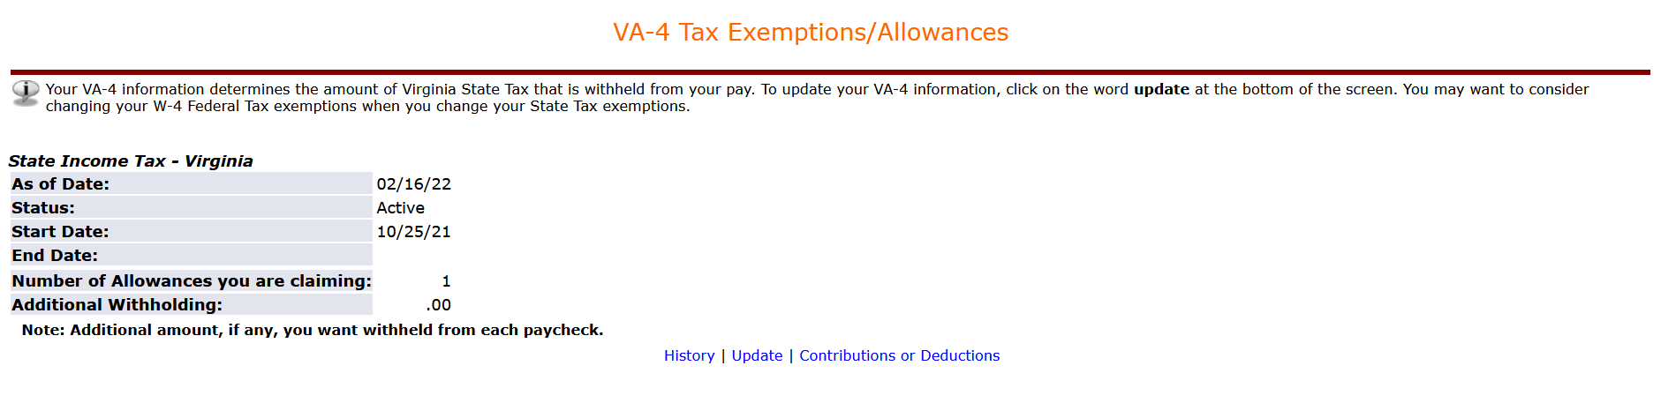

: Maname back request cheyalanta

: Ah dabbulu

Virginia state nundi

$138.\*\*

So amended w2 manaki raadu andi

