Hi Bhagya,

Please find signed attachment.

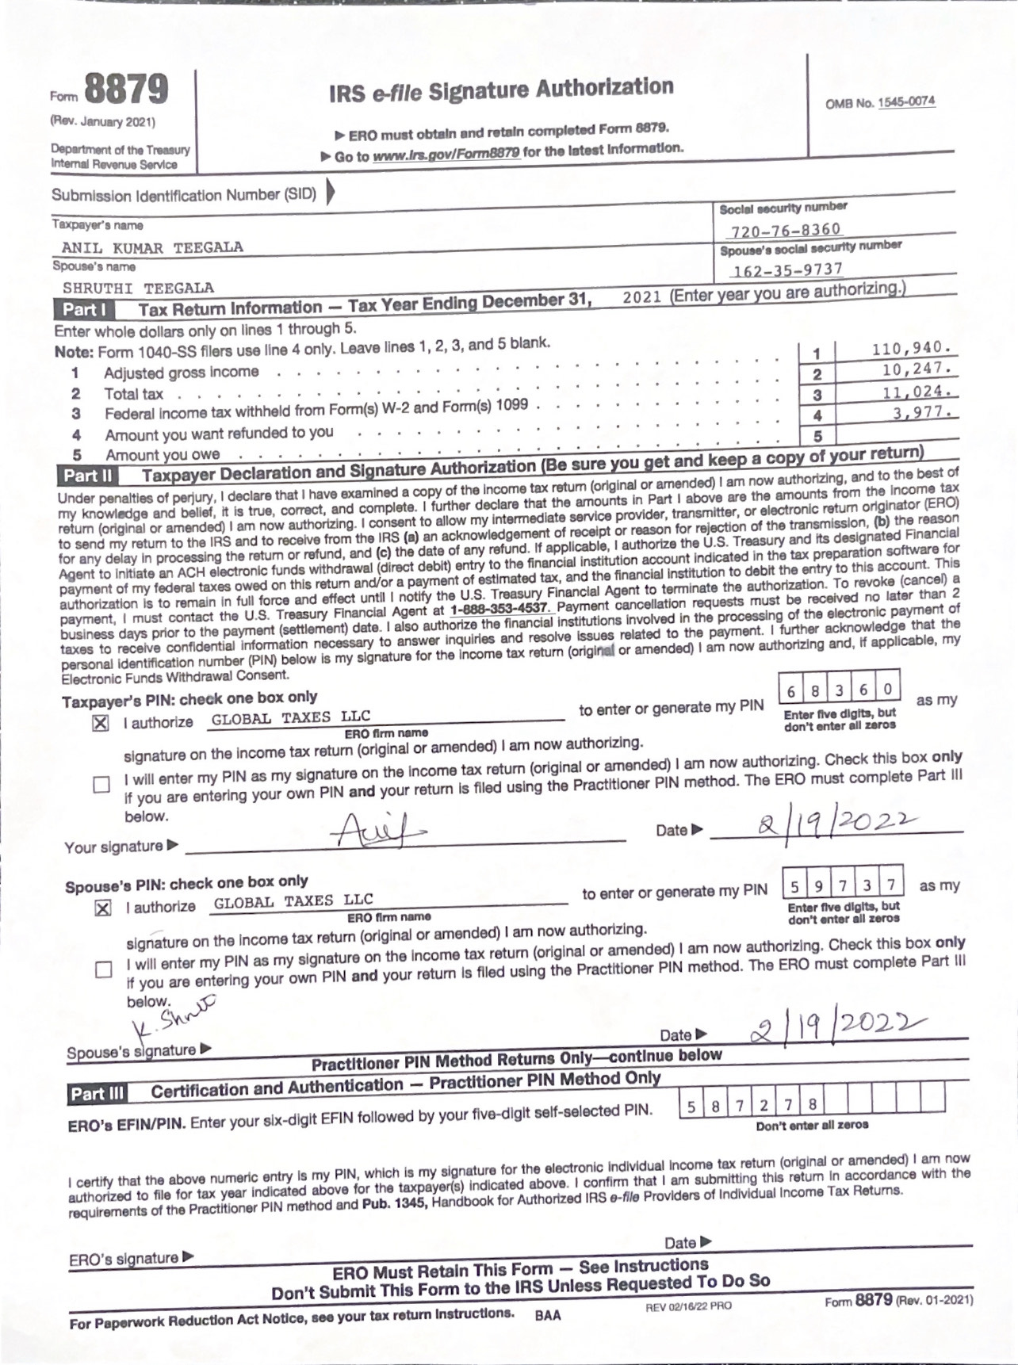

￼

On Sat, Feb 19, 2022 at 10:50 AM Bhagya - Gtax <[bhagya@gtaxfile.com](mailto:bhagya@gtaxfile.com)> wrote:

**Dear Anil,**

**I am sharing the final draft copy for your review , please cross check the NAMES,SSN,BANK DETAILS,CURRENT ADDRESS AND REFUNDS TOO.**

**Let me know if any corrections needed if all details are fine, then please sign on the 8879 first page of the final document and revert it back for e-filing confirmation.**

**Thank you,**

**Regards:**

**Bhagya,**

**TEAM LEADER**

**Phone:  628-288-3658**

**what's app: 919-399-3028**

**Email:** [**bhagya@gtaxfile.com**](mailto:hema@gtaxfile.com)

**Website:** [**www.gtaxfile.com**](http://www.gtaxfile.com/)