First name : Akshita Chowdary   
Last name : Tripuraneni   
SSN NO: 396-49-5724  
Occupation : Site Reliability engineer   
date of birth : August 1st 1993   
email id : [akshita2324@gmail.com](mailto:akshita2324@gmail.com)  
phone number : 8135854508   
current address : 1545 S 29th blvd, Cornelius, Oregon  
Visa status : H1B

State of residence 2022: Florida and Oregon

Marital status : Single  
Port of entry dates : in picture below   
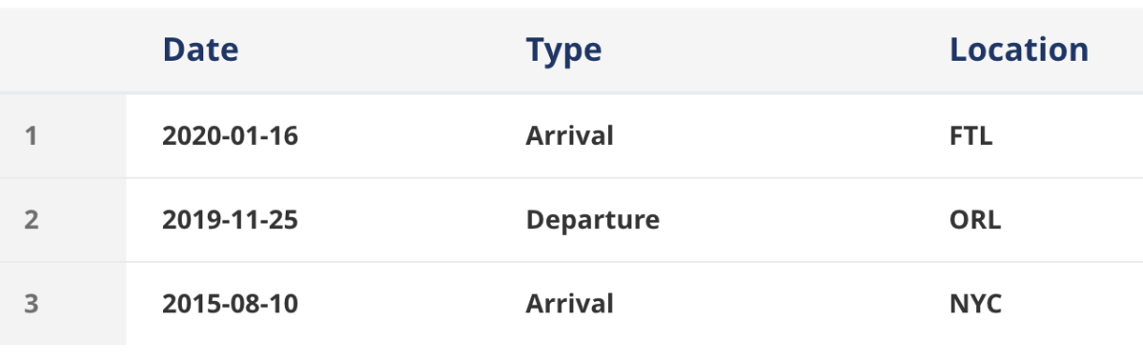

1545 S 29TH BLVD, CORNELIUS, OR -97113