Hi Rama,

Here is the new address:

**1307 Meadow Creek Dr, Apt 237, Irving, Texas 75038**

Wife passport expire date correction.

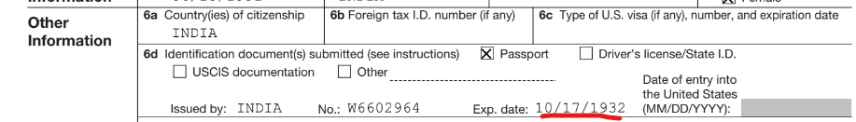

pls space in below screenshot for the reference.

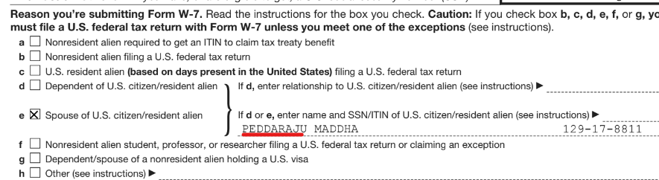

pls make corrections and send back to me.