Hi Rama-

Please find the details below:

Thanks

Pankaj Singh

4699567466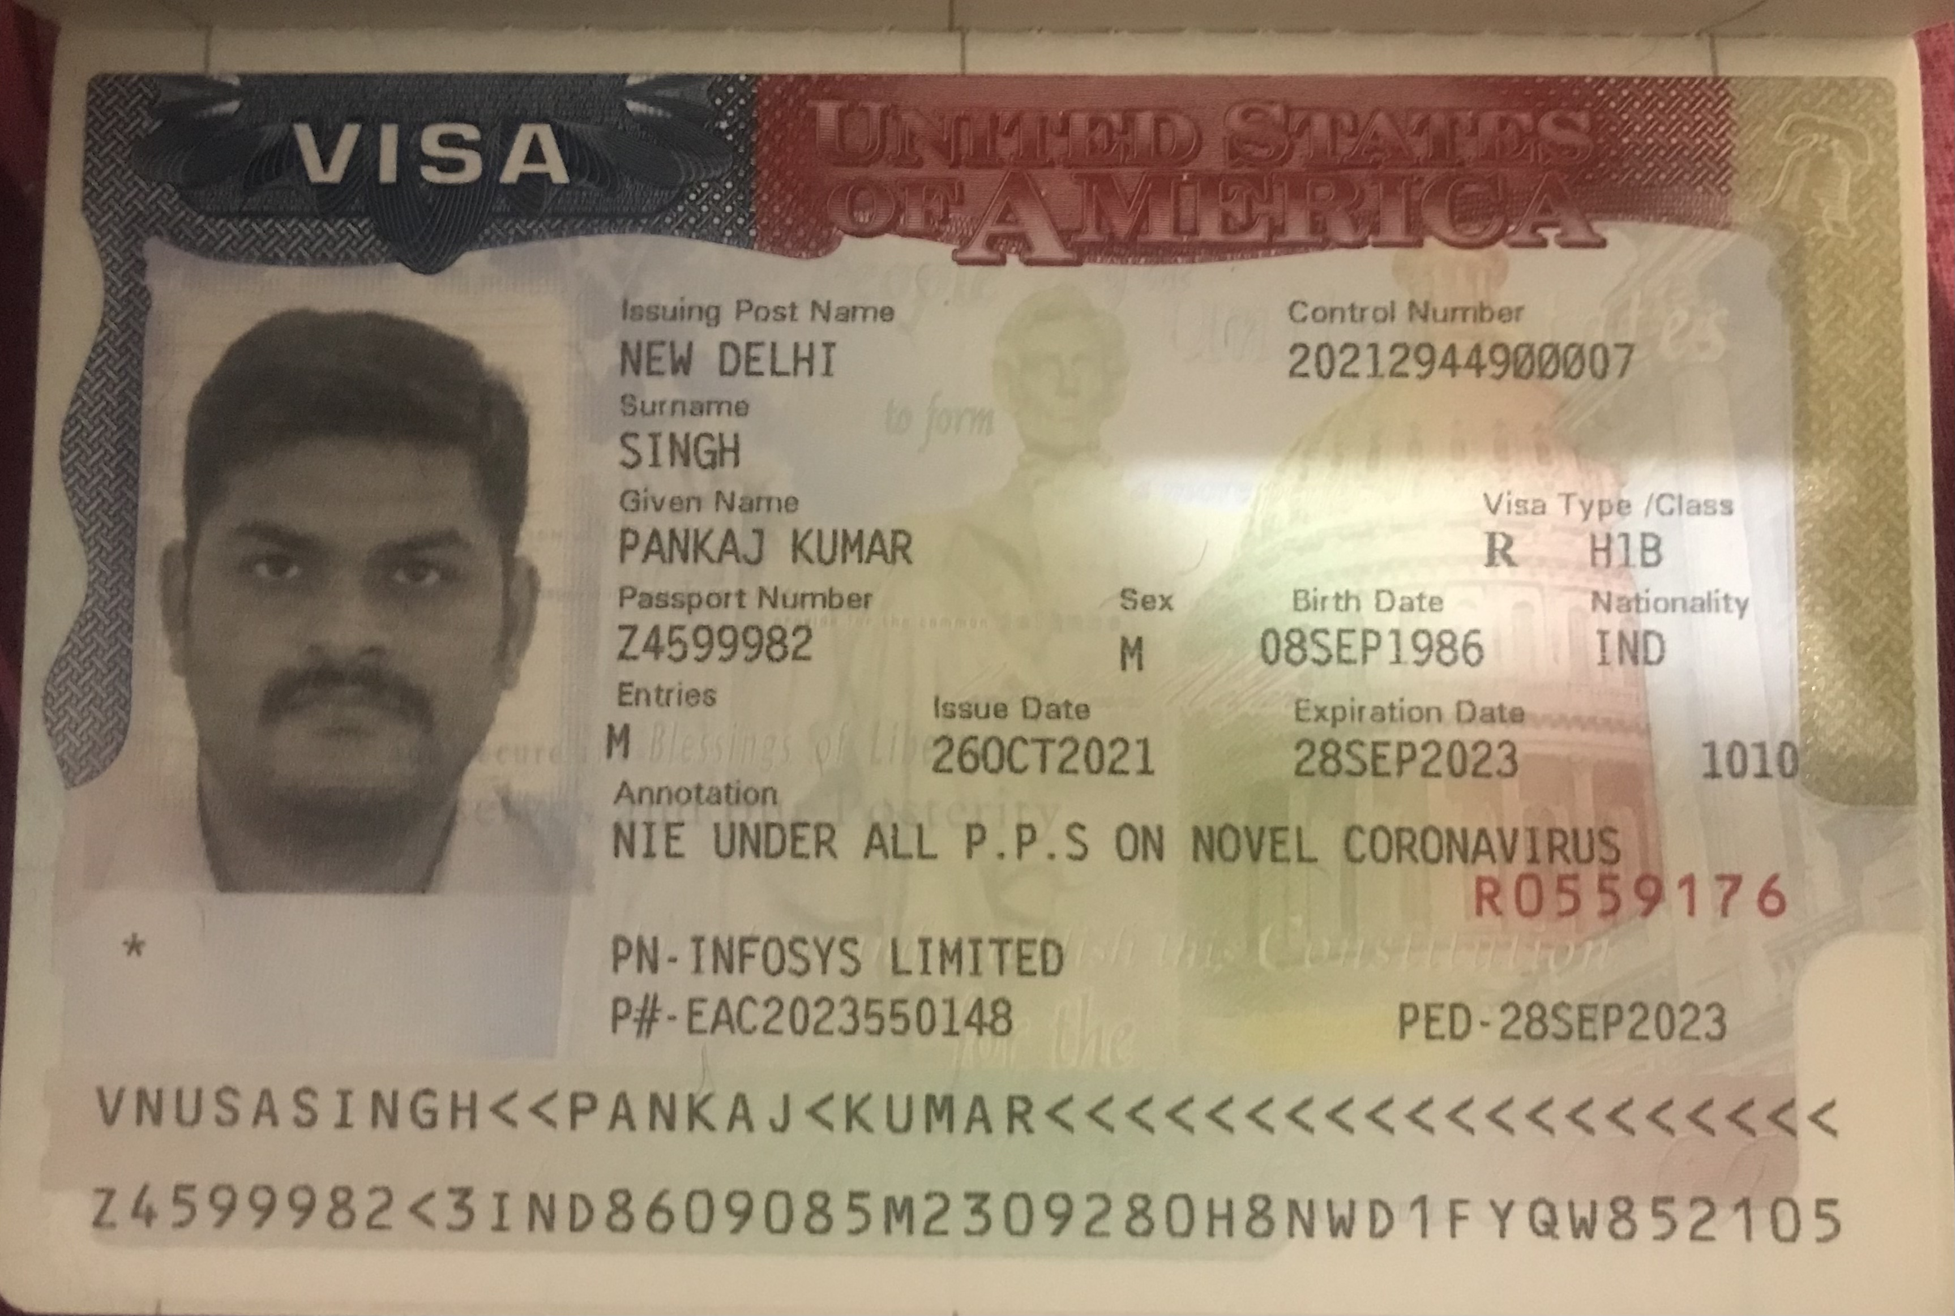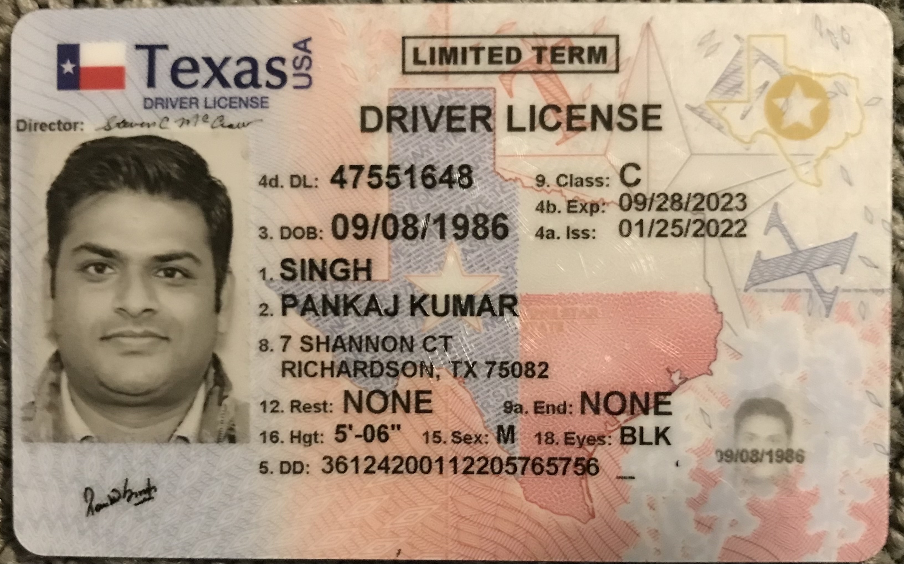

Sent from my iPhone

On Jan 27, 2023, at 8:53 AM, pankaj kumar <[pkcusat@gmail.com](mailto:pkcusat@gmail.com)> wrote:

﻿

Sent from my iPhone

Begin forwarded message:

**From:** Ramadevi - gtaxfile <ramadevi@gtaxfile.com>  
**Date:** January 27, 2023 at 10:21:16 AM CST  
**To:** pkcusat@gmail.com  
**Subject:** **Gtax-IDS**

﻿

**Dear  Pankaj,**

**Thanks for making the payment, we request you to Pls. give us your Consent to E- File your taxes. let us know if any changes are their before we file the returns.**

**Pls. cross check your bank details, if you have not provided pls. share them with us to get direct deposit of Refund amount.**

|  |  |
| --- | --- |
| **Bank Name** | JPMorgan Chase |
| **Routing Number (Paper/Electronic)** | 111000614 |
| **Account Number** | 789575765 |
| **Checking / Saving Account** | Checking |
| **Account Holder** | Pankaj kumar singh |

**Pls. provide the below details to E - File your taxes with IRS and state departments.**

1. **If Filing status is Single, provide only your ID proof**
2. **If Filing Jointly, provide you and your Spouse ID proof**

|  |  |  |
| --- | --- | --- |
| **Driving License/ State issued photo ID** | **Taxpayer** | **Spouse** |
| **Number** | 47551648 | NA |
| **Issued State** | Texas | NA |
| **Issued Date** | 01/25/2022 | NA |
| **Expiration date** | 09/28/2023 | NA |
| **Type of ID (Driving License / State issued ID)** | Driving License | NA |
|  |  |  |

**Pls. Refer your friends and colleagues to utilize our services to file their taxes with IRS respectively.**

**Note:**

**1. For All E-Filing Cases, Refund will be credited within 21 days in bank account.**

**2. For All Paper Filing case, it will take 9 – 13 week's to get Refund and ITIN from IRS.**

**Let us know if you have any question, where we can help you out.**

**Refer Your Friends/Colleagues & Get $10 Per Referral...**

**Please feel free to reach us on the below coordinates for more information on our above services. Also, we will be pleased to serve your referrals and honor with $10 per paid client.**

**Thanks in advance for your business and referrals,**

**Thanks & Regards,**

**Ramadevi**

**Client Executive**

**Phone : 520-500-9245, 251-285-1235(whatsApp number)**

**Email :** [**ramadevi@gtaxfile.com**](mailto:ramadevi@gtaxfile.com)

**Website :** [**www.gtaxfile.com**](http://www.gtaxfile.com/)