Form**8879** (Rev. January 2021)

Department of the TreasuryInternal Revenue Service

SubmissionIdentificationNumber(SID)

**IRS*e-file*SignatureAuthorization**

aEROmustobtainandretaincompletedForm8879.

a**Goto**[***www.irs.gov/Form8879***](http://www.irs.gov/Form8879)**forthelatestinformation.**

F

OMBNo.1545-0074

|  |  |  |
| --- | --- | --- |
| Taxpayer’s name  YESHWANTH YENUGULA | | **Socialsecuritynumber**  181-13-6988 |
| Spouse’sname | | **Spouse’ssocialsecuritynumber** |
| **PartI** | **TaxReturn Information— TaxYear EndingDecember 31,** 2022(Enteryearyouareauthorizing.) | |

Enterwholedollarsonlyonlines1through5.

**Note:**Form1040-SSfilersuseline4only.Leavelines1,2,3,and5 blank.

|  |  |  |  |  |  |  |  |  |  |  |  |  |  |  |  |  |  |
| --- | --- | --- | --- | --- | --- | --- | --- | --- | --- | --- | --- | --- | --- | --- | --- | --- | --- |
| **1** | Adjustedgrossincome ............. | | . | . | . | . | . | . | . | . | . | . | . | . | . | **1** | 112,887. |
| **2** | Total tax.................. | | . | . | . | . | . | . | . | . | . | . | . | . | . | **2** | 17,818. |
| **3** | Federalincome tax withheld from Form(s) W-2 and Form(s) 1099 | | . | . | . | . | . | . | . | . | . | . | . | . | . | **3** | 18,924. |
| **4** | Amountyouwantrefundedtoyou ......... | | . | . | . | . | . | . | . | . | . | . | . | . | . | **4** | 1,106. |
| **5** | Amountyouowe ............... | | . | . | . | . | . | . | . | . | . | . | . | . | . | **5** |  |
| **PartII** | | **TaxpayerDeclarationandSignatureAuthorization(Besureyougetandkeepacopyofyourreturn)** | | | | | | | | | | | | | | | |

Under penalties of perjury, I declare that I have examined a copy of the income tax return (original or amended) I am now authorizing, and to the best of myknowledgeandbelief,itistrue,correct,andcomplete.IfurtherdeclarethattheamountsinPartIabovearetheamountsfromtheincometax return (original or amended) I am now authorizing. I consent to allow my intermediate service provider, transmitter, or electronic return originator (ERO)to send my return to the IRS and to receive from the IRS **(a)** an acknowledgement of receipt or reason for rejection of the transmission, **(b)** the reasonfor any delay in processing the return or refund, and **(c)** the date of any refund. If applicable, I authorize the U.S. Treasury and its designated Financial Agent to initiate an ACH electronic funds withdrawal (direct debit) entry to the financial institution account indicated in the tax preparation software for payment of my federal taxes owed on this return and/or a payment of estimated tax, and the financial institution to debit the entry to this account. This authorization is to remain in full force and effect until I notify the U.S. Treasury Financial Agent to terminate the authorization. To revoke (cancel) a payment, I must contact the U.S. Treasury Financial Agent at **1-888-353-4537**. Payment cancellation requests must be received no later than 2business days prior to the payment (settlement) date. I also authorize the financial institutions involved in the processing of the electronic payment of taxes to receive confidential information necessary to answer inquiries and resolve issues related to the payment. I further acknowledge that thepersonal identification number (PIN) below is my signature for the income tax return (original or amended) I am now authorizing and, if applicable, my Electronic Funds Withdrawal Consent.

###### Taxpayer’sPIN:checkoneboxonly

|  |  |  |  |  |
| --- | --- | --- | --- | --- |
| 3 | 6 | 9 | 8 | 8 |

Iauthorize

GLOBAL TAXES LLC

**EROfirmname**

to enterorgenerate myPIN

**Enterfivedigits,butdon’t enter all zeros**

asmy

signature on the income tax return (original or amended) I am now authorizing.

I will enter my PIN as my signature on the income tax return (original or amended) I am now authorizing. Check this box **only**if you are entering your own PIN **and** your return is filed using the Practitioner PIN method. The ERO must complete Part III below.

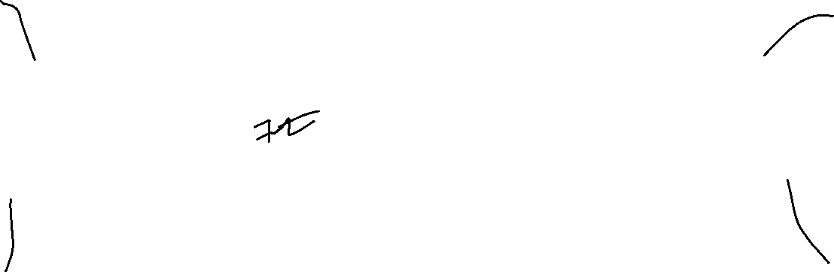Your signature a Datea 04/05/2023

###### Spouse’sPIN:checkonebox only

I authorize

**EROfirmname**

to enterorgenerate myPIN

**Enterfivedigits,but**

|  |  |  |  |  |
| --- | --- | --- | --- | --- |
|  |  |  |  |  |

asmy

signature on the income tax return (original or amended) I am now authorizing.

**don’t enter all zeros**

I will enter my PIN as my signature on the income tax return (original or amended) I am now authorizing. Check this box **only**if you are entering your own PIN **and** your return is filed using the Practitioner PIN method. The ERO must complete Part III below.

Spouse’ssignaturea Datea

### PractitionerPINMethodReturnsOnly—continuebelow

**PartIII Certification andAuthentication—PractitionerPINMethodOnly**

|  |  |  |  |  |  |  |  |  |  |  |  |  |
| --- | --- | --- | --- | --- | --- | --- | --- | --- | --- | --- | --- | --- |
| **ERO’sEFIN/PIN.**Enteryoursix-digitEFINfollowedbyyourfive-digitself-selectedPIN. | 2 | 2 | 2 | 4 | 9 | 6 | 6 | 1 | 9 | 8 | 9 |  |

**Don’t enter all zeros**

I certify that the above numeric entry is my PIN, which is my signature for the electronic individual income tax return (original or amended) I am now authorized to file for tax year indicated above for the taxpayer(s) indicated above. I confirm that I am submitting this return in accordance with the requirements of the Practitioner PIN method and **Pub. 1345,** Handbook for Authorized IRS *e-file* Providers of Individual Income Tax Returns.

ERO’ssignaturea Datea

### EROMustRetainThisForm—See Instructions

**Don’tSubmitThisFormtotheIRSUnlessRequestedToDoSo**

ForPaperworkReductionActNotice,seeyourtaxreturn instructions.

**BAA** REV03/22/23 PRO

Form**8879**(Rev.01-2021)