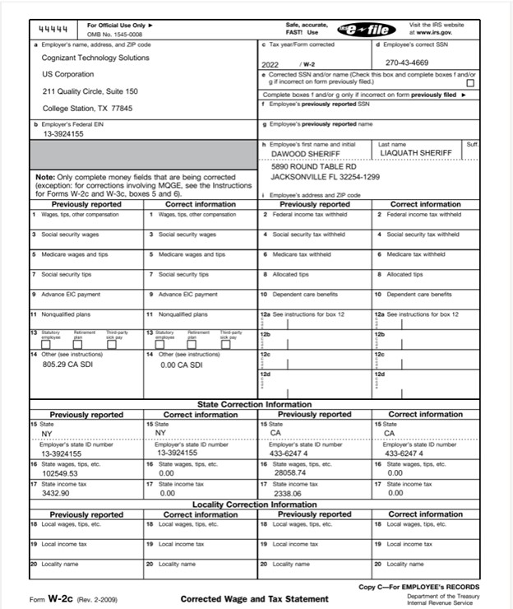

Attached is also EIN for my LLC Chop technologies and W2 from Systems technology group which is 2nd job.

Thanks,

Sheriff