|  |  |
| --- | --- |
| **BANK NAME** | **CHASE** |
| **ROUTING NUMBER (PAPER/ELECTRONIC)** | **022300173** |
| **ACCOUNT NUMBER** | **595800589** |
| **CHECKING / SAVING ACCOUNT** | **CHECKING** |
| **ACCOUNT HOLDER** | INDRANEEL GAJAVALLI |

**PLS. PROVIDE THE BELOW DETAILS TO E - FILE YOUR TAXES WITH IRS AND STATE DEPARTMENTS.**

1. **IF FILING STATUS IS SINGLE, PROVIDE ONLY YOUR ID PROOF**
2. **IF FILING JOINTLY, PROVIDE YOU AND YOUR SPOUSE ID PROOF**

|  |  |  |
| --- | --- | --- |
| **DRIVING LICENSE/ STATE ISSUED PHOTO ID** | **TAXPAYER** | **SPOUSE** |
| **NUMBER** | 147987552 |  |
| **ISSUED STATE** | TENNESSEE |  |
| **ISSUED DATE** | 09/07/2022 |  |
| **EXPIRATION DATE** | 01/02/2023 |  |
| **TYPE OF ID (DRIVING LICENSE / STATE ISSUED ID)** | STATE ID |  |
| **REFERENCE ADDRESS OF INDIA** | 4-240, VVS NAGAR 1ST LINE, 523331. ANDHRA PRADESH, INDIA |  |

5-240, P Dornala, Dornala m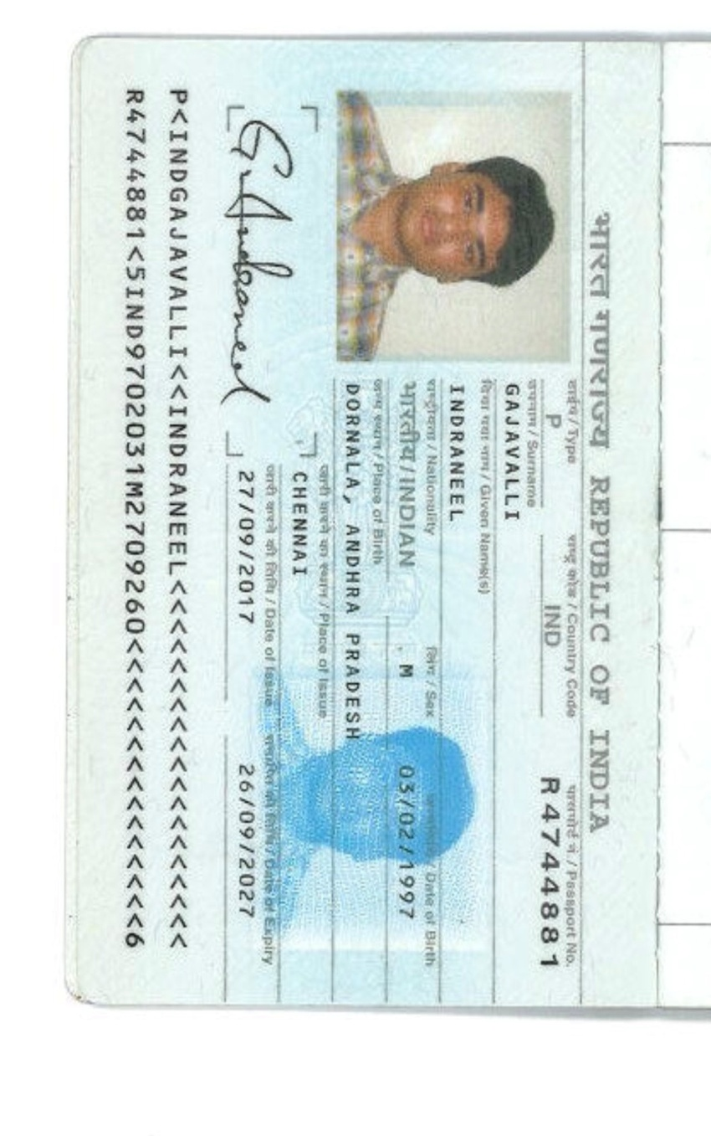d post, PrakasamDT