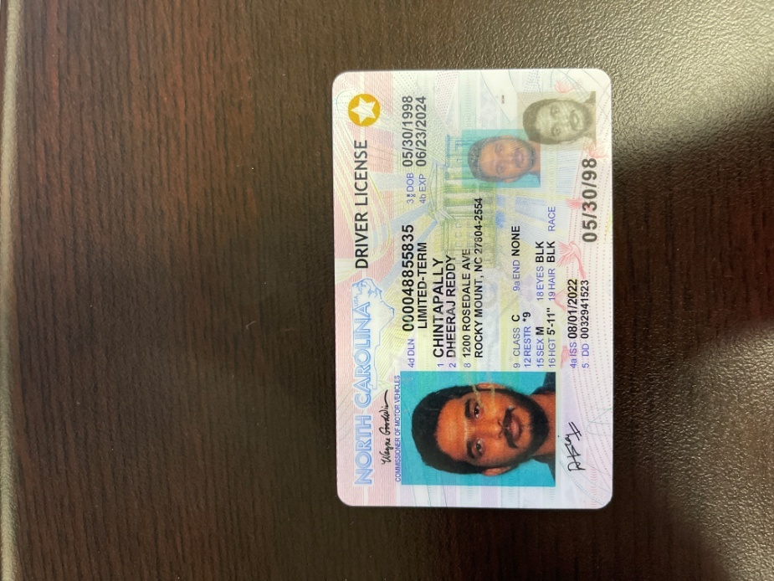

|  |  |
| --- | --- |
| **BANK NAME** | BANK OF AMERICA |
| **ROUTING NUMBER (PAPER/ELECTRONIC)** | 021200339 |
| **ACCOUNT NUMBER** | 381057812371 |
| **CHECKING / SAVING ACCOUNT** | CHECKING |
| **ACCOUNT HOLDER** | DHEERAJ REDDY CHINTAPALLY |

|  |  |  |
| --- | --- | --- |
| **DRIVING LICENSE/ STATE ISSUED PHOTO ID** | **TAXPAYER** | **SPOUSE** |
| **NUMBER** | 000048855835 |  |
| **ISSUED STATE** | NORTH CAROLINA |  |
| **ISSUED DATE** | 08/01/2022 |  |
| **EXPIRATION DATE** | 06/23/2024 |  |
| **TYPE OF ID (DRIVING LICENSE / STATE ISSUED ID)** | N/A |  |
| **REFERANCE ADDRESS INDIA** | PLOT NO:34, FLAT NO:101, MNC HOMES, SAMA SARASWATHI COLONY, KARMANGHAT,RANGA REDDY DISTRICT, TELANGANA, 500079 |  |