Form

8879

(

Rev.January

2021)

DepartmentoftheTreasury

InternalRevenueService

IRS

e-file

SignatureAuthorization

EROmustobtainandretaincompletedForm8879.

Goto

www.irs.gov/Form8879

forthelatest information.

OMBNo.1545-0074

SubmissionIdentificationNumber(SID)

|  |  |  |  |
| --- | --- | --- | --- |
| Taxpayer’s name | |  | Social security number |
| ANUSHA RAMINENI | |  | 181-41-4548 |
| Spouse’s name | |  | Spouse’s social security number |
| Part I | Tax Return Information — Tax Year Ending December 31, | 2022 (Enter year you are authorizing.) | |

Enter whole dollars only on lines 1 through 5.

Note: Form 1040-SS filers use line 4 only. Leave lines 1, 2, 3, and 5 blank.

|  |  |  |  |
| --- | --- | --- | --- |
| 1 Adjusted gross income . . . . . . . . . . . . . . . . . . . . . . . . . . 2 Total tax . . . . . . . . . . . . . . . . . . . . . . . . . . . . . . . 3 Federal income tax withheld from Form(s) W-2 and Form(s) 1099 . . . . . . . . . . . . . 4 Amount you want refunded to you . . . . . . . . . . . . . . . . . . . . . . 5 Amount you owe . . . . . . . . . . . . . . . . . . . . . . . . . . . . | | 1 | 6,079. |
| 2 | 0. |
| 3 | 161. |
| 4 | 161. |
| 5 |  |
| Part II | Taxpayer Declaration and Signature Authorization (Be sure you get and keep a copy of your return) | | |

Under penalties of perjury, I declare that I have examined a copy of the income tax return (original or amended) I am now authorizing, and to the best of my knowledge and belief, it is true, correct, and complete. I further declare that the amounts in Part I above are the amounts from the income tax return (original or amended) I am now authorizing. I consent to allow my intermediate service provider, transmitter, or electronic return originator (ERO) to send my return to the IRS and to receive from the IRS (a) an acknowledgement of receipt or reason for rejection of the transmission, (b) the reason for any delay in processing the return or refund, and (c) the date of any refund. If applicable, I authorize the U.S. Treasury and its designated Financial Agent to initiate an ACH electronic funds withdrawal (direct debit) entry to the financial institution account indicated in the tax preparation software for payment of my federal taxes owed on this return and/or a payment of estimated tax, and the financial institution to debit the entry to this account. This authorization is to remain in full force and effect until I notify the U.S. Treasury Financial Agent to terminate the authorization. To revoke (cancel) a payment, I must contact the U.S. Treasury Financial Agent at 1-888-353-4537. Payment cancellation requests must be received no later than 2 business days prior to the payment (settlement) date. I also authorize the financial institutions involved in the processing of the electronic payment of taxes to receive confidential information necessary to answer inquiries and resolve issues related to the payment. I further acknowledge that the personal identification number (PIN) below is my signature for the income tax return (original or amended) I am now authorizing and, if applicable, my Electronic Funds Withdrawal Consent. Taxpayer’s PIN: check one box only

# 4 5 4 8

I authorize GLOBAL TAXES LLC to enter or generate my PIN as my

ERO firm name Enter five digits, but don’t enter all zeros

signature on the income tax return (original or amended) I am now authorizing.

I will enter my PIN as my signature on the income tax return (original or amended) I am now authorizing. Check this box only if you are entering your own PIN and your return is filed using the Practitioner PIN method. The ERO must complete Part III below.

Your signatureAnusha Ramineni Date2/2/2023

asmy

Spouse’s PIN: check one box only

I authorize to enter or generate my PIN

ERO firm name Enter five digits, but

signature on the income tax return (original or amended) I am now authorizing. don’t enter all zeros

I will enter my PIN as my signature on the income tax return (original or amended) I am now authorizing. Check this box only if you are entering your own PIN and your return is filed using the Practitioner PIN method. The ERO must complete Part III below.

Spouse’ssignature

Date

Practitioner PIN Method Returns Only—continue below

|  |  |  |  |  |  |  |  |  |  |  |  |  |  |
| --- | --- | --- | --- | --- | --- | --- | --- | --- | --- | --- | --- | --- | --- |
| Part III | Certification and Authentication — Practitioner PIN Method Only | | | | | | | | | | | | |
| ERO’s EFIN/PIN. Enter your six-digit EFIN followed by your five-digit self-selected PIN. | | 2 | 2 | 2 | 4 | 9 | 6 | 6 | 1 | 9 | 8 | 9 |  |

Don’t enter all zeros

I certify that the above numeric entry is my PIN, which is my signature for the electronic individual income tax return (original or amended) I am now authorized to file for tax year indicated above for the taxpayer(s) indicated above. I confirm that I am submitting this return in accordance with the requirements of the Practitioner PIN method and Pub. 1345, Handbook for Authorized IRS e-file Providers of Individual Income Tax Returns.

ERO’s signature Date

ERO Must Retain This Form — See Instructions

Don’t Submit This Form to the IRS Unless Requested To Do So

For Paperwork Reduction Act Notice, see your tax return instructions. BAA REV 02/14/23 PRO Form 8879 (Rev. 01-2021)

1040-NR U.S. Nonresident Alien Income Tax Return 2022 OMB No. 1545-0074 IRS Use Only—Do not write or staple in this space. Department of the Treasury—Internal Revenue Service

For the year Jan. 1–Dec. 31, 2022, or other tax year beginning , 2022, ending , 20 See separate instructions. Filing Single Married filing separately (MFS) Qualifying surviving spouse (QSS) Estate Trust Status

If you checked the QSS box, enter the child’s name if the qualifying person is a child but not your dependent:

Check only one box.

Your first name and middle initial Last name Your identifying number

(see instructions)

ANUSHA RAMINENI 181-41-4548

Home address (number and street). If you have a P.O. box, see instructions. Apt. no.

814 NORTH CORY STREET

City, town, or post office. If you have a foreign address, also complete spaces below. State ZIP code

# FINDLAY OH 45840

Foreign country name Foreign province/state/county Foreign postal code

Digital Assets At any time during 2022, did you: (a) receive (as a reward, award, or payment for property or services); or (b) sell, exchange, gift, or

otherwise dispose of a digital asset (or a financial interest in a digital asset)? (See instructions.) . . . . . . Yes No

Dependents (4) Check the box if qualifies for (see inst.):

(see instructions): (1) First name Last name identifying number(2) Dependent’s (3) Relationship to you Child tax credit Creditfodependentsr other

If more than four dependents, see

instructions and check here

Income

Effectively

Connected With U.S.

Trade or

Business

Attach

Form(s) W-2, 1042-S,

SSA-1042-S, RRB-1042-S, and 8288-A here. Also attach Form(s) 1099-R if tax was withheld.

If you did not get a Form W-2, see instructions.

1a Total amount from Form(s) W-2, box 1 (see instructions) . . . . . . . . . . . . . 1a 6,079.

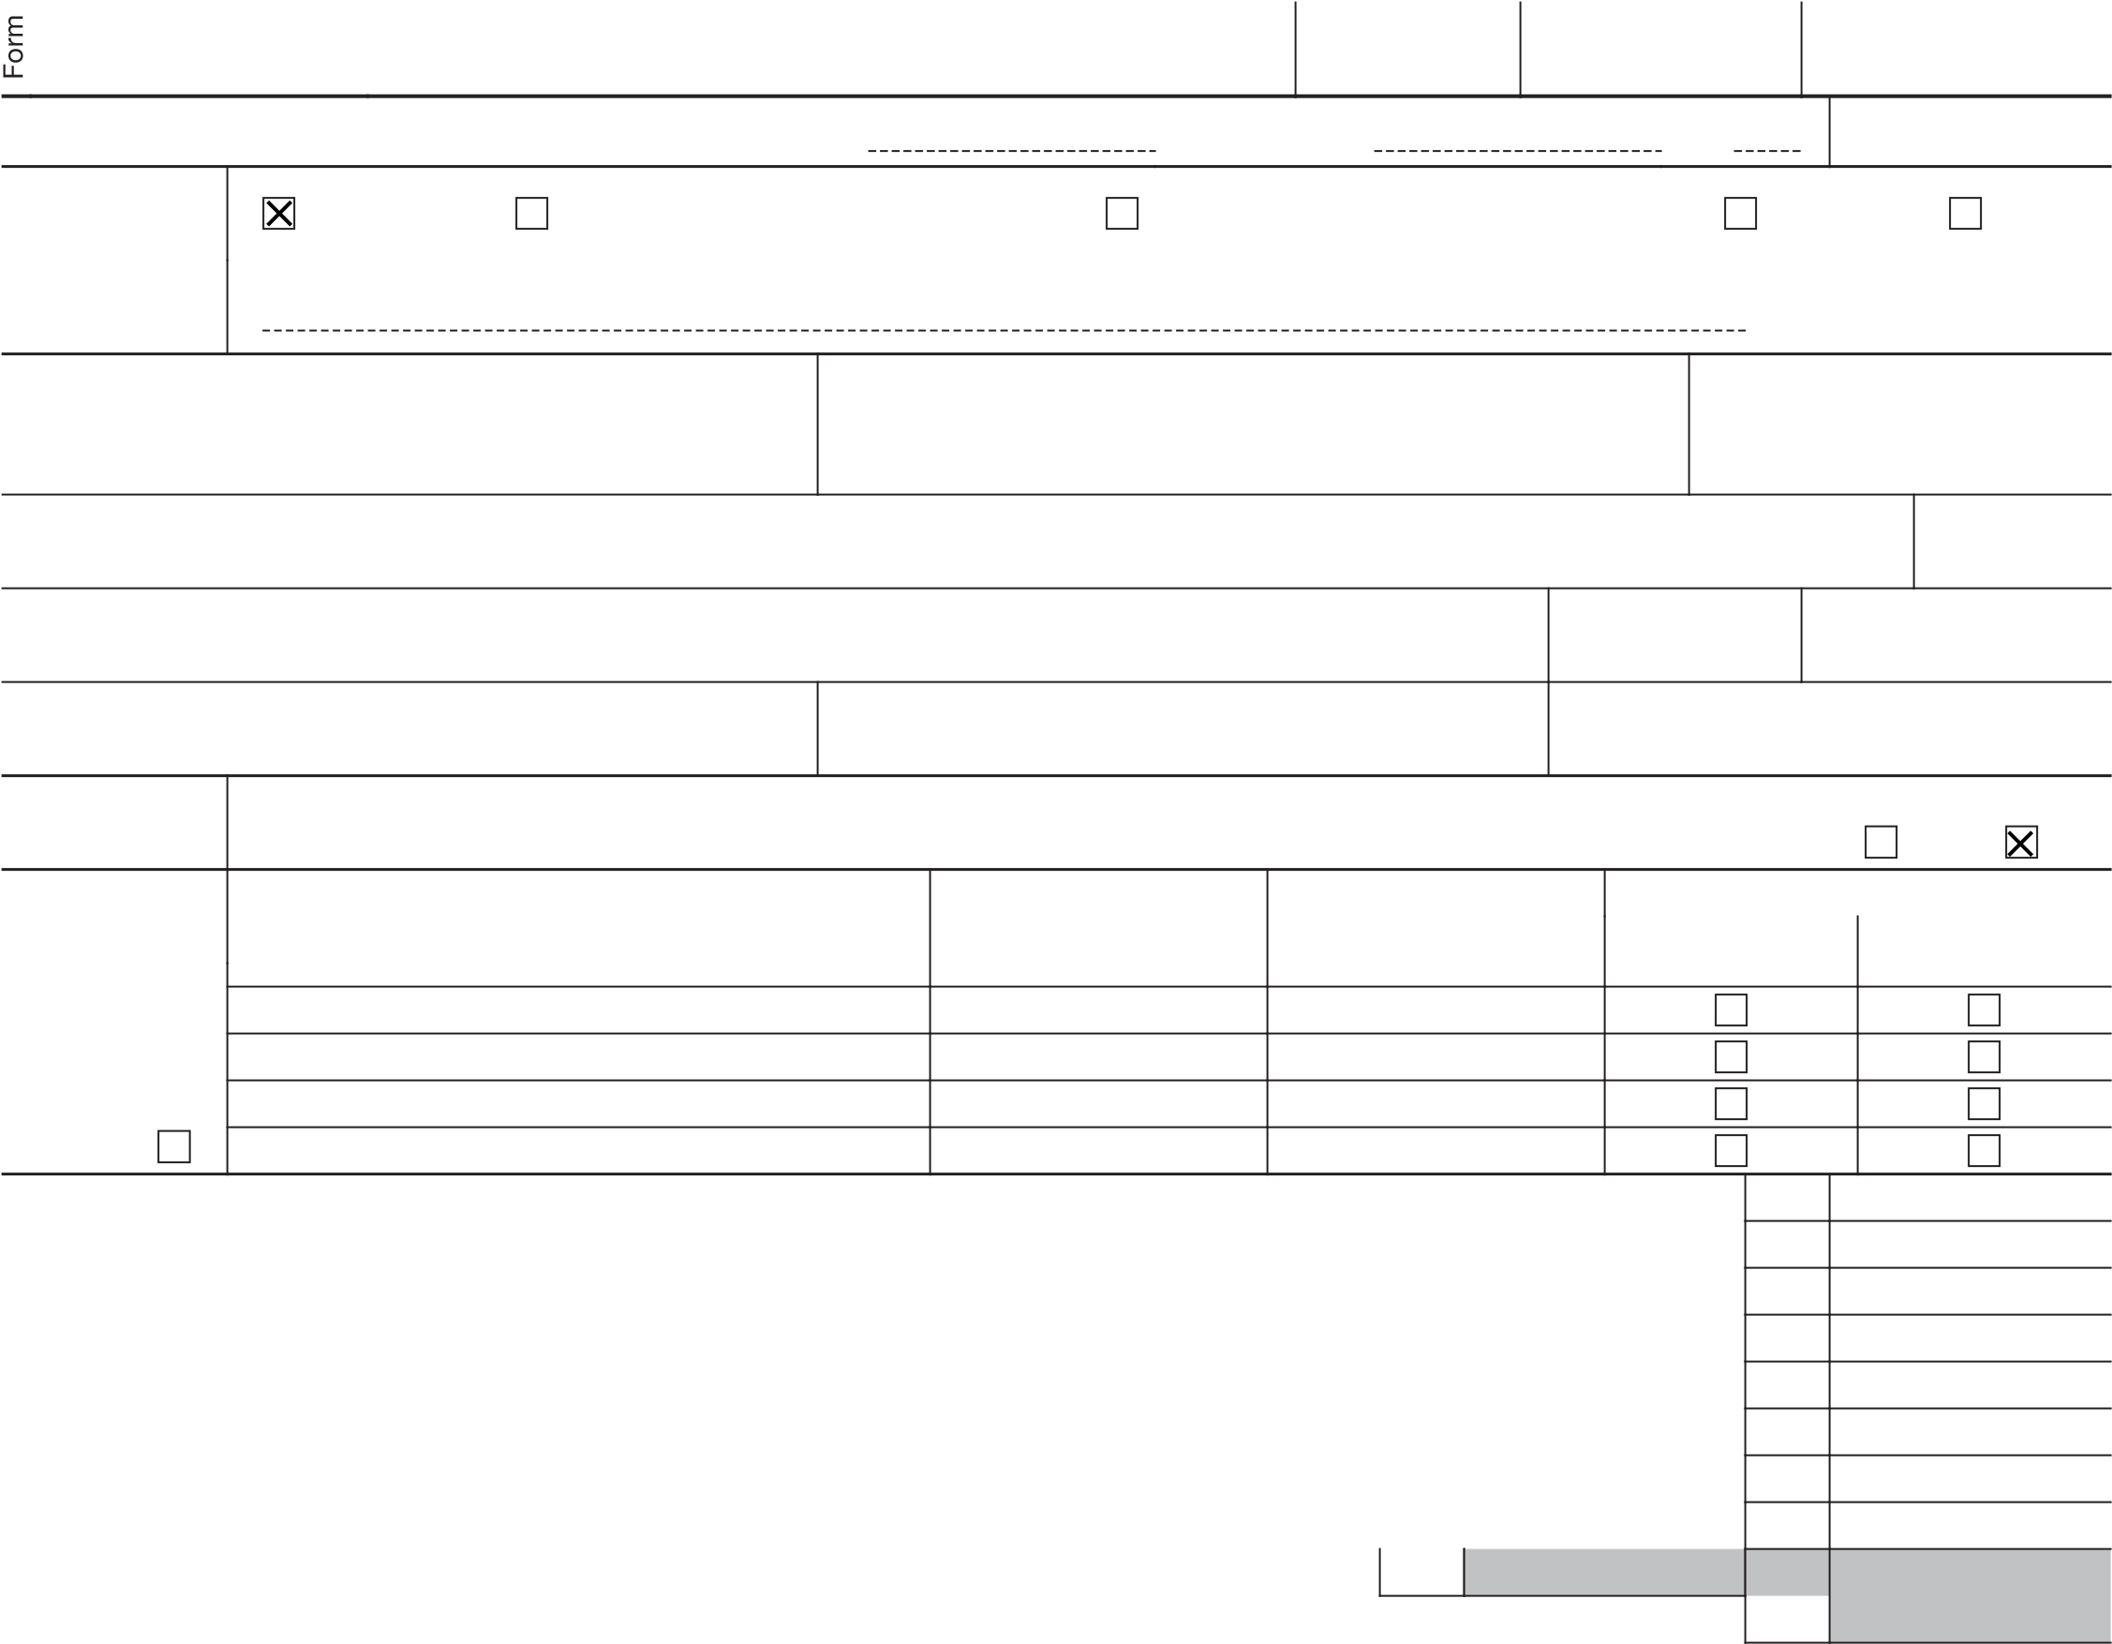b Household employee wages not reported on Form(s) W-2 . . . . . . . . . . . . . 1b c Tip income not reported on line 1a (see instructions) . . . . . . . . . . . . . . 1c d Medicaid waiver payments not reported on Form(s) W-2 (see instructions) . . . . . . . . 1d e Taxable dependent care benefits from Form 2441, line 26 . . . . . . . . . . . . . 1e f Employer-provided adoption benefits from Form 8839, line 29 . . . . . . . . . . . 1f g Wages from Form 8919, line 6 . . . . . . . . . . . . . . . . . . . . . 1g h Other earned income (see instructions) . . . . . . . . . . . . . . . . . . 1h

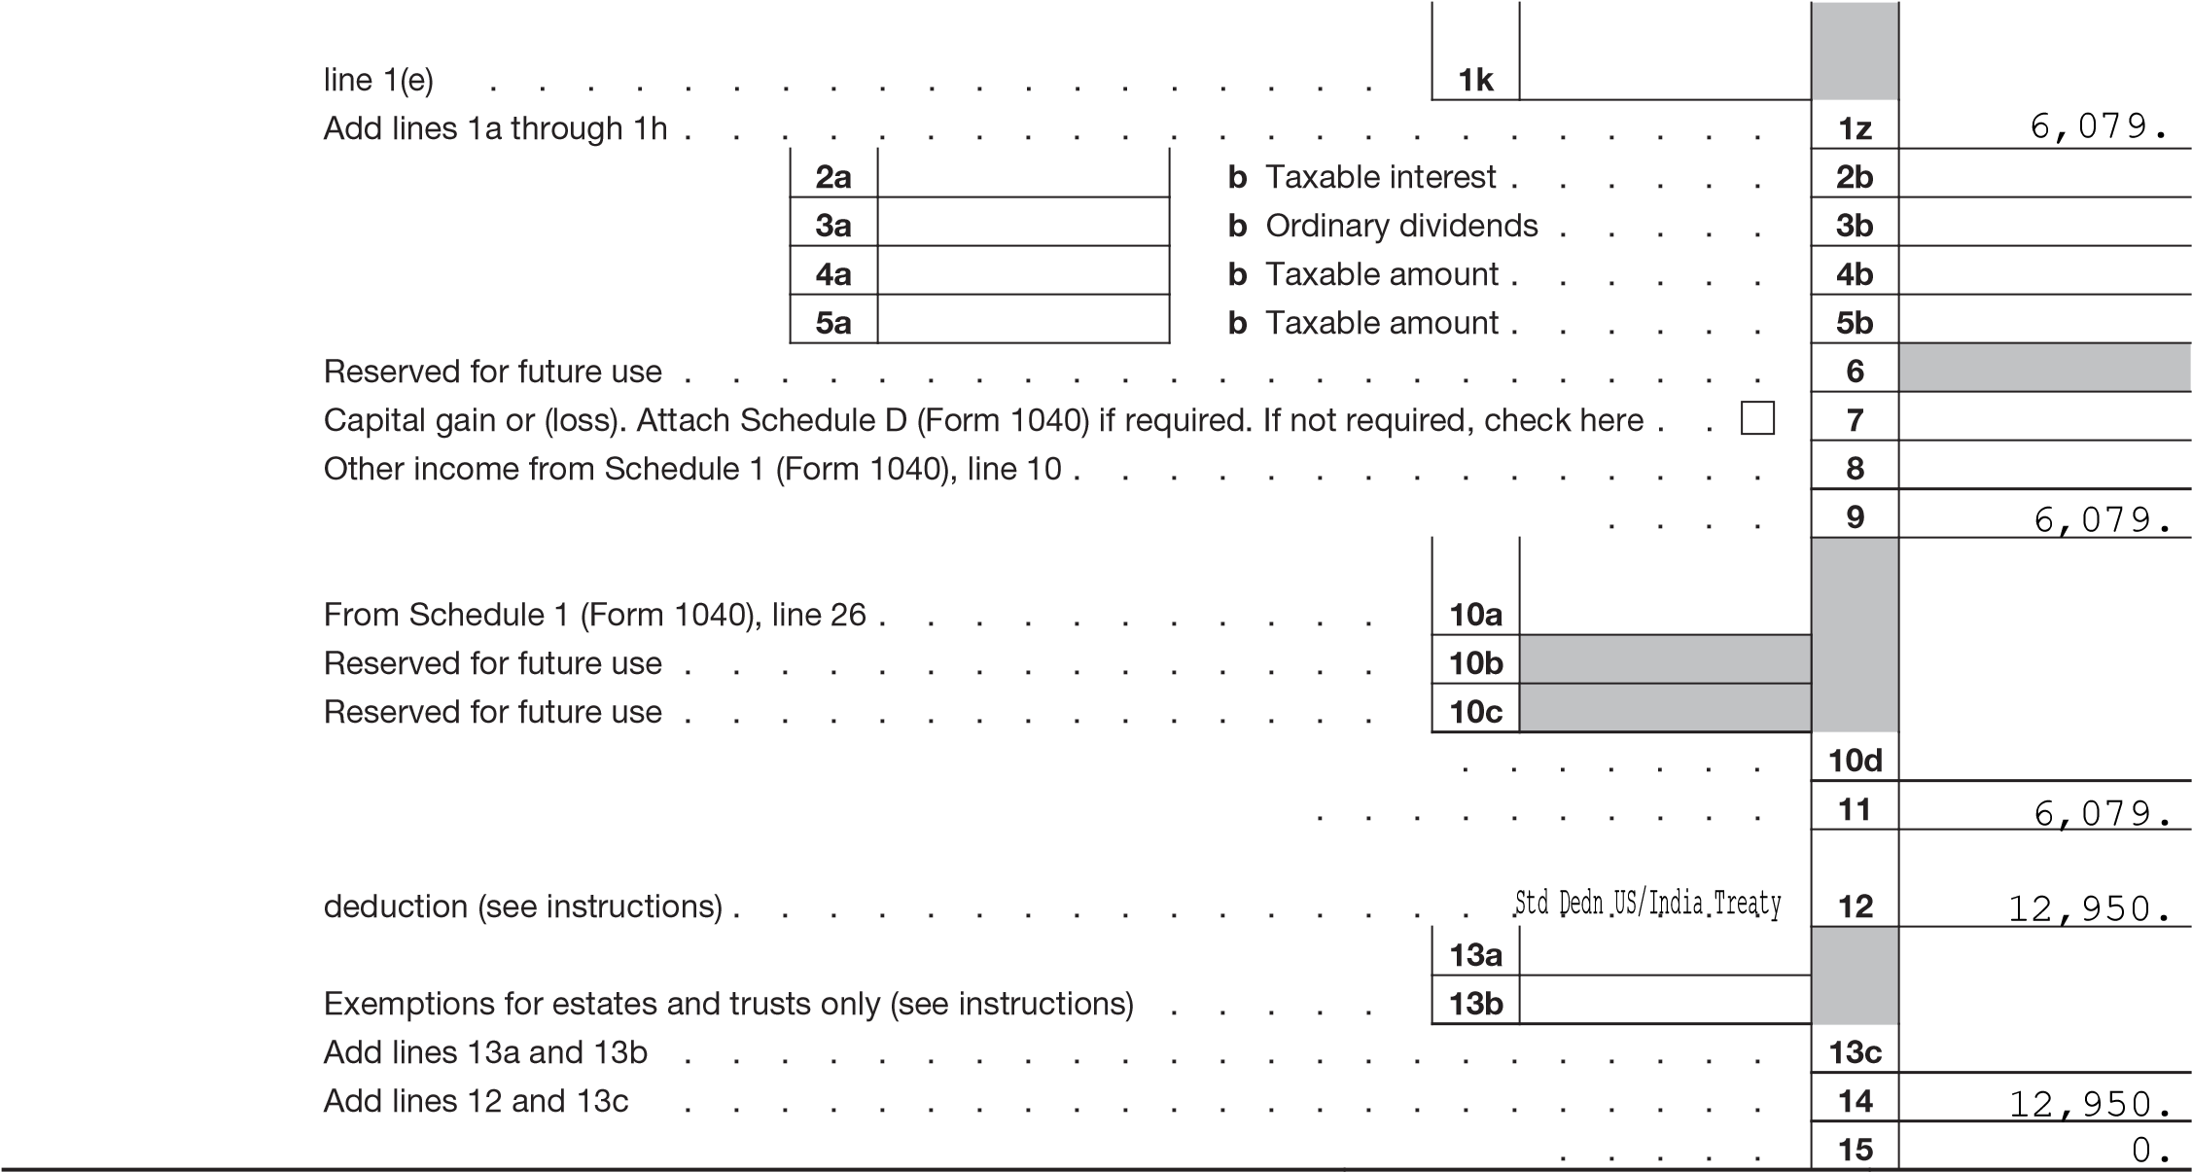i Reserved for future use . . . . . . . . . . . . . . . 1i j Reserved for future use . . . . . . . . . . . . . . . . . . . . . . . 1j k Total income exempt by a treaty from Schedule OI (Form 1040-NR), item L, line 1(e) . . . . . . . . . . . . . . . . . . z Add lines 1a through 1h . . . . . . . . . . . . . .

2a Tax-exempt interest . . . 3a Qualified dividends . . . 4a IRA distributions . . . . 5a Pensions and annuities . .

1. Reserved for future use . . . . . . . . . . . . .
2. Capital gain or (loss). Attach Schedule D (Form 1040) if required. If not required, check here .
3. Other income from Schedule 1 (Form 1040), line 10 . . . . . .
4. Add lines 1z, 2b, 3b, 4b, 5b, 7, and 8. This is your total effectively connected income .
5. Adjustments to income:

a From Schedule 1 (Form 1040), line 26 . . . . . . . . . . b Reserved for future use . . . . . . . . . . . . . . c Reserved for future use . . . . . . . . . . . . . . d Enter the amount from line 10a. These are your total adjustments to income .

1. Subtract line 10d from line 9. This is your adjusted gross income .
2. Itemized deductions (from Schedule A (Form 1040-NR)) or, for certain residents of India, standard deduction (see instructions) . . . . . . . . . . . . .

13a Qualified business income deduction from Form 8995 or Form 8995-A . b Exemptions for estates and trusts only (see instructions) . . . . c Add lines 13a and 13b . . . . . . . . . . . . . . 14 Add lines 12 and 13c . . . . . . . . . . . . . .

15 Subtract line 14 from line 11. If zero or less, enter -0-. This is your taxable income

For Disclosure, Privacy Act, and Paperwork Reduction Act Notice, see separate instructions. BAA REV 02/14/23 PRO Form 1040-NR (2022)

Form 1040-NR (2022) Page 2

Tax and 16 Tax (see instructions). Check if any from Form(s): 1 8814 2 4972 3 16 0. Credits 17 Amount from Schedule 2 (Form 1040), line 3 . . . . . . . . . . . . . . . . . 17 0. 18 Add lines 16 and 17 . . . . . . . . . . . . . . . . . . . . . . . . 18 0.

1. Child tax credit or credit for other dependents from Schedule 8812 (Form 1040) . . . . . . 19
2. Amount from Schedule 3 (Form 1040), line 8 . . . . . . . . . . . . . . . . . 20 21 Add lines 19 and 20 . . . . . . . . . . . . . . . . . . . . . . . . 21

22 Subtract line 21 from line 18. If zero or less, enter -0- . . . . . . . . . . . . . . 22 0.

23a Tax on income not effectively connected with a U.S. trade or business from

Schedule NEC (Form 1040-NR), line 15 . . . . . . . . . . 23a b Other taxes, including self-employment tax, from Schedule 2 (Form 1040),

line 21 . . . . . . . . . . . . . . . . . . . . 23b c Transportation tax (see instructions) . . . . . . . . . . . 23c

1. Add lines 23a through 23c . . . . . . . . . . . . . . . . . . . . . . 23d

24 Add lines 22 and 23d. This is your total tax . . . . . . . . . . . . . . . . . 24 0.

Payments 25 Federal income tax withheld from: a Form(s) W-2 . . . . . . . . . . . . . . . . . . 25a 161.

b Form(s) 1099 . . . . . . . . . . . . . . . . . . 25b c Other forms (see instructions) . . . . . . . . . . . . . 25c d Add lines 25a through 25c . . . . . . . . . . . . . . . . . . . . . . 25d 161.

1. Form(s) 8805 . . . . . . . . . . . . . . . . . . . . . . . . . . 25e f Form(s) 8288-A . . . . . . . . . . . . . . . . . . . . . . . . . 25f g Form(s) 1042-S . . . . . . . . . . . . . . . . . . . . . . . . . 25g
2. 2022 estimated tax payments and amount applied from 2021 return . . . . . . . . . . 26
3. Reserved for future use . . . . . . . . . . . . . . . 27
4. Additional child tax credit from Schedule 8812 (Form 1040) . . . . 28
5. Credit for amount paid with Form 1040-C . . . . . . . . . 29
6. Reserved for future use . . . . . . . . . . . . . . . 30
7. Amount from Schedule 3 (Form 1040), line 15 . . . . . . . . 31
8. Add lines 28, 29, and 31. These are your total other payments and refundable credits . . . . 32
9. 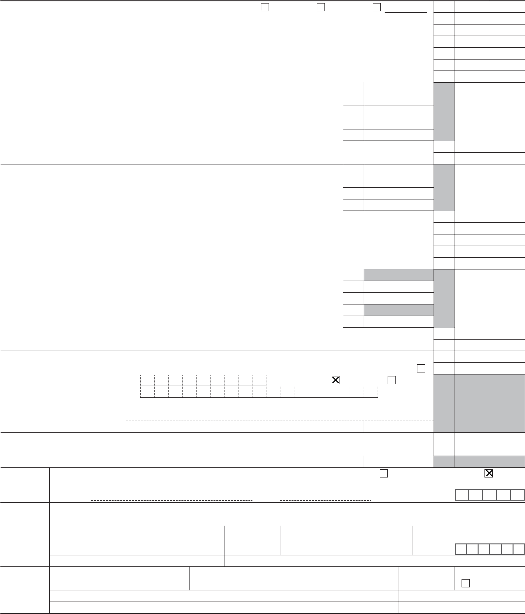Add lines 25d, 25e, 25f, 25g, 26, and 32. These are your total payments . . . . . . . . 33 161. Refund 34 If line 33 is more than line 24, subtract line 24 from line 33. This is the amount you overpaid . . 34 161. 35a Amount of line 34 you want refunded to you. If Form 8888 is attached, check here . . . . 35a 161.

Direct deposit? b Routing number 0 4 4 0 0 0 0 3 7 c Type: Checking Savings

See instructions. d Account number 7 7 3 6 0 9 0 2 6

e If you want your refund check mailed to an address outside the United States not shown on page 1, enter it here.

36 Amount of line 34 you want applied to your 2023 estimated tax . . 36 Amount 37 Subtract line 33 from line 24. This is the amount you owe.

You Owe For details on how to pay, go to www.irs.gov/Payments or see instructions . . . . . . . . 37

38 Estimated tax penalty (see instructions) . . . . . . . . . . 38

Third Do you want to allow another person to discuss this return with the IRS? See instructions. Yes. Complete below. No

Party Designee’s Phone Personal identification

Designee name no. number (PIN)

Under penalties of perjury, I declare that I have examined this return and accompanying schedules and statements, and to the best of my knowledge and belief, they are true, correct, and complete. Declaration of preparer (other than taxpayer) is based on all information of which preparer has any knowledge.

Sign Your signature Date Your occupation If the IRS sent you an Identity

Here Protection PIN, enter it here

STUDENT (see inst.)

Phone no. Email address

Paid Preparer’s name Preparer’s signature Date PTIN Check if:

# Preparer SYAM PRIYA RAM SAGAR GUPTA TALLAM 02/24/2023 P02082703 Self-employed Use Only Firm’s nameFirm’saddressSYAM PRIYA RAM SAGAR GUPTA TALLAMGLOBAL TAXES LLC245 ROONEY CT E BRUNSWICK NJ 08816 Phone no. Firm’s EIN (678)965-952284-3171965

Go to www.irs.gov/Form1040NR for instructions and the latest information. REV 02/14/23 PRO Form 1040-NR (2022)

|  |  |  |  |
| --- | --- | --- | --- |
| SCHEDULE NEC  (Form 1040-NR)  Department of the Treasury  Internal Revenue Service | Tax on Income Not Effectively Connected With a U.S. Trade or Business  Go to www.irs.gov/Form1040NR for instructions and the latest information.  Attach to Form 1040-NR. |  | OMB No. 1545-0074 |
| 2022  Attachment Sequence No. 7B |
| Name shown on Form 1040-NR |  | Your identifying number | |
| ANUSHA RAMINENI |  | 181-41-4548 | |

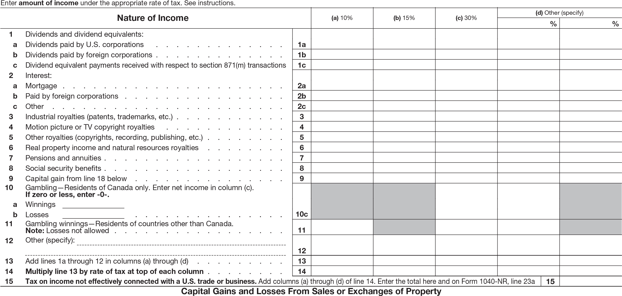

|  |  |  |  |  |  |  |  |  |  |
| --- | --- | --- | --- | --- | --- | --- | --- | --- | --- |
| Enter only the capital gains and losses from property sales or exchanges that are from sources within the United States and not effectively connected with a U.S. business. Do not include a gain or loss on disposing of a U.S. real property interest; report these gains and losses on Schedule D (Form 1040).  Report property sales or exchanges that are effectively connected with a U.S. business on Schedule D (Form 1040), Form 4797, or both. | 16 (a) Kind of property and description  (if necessary, attach statement of descriptive details not shown below) | (b) Date acquired mm/dd/yyyy | (c) Date sold mm/dd/yyyy | (d) Sales price | (e) Cost or other basis | | (f) LOSS  If (e) is more than (d), subtract (d) from (e). | | (g) GAIN  If (d) is more than (e), subtract (e) from (d). |
|  |  |  |  |  | |  | |  |
|  |  |  |  |  | |  | |  |
|  |  |  |  |  | |  | |  |
|  |  |  |  |  | |  | |  |
|  |  |  |  |  | |  | |  |
| 17 Add columns (f) and (g) of line 16 . . . . . . . . . . . . . . . . . . . . . . . 18 Capital gain. Combine columns (f) and (g) of line 17. Enter the net gain here and on line 9 above. If a loss, | | | | | 17 | ( ) | |  |
| enter -0- . . | | 18 |  |

For Paperwork Reduction Act Notice, see the Instructions for Form 1040-NR. REV 02/14/23 PRO Schedule NEC (Form 1040-NR) 2022

|  |  |  |  |
| --- | --- | --- | --- |
| SCHEDULE OI (Form 1040-NR)  Department of the Treasury  Internal Revenue Service | Other Information  Go to www.irs.gov/Form1040NR for instructions and the latest information.  Attach to Form 1040-NR.  Answer all questions. | | OMB No. 1545-0074 |
| 2022  Attachment Sequence No. 7C |
| Name shown on Form 104 | NR  0- | Your identifying number | |
| ANUSHA RAMINE | NI | 181-41-4548 | |

1. Of what country or countries were you a citizen or national during the tax year? INDIA
2. 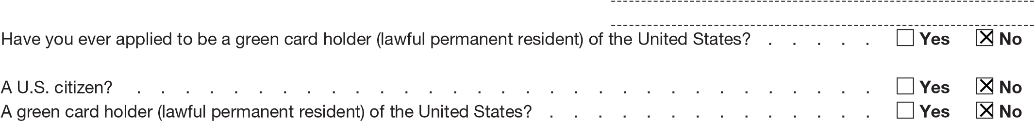In what country did you claim residence for tax purposes during the tax year? United States C Have you ever applied to be a green card holder (lawful permanent resident) of the United States? .
3. Were you ever:

1. A U.S. citizen? . . . . . . . . . . . . . . . . . . . . 2. A green card holder (lawful permanent resident) of the United States? . . .

If you answer “Yes” to (1) or (2), see Pub. 519, chapter 4, for expatriation rules that apply to you.

1. If you had a visa on the last day of the tax year, enter your visa type. If you didn’t have a visa, enter your U.S.

immigration status on the last day of the tax year. F1

1. Have you ever changed your visa type (nonimmigrant status) or U.S. immigration status? . . . . . . . . Yes No

If you answered “Yes,” indicate the date and nature of the change:

1. List all dates you entered and left the United States during 2022. See instructions.

Note: If you’re a resident of Canada or Mexico AND commute to work in the United States at frequent intervals, check the box for Canada or Mexico and skip to item H . . . . . . . . . Canada Mexico

|  |  |  |  |  |
| --- | --- | --- | --- | --- |
| Date entered United States mm/dd/yy | Date departed United States mm/dd/yy |  | Date entered United States mm/dd/yy | Date departed United States mm/dd/yy |
|  |  |  |  |
|  |  |  |  |
|  |  |  |  |
|  |  |  |  |

1. Give number of days (including vacation, nonworkdays, and partial days) you were present in the United States during:

2020 , 2021 , and 2022 365 .

1. Did you file a U.S. income tax return for any prior year? . . . . . . . . . . . . . . . . . . . YesNo

If “Yes,” give the latest year and form number you filed:

1. Are you filing a return for a trust? . . . . . . . . . . . . . . . . . . . . . . . . . . YesNo

If “Yes,” did the trust have a U.S. or foreign owner under the grantor trust rules, make a distribution or loan to a

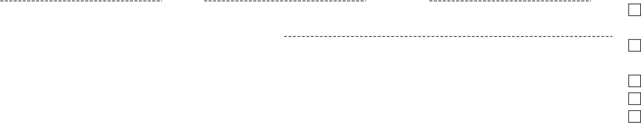 U.S. person, or receive a contribution from a U.S. person? . . . . . . . . . . . . . . . . . . YesNo

1. Did you receive total compensation of $250,000 or more during the tax year? . . . . . . . . . . . . YesNo

If “Yes,” did you use an alternative method to determine the source of this compensation? . . . . . . . YesNo

1. Income Exempt From Tax—If you are claiming exemption from income tax under a U.S. income tax treaty with a foreign country, complete (1) through (3) below. See Pub. 901 for more information on tax treaties.
2. Enter the name of the country, the applicable tax treaty article, the number of months in prior years you claimed the treaty benefit, and the amount of exempt income in the columns below. Attach Form 8833 if required. See instructions.

|  |  |  |  |
| --- | --- | --- | --- |
| (a) Country | (b) Tax treaty article | (c) Number of months claimed in prior tax years | (d) Amount of exempt income in current tax year |
|  |  |  |  |
|  |  |  |  |
|  |  |  |  |
| (e) Total. Enter this amount on Form 1040-NR, line 1k. Do not enter it anywhere else on line 1 . . | | |  |

1. Were you subject to tax in a foreign country on any of the income shown in 1(d) above? . . . . . . . .YesNo
2. Are you claiming treaty benefits pursuant to a Competent Authority determination? . . . . . . . . . .YesNo

If “Yes,” attach a copy of the Competent Authority determination letter to your return.

M Check the applicable box if:

1. This is the first year you are making an election to treat income from real property located in the United States as effectively connected with a U.S. trade or business under section 871(d). See instructions . . . . . . . . . . . . . . . . . . . .
2. You have made an election in a previous year that has not been revoked, to treat income from real property located in the United States as effectively connected with a U.S. trade or business under section 871(d). See instructions . . . . . . . . . .

For Paperwork Reduction Act Notice, see the Instructions for Form 1040-NR. REV 02/14/23 PRO Schedule OI (Form 1040-NR) 2022