Hi RamaDevi,

As discussed, can you please do the below changes. Please generate new docs and send to me.. My wife will do courier on tomorrow.

**Address for Documentation:** 5151 CERRETO ST, DUBLIN, CA 94568

**Address for Docs Courier to Me:** RAMALINGESWARARAO BAPANAPALLI 35566 COLLIER PL. FREMONT CA 94536

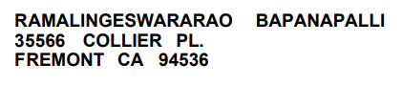

Regret the inconvenience caused.