Hi Ramadevi,

As per trailing mail, Please find the required details below.

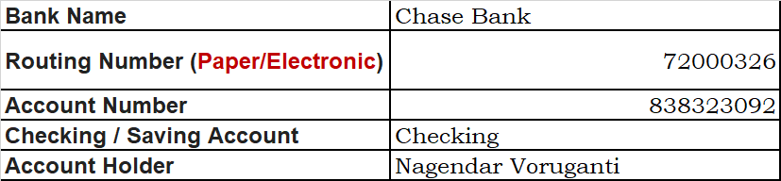

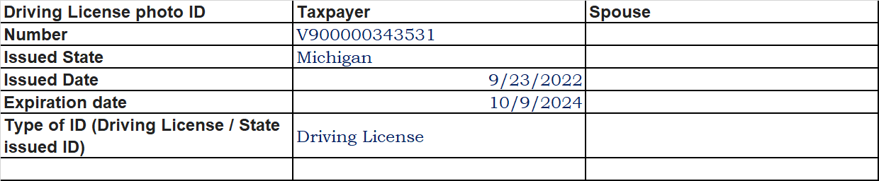

Regards,

NagendarV