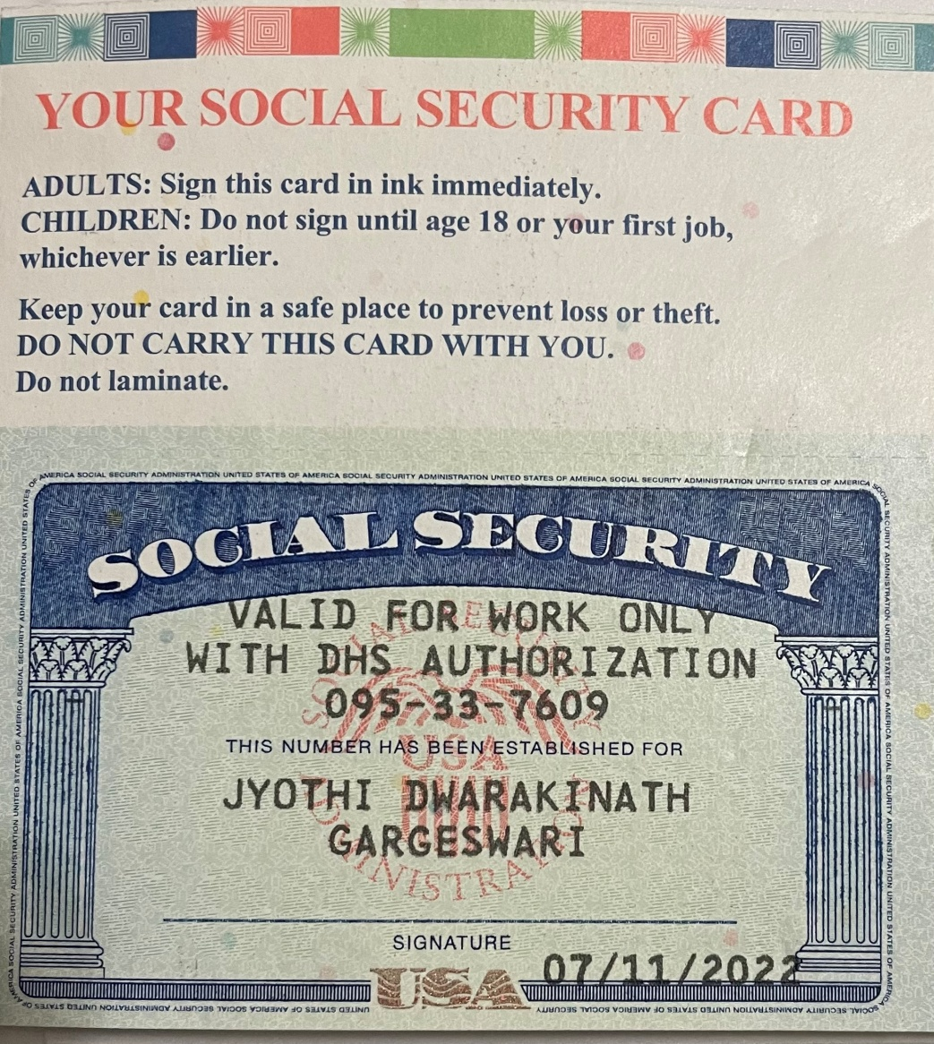

HI GANESH,

MY NAME MENTIONED IN THE DOCUMENT IS NOT COMPLETE. OTHERWISE ALL OTHER INFORMATION IS CORRECT. CAN YOU PLEASE CONFIRM THE CONFUSION ABOUT MY NAME. PLEASE FIND ATTACHED MY SSN FOR NAME CLARIFICATION.