HI HEMA,

PLEASE FIND MY DETAILS BELOW:

BANK NAME

 BANK OF AMERICA

ROUTING NUMBER (PAPER/ELECTRONIC)

 021200339

ACCOUNT NUMBER

 381064333416

CHECKING / SAVING ACCOUNT

 CHECKING

ACCOUNT HOLDER

 KRISHNA KUMARI REPALLE

PLEASE FIND STATE ID OF NJ ALSO ATTACHED.

ISSUED DATE : 08-22-2022

EXPIRATION DATE : 08-28-2026

ISSUE STATE : NEW JERSEY.

REGARDS,

KRISHNA K R

HI JASWANTH,

EVERY THING LOOKS GOOD, EXCEPT MY HOME ADDRESS.

ITS 300 LEGACY DR, PLEASE CHANGE THIS. OTHER THAN THIS EVERYTHING LOOKS GOOD.

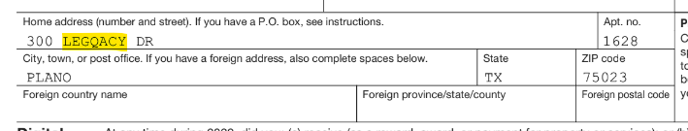

REGARDS,

KRISHNA KR