Please file my status as Married filing separately.

Name: Jhansi L Gayam  
  
SSN : 736723230

Address: 818 Players Ct, Nashville, TN 37211

My Dependents:

Daughter : Aadvika L Gavva

DOB: 07-20-2015

SSN: 788-20-5492

Son: Advyth R Gavva

DOB: 07-20-2015

SSN: 539-87-8717  
  
Attached driving license. And here is email I’d : [Jhansi.gayam@gmail.com](mailto:Jhansi.gayam@gmail.com)     DOB: 11-11-1983  
  
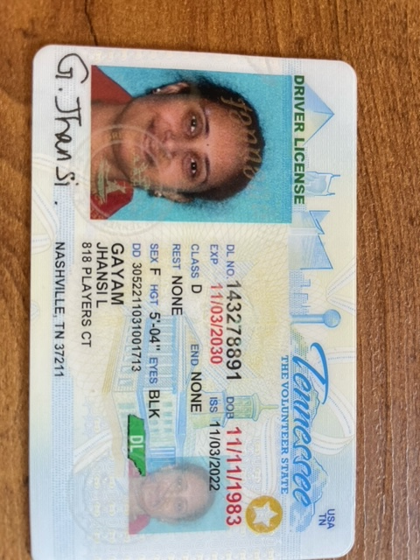

Please let me know if you need any further info.

Thanks,

Jhansi

408-5945998