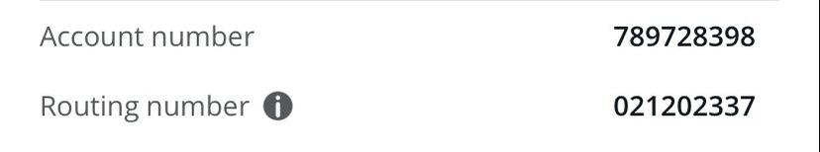  
CHASE BANK; CHECKING ACCOUNT; ACCOUNT HOLDER NAME: SANA CHAWLA