HEY HEMA,

SORRY FOR THE DELAY! HERE ARE ALL THE DETAILS AND THE DOCUMENTS I HAVE. PLEASE LET ME KNOW IF THERE WOULD BE ANYTHING ELSE THAT YOU NEED FROM ME.

CURRENT ADDRESS: 3838 DEVELOPMENT TER, UNIT 1003, FREMONT, CA, 94538

MARITAL STATUS: SINGLE

WHICH STATE DID YOU STAYED FROM 1ST JAN 2022 TO 31ST DEC 2022: CALIFORNIA

IF YOU HAVE HEALTH INSURANCE OUTSIDE? THEN SEND ME DOCUMENT 1095-A: NA

DID YOU RECEIVE ANY IRS INTEREST FOR LATE REFUND? NO

DID YOU HAVE ANY OTHER INCOMES LIKE NEC OR 1099S OR 1099 MISCELLANEOUS OR SHARES LIKE ROBINHOOD OR COINBASE: NO JUST ETRADE

DID YOU RECEIVE 1099-G FROM IRS ? NO

DO YOU PURCHASE ANY ELECTRONIC CAR LIKE TESLA? NO

DO YOU HAVE HOME LOAN IN USA OR INDIA? NO

DID YOU DEPOSIT ANY TRADITIONAL IRA CONTRIBUTION 6000$ NO

DID YOU PAY ANY COLLEGES FEES IF YES THEN PROVIDE ME 1098-T TUTION FEES DOCUMENT: NO

FIRST NAME : SUSHIL DILIP

LAST NAME : SAVLA

SSN: 221-87-0827

CURRENT ADDRESS: 3838 DEVELOPMENT TER, UNIT 1003, FREMONT, CA, 94538

OCCUPATION: MECHANICAL DESIGN ENGINEER, TESLA

VISA STATUS: H1B (WAS CONVERTED ON 1ST OCT,2022)

DOB: 06/26/1997

DATE OF MARRIAGE: NA

NUMBER: 8643549946

EMAIL ID: [SSAVLA@CLEMSON.EDU](mailto:ssavla@clemson.edu)

MARITAL STATUS: SINGLE

INDIAN ADDRESS: B-507, KALPATARU BLDG, SATYA NAGAR, BORIVALI (W), MUMBAI, 400092

 RESIDENT STATES FROM 1ST JAN TO 31ST DEC 2022: CALIFORNIA

OTHER INCOME DOCS. LIKE 1099 & 1098'S: ATTACHED

REGARDS,

SUSHIL SAVLA

HEY GANESH,

PLEASE CAN YOU LOOK HERE THE ADDRESS SEEMS TO BE MISSING THE LAST DIGIT FOR UNIT NO.   
  
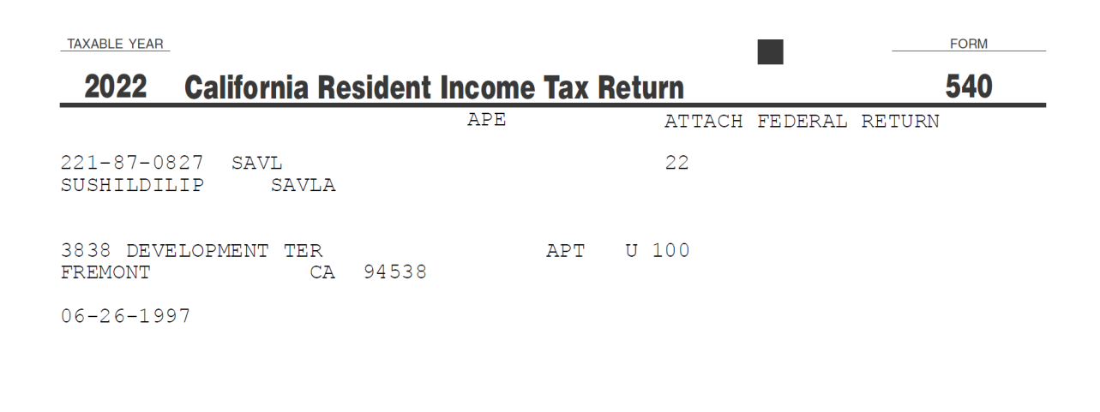

3838 DEVELOPMENT TER UNIT 1003, FREMONT, CA, 94538

CAN YOU MAKE THIS CHANGE AND I CAN SIGN AND SEND THE COPY BACK FOR FILING TAX

THANK YOU!

REGARDS,

**SUSHIL SAVLA**