Bank of America  
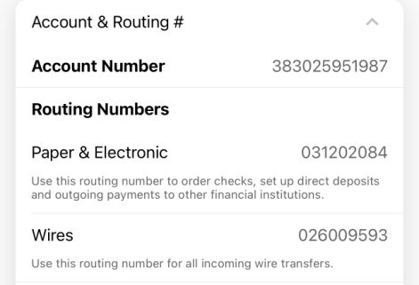  
Checking account  
Akash Arun