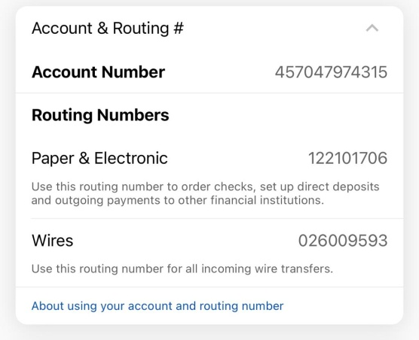

Checking account  
Bank of America  
Account holder ; Surya Sai Siddesh Danda