**Form 843 AND 8316 Paper Filing Instructions.Federal**

1. Download the Attached 1040NR Filing Document set
2. Download the Attached FORM-843 AND FORM-8316 FilingDocuments
3. Print them on ONE Side Page only and DO NOT Staplethem
4. You have to SIGN the Form 1040NR page 3 and mention datein MM/DD/YYYYformat.

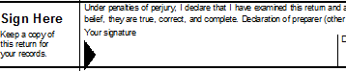

1. You have to SIGN the Form 843 and mention date in MM/DD/YYYY format

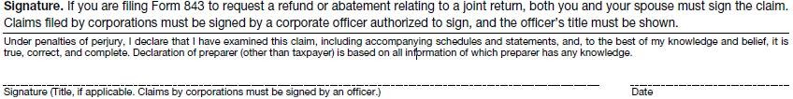

1. You have to SIGN the Form 8316 and mention date in MM/DD/YYYY format

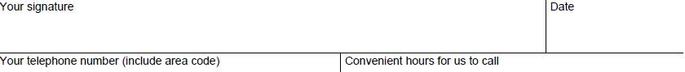

1. Attach a copy of the following documents
   * W-2 OF THE TAX YEAR
   * VISA COPY
   * ID PROOFCOPY
2. POST the ENTIRE SET OF Documents to the below IRS Address.

Department of the Treasury Internal Revenue Service Austin, TX 73301-0215

**Note**: Pls. Cross check your Bank details before you send the documents to IRS and it will take 4 – 9 weeks to get the FICA TAXES amount credited into your Bank Account.

Let us know if you have any further questions.

**------------------------------------------------------------------------------------------------------------------------------------------**