|  |  |
| --- | --- |
| **BANK NAME** | BANK OF AMERICA |
| **ROUTING NUMBER (PAPER/ELECTRONIC)** | 123103716 |
| **ACCOUNT NUMBER** | 139105256015 |
| **CHECKING / SAVING ACCOUNT** | CHECKING ACCOUNT |
| **ACCOUNT HOLDER** | SRINIDHI BASAVARAJU |

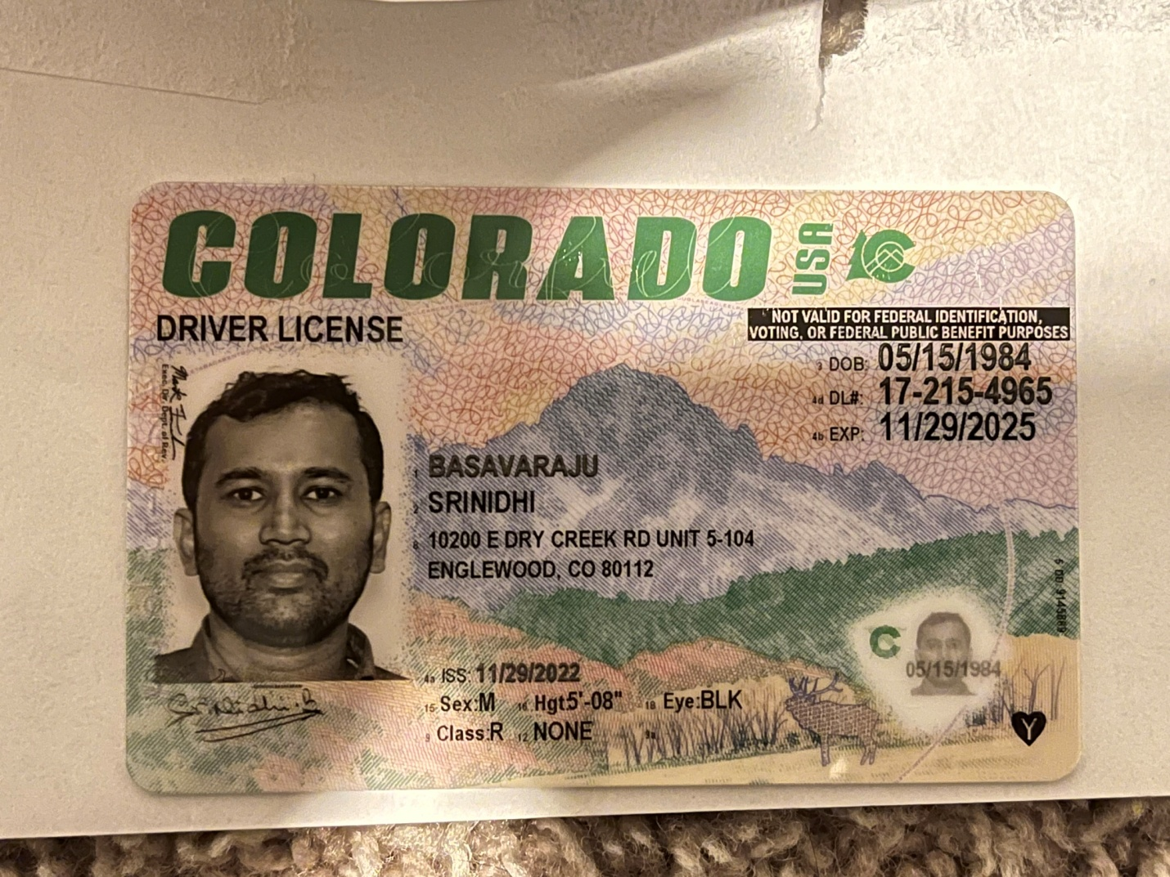

 #310, SAI MEGA BLOSSOM, 5TH PHASE, JP NAGAR, BANGLORE 560078 KARNATAKA