Please include this as well as mentioned in email ...
---------- Forwarded message ---------
From: GovHub <no-reply@govhub.com>
Date: Sat, Jul 30, 2022 at 5:45 PM
Subject: Contra Costa County Treasurer - Tax Collector Payment Confirmation
To: MANISH KUMAR BILLAIYA <manish.billaiya@gmail.com>

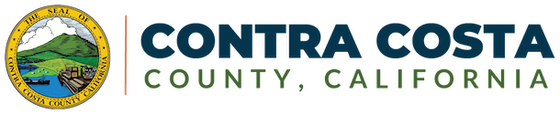

Thank you for your payment

Confirmation Number
T4293228097

Items Paid
DESCRIPTION | QUANTITY | AMOUNT
Property Tax  Redemption - Parcel Number: 406-412-009  Sale ID: 2021-01477 Installment Number: 1 Due Date: Aug 1, 2022 | 1 | $4305.38
Subtotal | $4305.38
The payment will appear on your statement as "CONTRA COSTA TAX COLL.".
TOTAL CHARGED |  | $4305.38

Transaction Details

Payment | Checking Account
Account | Checking ending in 6388
Paid | $4305.38
Payment Date | Jul 30, 2022, 5:45 PM PDT
Recipient | Contra Costa County

Paid by
MANISH KUMAR BILLAIYA
manish.billaiya@gmail.com

Your payment still needs to be cleared by your bank. Your bank should inform us of an unsuccessful e-check within three business days.

Contact Information
Contra Costa County - Treasurer - Tax Collector
625 Court St. #100, Martinez, CA 94553
(925) 608-9500 | Website

