HI HEMA,

MAIL ID: ANILJAGADAL@OUTLOOK.COM

PLEASE FIND THE DETAILS BELOW.

FIRST NAME: ANIL

LAST NAME: JAGADAL

SSN: 716-77-3336

CURRENT ADDRESS: 4421 GILBERT ST,APT 119, OAKLAND 94611

OCCUPATION: SENIOR ASSOCIATE, AUDIT

VISA STATUS: L1

DOB: FEBRUARY 1, 1990

DATE OF MARRIAGE: MAY 8, 2015

NUMBER: 5109348124

MARITAL STATUS: MARRIED

INDIAN ADDRESS: MANASA SAROVARA, ADITYA NAGAR, DALAVAYI LAYOUT, GOKAK 591307

SPOUSE DETAILS:

FIRST NAME: ASHWINI ANIL

LAST NAME: JAGADAL

DOB: DECEMBER 9, 1989

ITIN/SSN: NA

OCCUPATION: NOT WORKING

KIDS DETAILS:

FIRST NAME: AGASTYA ANIL

LAST NAME: JAGADAL

SSN: NA

DOB: NOVEMBER 28, 2019

CURRENT ADDRESS? **4421 GOLBERT ST, APT 119, OAKLAND 94611**

MARITAL STATUS: **MARRIED**

WHICH STATE DID YOU STAYED FROM 1ST JAN 2022 TO 31ST DEC 2022: **CALIFORNIA**

IF YOU HAVE HEALTH INSURANCE OUT SIDE ? THEN SEND ME  DOCUMENT 1095-A: **NA**

DID YOU RECEIVE ANY IRS INTEREST FOR LATE REFUND ?**NO**

DID YOU HAVE ANY OTHER INCOMES LIKE NEC OR 1099S OR 1099 MISCELLANEOUS OR SHARES LIKE ROBINHOOD OR COINBASE: **NO**

DID YOU RECEIVE 1099-G FROM IRS ?**NO**

DO YOU PURCHASE ANY ELECTRONIC CAR LIKE TESLA ?**NO**

DO YOU HAVE HOME LOAN IN USA OR INDIA ?**I HAVE IN INDIA**

DID YOU DEPOSIT ANY TRADITIONAL IRA CONTRIBUTION 6000$ **NO**

DID YOU PAY ANY COLLEGES FEES IF YES THEN PROVIDE ME 1098-T TUTION FEES DOCUMENT - **NO**

**I HAVE ALSO ATTACHED THE PASSPORT OF MY WIFE AND MY W2 FORM.  LET ME KNOW IF YOU NEED ANY OTHER INFORMATION.**

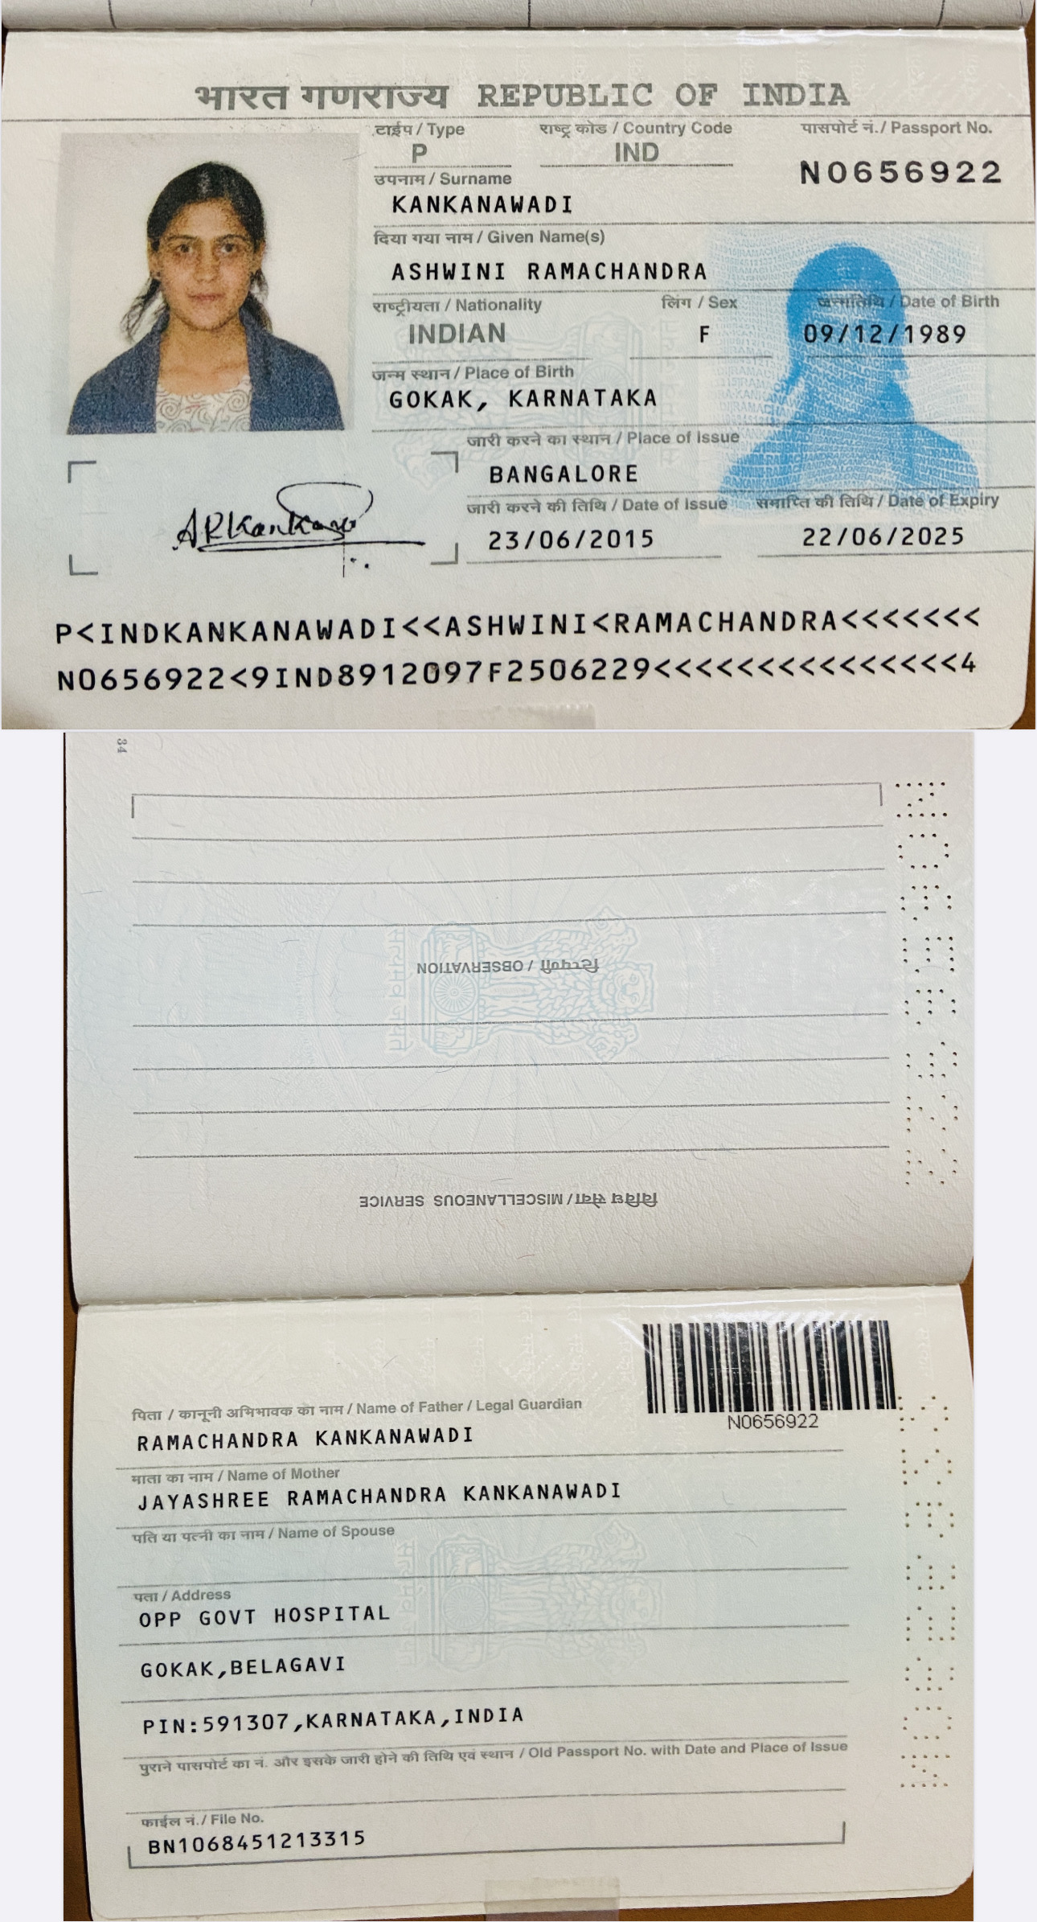

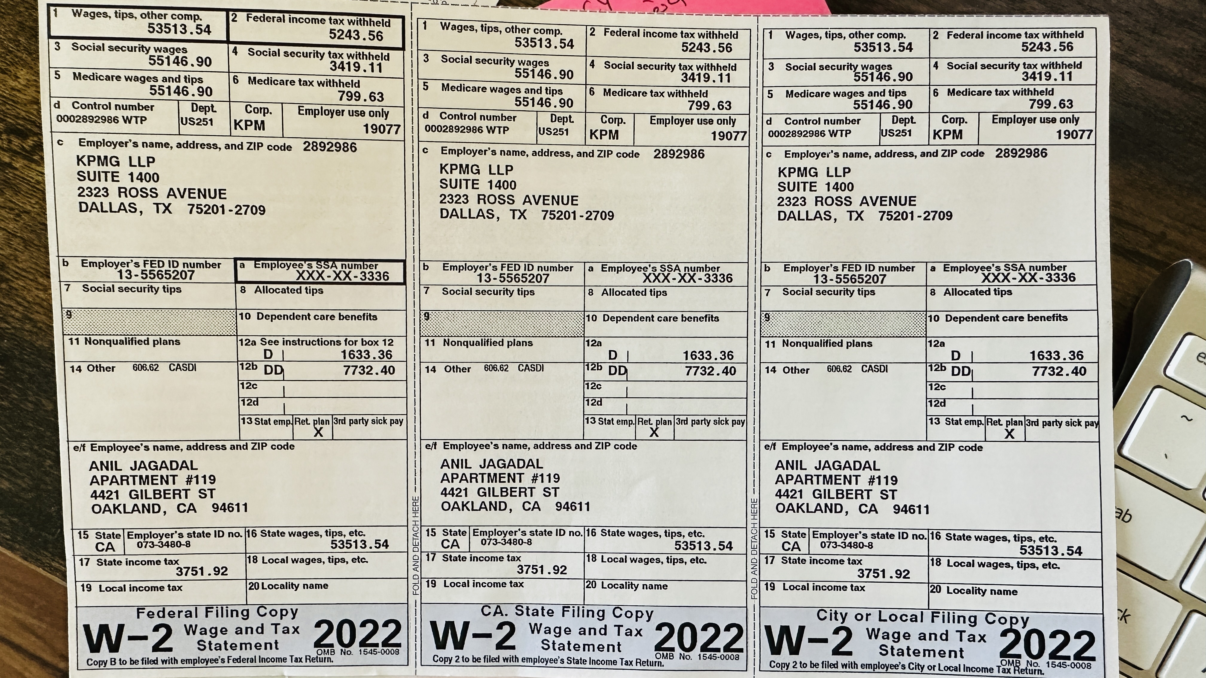

**THANK YOU,**

**ANIL JAGADAL**

SENT FROM MY IPAD